**Air-Conditioner performance estimation and monitoring using IOT**

by:

**Mr F.J. Fourie**

**26047799**

**Final Report**

submitted in pursuit of the degree

BACHELOR OF ENGINEERING

In

COMPUTER AND ELECTRONIC ENGINEERING

North-West -University Potchefstroom Campus

Supervisor: Prof A. Helberg and Dr M Ferreira

Potchefstroom

2018

DECLARATION

I, **FJ Fourie**, declare that this report is a presentation of my own original work.

Whenever contributions of others are involved, every effort was made to indicate this clearly, with due reference to the literature.

No part of this work has been submitted in the past or is being submitted, for a degree or examination at any other university or course.

Signed on this, 27th day of October 2018, in Potchefstroom.

_________________________________

FJ Fourie

# Abstract

Split type air -conditioning units are widely used in commercial and domestic premises. At present most users of the split type air-conditioning units manage the maintenance of these split type air-conditioning units in one of two ways.

The first procedure is to replace the split type air-conditioning unit once the unit has been in operation for a predetermined period [1].

The second procedure followed is to operate the split type-air-conditioning unit breakdown.

Both these procedures are inefficient and lead to a monetary loss and a waste of electricity. This is detrimental to the environment as most of the national supply electricity in South Africa is coal power stations which are damaging to the environment. Therefore, it is unethical to squander electricity when more efficient solutions can be found. The national supply electricity cost in South Africa is a major contributor to the high operating costs for both commercial and private properties. Therefore, a system that detects the inefficient operation of the split type air-conditioning unit will be financially beneficial to industry and the broader community.

The aim of the project documented in the following report is to develop a low-cost IOT module which can be installed and used with currently operational split air-conditioner units in commercial and private properties. The sensor consoles should be cost efficient by means of saving more energy through early detection, than the cost to produce the module.

In order to solve the complex problem, set in the project, the engineering design process was followed. The engineering design process in its simplest terms is design, implementation, and testing.

This process is broken down into subcategories in order to solve the problem more effectively. In this report the engineering design process is documented in the following chapters:

Chapter 1 defines the problem, Chapter 2 is a literature study on aspects of the problem and possible solutions, Chapter 3 records the design, Chapter 4 shows the implementation of the design, Chapter 5 sets out the test and evaluation and Chapter 6 reflect the conclusion of the report. Within these chapters, various versions of the design where made, implemented and tested.

In order to identify errors in the split type air-conditioning unit operation, such as a dirty filter and a broken compressor fan, the distributed IOT environmental monitoring module does the following:

The distributed IOT environmental monitoring module collects data on the split type air-conditioning unit via two DS18B20 waterproof temperature sensors, one on the inlet and one on the outlet gas pipe of the air-conditioning unit. The module further measures the current used by the air-conditioning unit with a non-invasive SCT013 current sensor clamped over the live wire of the main power supply to the air-conditioning unit. The data measured by these sensors is sent via wire from the controller module to the LoRa module.

The LoRa module transceiver sends the data to the public gateway after sending a join request to the gateway. Loriot is then used to retrieve the data from the gateway.

Using WebSocket the data is then collected from the Loriot website by the Python data collection program written in this project. The Python data collection program writes the data to a CSV file which acts as the data storage format for this project. The data analysis program written in this project accesses the CSV files in order to collect the data necessary for the data analysis. The data analysis program analyses the data and displays it for the user on a simple GUI. From this GUI the user can select which aspect of the split type air-conditioning unit to inspect.

In its current form, the distributed IOT environmental monitoring module still has some room for improvement as noted in Chapter 6. However, the distributed IOT environmental monitoring module fulfils the requirements of the project scope and will add value to a building's HVAC management and monitoring systems.

Table of Contents

Abstract iii

Table of Figures x

Table of equations xiii

List of Tables xiv

Chapter 1 – Introduction 1

1.1. Introduction 1

1.2. Background 1

1.3. Problem Statement 1

1.4. Envisaged Solution 2

1.4.1 Alternative Solution 2

1.4.2 Project Objectives 3

1.4.3 Project Scope 4

1.4.4 Proposed Solution 6

1.4.5 Project Testability 6

1.4.6 Project Deliverables 7

1.4.7 Project Limitations 7

1.4.8 Project Safety 7

1.5. Project Plan 8

1.5.1 Methodology 9

1.5.2 Work Breakdown Structure 9

1.5.3 Project Feasibility 10

1.6. Conclusion 11

Chapter 2 – Literature Study 12

2.1. Introduction 12

2.2. Previous Solutions 12

2.3. Air Conditioner 13

2.4. COP (Coefficient of Performance) 13

2.5. Communication 14

2.6. Sensors 15

2.7. Controller 16

2.8. Databases 17

2.9. Airspeed measurement 18

2.10. Expert consultation 19

2.10.1 Air-conditioning unit experts 19

2.10.2 Electronics Experts 19

2.10.3 Electrical experts 20

2.11. Conclusion 20

Chapter 3 –Design 21

3.1 Introduction 21

3.2. Conceptual Design 23

3.9.1 Controller selection 23

3.9.2 Communication Selection 24

3.9.3 Database selection 25

3.9.4 Back-end programming language selection 26

3.3. Conceptual design summary 26

3.4. Conceptual design Conclusion 27

3.5. Detailed design 28

3.6. Power supply detailed design 28

3.7. Current sensor detailed design 28

3.8. Temperature sensor Detailed design 31

3.9. LoRa module Detailed Design V1.0 33

3.10. LoRa module Detailed Design V2.0 34

3.11. Enclosure Detailed design V1.0 37

3.12. Controller detailed design V1.0: Arduino Uno ® 37

3.13. Controller detailed design V1.1: PIC Microcontroller 38

3.14. Controller detailed design V1.2: ST MCU 40

3.15. Controller V2.0: Development board design 41

3.16. Data storage design V1.0: MYSQL Database 42

3.17. Data storage design V2.0: CSV file 44

3.18. Programming language V1.0: C++ 44

3.19. Programming language V2.0: Python 44

3.20. Human machine interface V1.0 45

3.21. Human machine interface V2.0 46

3.22. PCB design (Final module design) 47

3.23. Mobile Air-Conditioning Test Jig 53

3.24. Website: Loriot 55

3.25. Enclosure 55

3.26. COP Estimation 56

3.27. Conclusion 56

Chapter 4 – Implementation 59

4.1. Introduction 59

4.2. Temperature sensor 59

4.3. Current sensor 59

4.4. LoRa Module V1.0 60

4.5. LoRa Module V2.0 61

4.6. LoRa module Message Composition 62

4.7. Controller Prototype V1.0: Arduino Uno® 63

4.8. Controller Prototype V1.1: PIC microcontroller 64

4.9. Controller Prototype V1.2: ST microcontroller unit 65

4.10. Controller Prototype V2.0: Development-Board (ATmega328P) 66

4.11. Human machine interface V1.0 69

4.12. Human machine interface V2.0 69

4.13. Website: Loriot 75

4.14. Mobile split type air-conditioner Test Jig V1.0 76

4.15. Mobile split-type air-conditioner Test Jig V2.0 78

4.16. Distributed IOT environmental monitoring module Installation Procedure 82

4.17. Enclosure 82

4.18. Conclusion 83

Chapter 5 – Testing and Evaluation 84

5.1. Introduction 84

5.2. Current sensor Test 84

5.3. Temperature sensor Test 88

5.3.1 Hot bucket, cold bucket test 88

5.3.2 Ambient temperature test 90

5.4. Dirty Filter Test 90

5.5. Compressor Fan Test 91

5.6. Compressor decoupled Test 92

5.7. Package Test 93

5.8. Conclusion 95

Chapter 6 – Conclusion and Recommendation 97

6.1. Introduction 97

6.2. Project Overview 97

Summary of strengths 97

Cost 98

Deploy-ability 98

Non-Invasive 98

Robustness 98

Summary of weaknesses 99

Server reliability 99

Gateway reliability 99

Bi-directional communication 99

6.3. Recommendations 100

Recommendations for weaknesses 100

General recommendations 101

COP estimation recommendations 101

6.4. ECSA ELO outcomes 101

6.5. Conclusion 106

References 111

Appendix A: Systems requirements specification document I

Appendix B.1: Firmware Code II

Appendix B.2: Software code III

Appendix C: URS IV

Appendix D: Budget VII

Appendix E: LoRaWAN™ Certification VIII

Appendix F: Project Schedule XII

Appendix G: Arduino Uno ® schematic XIV

Appendix H: Work Breakdown Structure XV

**Table of Figures**

Figure 1: Project scope delimitation 5

Figure 2: High-level system overview 6

Figure 3: LoRa Network [9] 15

Figure 4: Arduino UNO ® pin layout [11] 17

Figure 5: An HHF91 Anemometer that can measure CFM 19

Figure 6: system architecture 22

Figure 7: 100 Amp Non-invasive current sensor 29

Figure 8: current sensor SCT013 specifications [18] 30

Figure 9 current sensor schematic [18] 30

Figure 10: Photo of a DS18B20-ND temperature sensor 32

Figure 11: Waterproof DS18B20 – ND 32

Figure 12: DS18B20 Block Diagram 33

Figure 13: Distance and elevation profile between point A and B from Google Earth from [19] 35

Figure 14: Results PER of the Range Test 7720 m with +20 dBm [19] 36

Figure 15: Results PER of the Range Test 7720 m with +14 dBm [19] 36

Figure 16: Example of RF Gain settings - iM880B-L & EU868 [20] 37

Figure 17: Controller detailed design V1.0 Arduino Uno ® circuit schematic 38

Figure 18: early circuit schematic 40

Figure 19: schematic programmer connection to ST MCU 40

Figure 20: ATmega328P simple circuit schematic 42

Figure 21: Database structure design part 1 43

Figure 22: Database structure design part 2 43

Figure 23: Login screen 45

Figure 24: Air-conditioner status screen model 46

Figure 25: Python HMI GUI schematic 47

Figure 26: Module schematic 48

Figure 27: Module PCB layout 49

Figure 28: PCB Bill of materials (BOM) 50

Figure 29: PCB 3D render top view 51

Figure 30: PCB 3D render bottom view 51

Figure 31: PCB 3D isometric render 1 52

Figure 32: PCB 3D isometric render Pin layout 52

Figure 33: Mobile split type air-conditioning unit Test Jig 55

Figure 34: Photo of implemented waterproof temperature sensor 59

Figure 35: Photo of implemented Current sensor 60

Figure 36: LoRa module V1.0 photo 60

Figure 37:LoRa module V1.0 connection with Arduino 61

Figure 38: photo of LoRa module V2.0 61

Figure 39: Schematic of iM880B packet structure [21] 62

Figure 40: Photo of the Arduino Uno ® of the V1.0 controller prototype 63

Figure 41: Photo of the breadboard of the V1.0 controller prototype 64

Figure 42: Photo of the breadboard and Arduino Uno® connection of the V1.0 controller prototype 64

Figure 43: Photo of LoRa module connections during Prototype V1.2 STM iteration 65

Figure 44: Photo of ST microcontroller programmer 66

Figure 45: Test connection V2.0 breadboard 67

Figure 46: Photo of homemade PCB top view 68

Figure 47: Photo of homemade PCB clip in 68

Figure 48: Photo of controller V2.0 in enclosure 69

Figure 49: GUI screenshot IOT aircon data analysis program 70

Figure 50: Screenshot of aircon on times display 71

Figure 51: Screenshot current vs time graph of program 71

Figure 52: Screenshot program detected air-conditioning not cooling 72

Figure 53: Screenshot program displayed times a dirty filter was detected 72

Figure 54: Screenshot of program displaying box plot of filtered delta temperature data 73

Figure 55: Boxplot of filtered aircon data of the current 73

Figure 56: Screenshot of program displaying temperature vs time of the aircon on and filtered data 74

Figure 57: Screenshot of program displaying current vs time for the aircon on and data filtered 74

Figure 58: Screenshot of the program displaying the delta temperature vs time 75

Figure 59: Photo of wood mobile air-conditioning test structure 76

Figure 60: Photo of wood mobile air-conditioning test Jig connected to IOT module 77

Figure 61: Photo of wood mobile air-conditioning test Jig with computer set up 77

Figure 62: Photo of steel framework of test jig 78

Figure 63: Photo of DB board with isolator and 5V transformer for Split type air-conditioning unit 79

Figure 64: Photo of steel mobile air-conditioning unit test Jig laboratory set up 79

Figure 65: Photo of steel mobile air-conditioning unit set up current sensor clamped over the live wire of the compressor of the air-conditioning unit 80

Figure 66: Photo of current sensor clamped over live wire 81

Figure 67: Photo of steel mobile air-conditioning unit set up temperature sensors connected to the inlet and outlet gas lines respectively of the air-conditioning unit 81

Figure 68: Photo of IOT module enclosure 82

Figure 69: photo of split type 3-point plug wire 84

Figure 70: Current sensor kettle current measurement test 85

Figure 71: Current sensor clamp and multi-meter clamp during kettle current measurements 86

Figure 72: Photo of Current sensor clamped over the live wire of the power cable for the air-conditioning unit 87

Figure 73: Hot bucket test temperature sensor probe 88

Figure 74: Cold bucket test 89

Figure 75: Photo of dirty filter test 91

Figure 76: Photo of compressor fan test 92

**Table of equations**

Equation 1: Relationship between the current in the secondary and primary winding 15

Equation 2: CT turns Ratio calculation 15

**List of Tables**

Table 1: Controller trade-off study 24

Table 2: Communication trade-off study 24

Table 3: Database trade-off study 25

Table 4: Back-end programming language selection matrix 26

Table 5: Current sensor information 29

Table 6: Current sensor characteristics 31

Table 7: LoRa provider 33

Table 8: Test settings LoRa range test iM880B [19] 35

Table 9: PIC microcontroller provider information 38

Table 10: ATmega328P pin layout 52

Table 11: IM880B pin layout 53

Table 12: Mobile split type air-conditioning test jig 54

Table 13: Current sensor measurements vs multimeter measurements experiment 1 85

Table 14: Current sensor measurements vs multimeter measurements experiment 1 87

Table 15: Hot bucket cold bucket measurements 89

Table 16:Ambient temperature sensor test 90

Table 17: Test results of packages 95

Table 18: Project budget VII

|  |  |
| --- | --- |
| TERM | DEFINITION |
| shall | Expresses a characteristic which must be present in the item of specification, thus a binding requirement |
| should | Expresses a goal or target to be pursued but not necessarily achieved |
| may | Expresses permissive guidance |
| will | Expresses a declaration of intent on the part of a party |
| STATE | The state of a system refers to a state of being of the system. |
| MODE | The mode of a system refers to the state of doing of a system. Typically modes are encapsulated within states. |

|  |  |
| --- | --- |
| Acronym | DEFINITION |
| NWU | North West University |
| tbd | To Be Defined |
| IOT | Internet of things |
| COP | Coefficient of performance |
| FSK | Frequency-shift keying |
| ISO | International Organization for Standardization |
| SANS | South African National standards |
| IEC | International Electro-technical Commission |
| LORA | Long range wide area network |
| GUI | Graphical user interface |
| IP | Ingress Protection |
| PCB | Printed circuit board |
| MCU | Microcontroller unit |
| ADC | Analog to digital converter |
| UART | Universal asynchronous receiver/transmitter |

|  |  |
| --- | --- |
| ABBREVIATION | EXPLANATION |
| e.g. | example |
| REQID | Requirement Identifier |
| IR | Infrared |
| $$mm$$ | Millimetre |
| $$mA$$ | Milliampere |
| $$μA$$ | Microampere |
| $$V$$ | Voltage |
| F/U | Functional Units |
| Syrs | System Requirements Specification |
| I/F | Interfaces |
| DFU | Device Firmware Upgrade |

# Chapter 1 – Introduction

## Introduction

Currently a large number of split type air-conditioning units are used in large commercial buildings. Most building managers deal with split type air-conditioning units in one of two ways. They either replace them after they have functioned for a predetermined period [1] or after they become aware that the air-conditioning unit has stopped functioning. This is inconvenient, inefficient, cost-intensive and has a negative ecological impact.

Currently, no effective monitoring system is commercially available for the split type air-conditioning units. Keeping ineffective split type air-conditioning units in operation results in wasted electricity, with the resultant increased electricity costs. This impacts on the profitability of a business.

The aim of this project is to optimise the use of split type air conditioning in industrial and commercial settings. The project is intended to provide real-time onscreen efficient measurements for each air conditioning unit.

## Background

During this project, a significant aspect of the problem identified is the lack of a reliable way to determine and know the coefficient of performance (COP) of a split type air-conditioning unit. This results in the common practice that air conditioning units are left to operate even after they have become far less efficient than they are supposed and expected to be and similarly air conditioning units are replaced (according to a time of use schedule) before it is truly necessary. This results in a loss of energy and capital for the company.

The implementation of a system that monitors the COP can also bring about another bonus such as predictive maintenance. In this project, the problem will be solved by making use of IOT sensors that will be fitted to existing installed split unit air conditioners. These sensors will be able to send data over the internet so that the COP of any air conditioning unit can be calculated at any time. The data will be used to enable a fact-based prediction when a unit needs to be repaired, serviced or replaced.

## Problem Statement

There is currently a considerable number of split type air-conditioning units used in large commercial buildings. Most entities that manage these buildings handle these split type air-conditioning units in one of two ways. They either replace them after they have reached a predetermined age [1] or they wait for the air-conditioning unit to break. This leads to a loss of capital and unnecessary wasting of electricity. Electricity is wasted by keeping ineffective split type air-conditioning units in operation. The loss in capital derive from an unnecessary high electricity bill and the unnecessary replacement of split type air-conditioning units. This is a problem and a method by which the performance of the air-conditioning unit is used to determine when it needs to be replaced is necessary.

The aim of the project is to develop a low-cost IOT sensor that can be installed and used with currently operational split air-conditioner units in commercial properties. The sensor consoles should be cost efficient to the extent that the amount saved due to the application of the sensor consoles is more than the cost of the sensor console itself. The sensor console should be capable of calculating the COP of any of the split air-conditioner units at any time. The sensor consoles should record data to send over the internet to a central computer that will interpret and analyse the data in order to gauge the overall condition of a split air-conditioner unit.

The central computer needs to be able to use the received data from the sensors to determine when an air-conditioner unit needs to be repaired or serviced. Predictive maintenance should be made possible by making use of IOT. Predictive maintenance is done by using algorithms to predict breakage of a split type air-conditioner unit. This should allow the system to automatically call maintenance staff to the site of the predicted breakage. A user-friendly GUI (Graphical User Interface) is necessary to ensure that the operator uses and understand the steps to be taken on the central computer. This will enable an operator to check the desired information more easily and effectively. There also needs to be a user-friendly method to establish and identify which split type air-conditioning units need to be repaired or serviced.

## Envisaged Solution



### Alternative Solution

For the Distributed IOT Environmental monitoring project, it is explicitly stated in the client student agreement of the project scope that the Distributed IOT Environmental Monitoring system must be applied to split type air-conditioning units. Therefore, there is no existing alternative solution for the monitoring of the split type air-conditioning units. At present, the only other solution is to use a split type air-conditioning unit until it breaks or replacing and servicing the split type air-conditioning units on a predetermined schedule.

### Project Objectives

All the necessary individual components such as sensors and transmitters necessary for this project already exist. These devices are within the budget of the project; therefore, it will be low cost to build and implement the device in the existing split type air-conditioning units. The low cost in combination with already existing technology availability and the low impact the device will have in the budget makes it technologically feasible. This project is designed in order that it can be implemented in a wide variety of buildings with a wide variety of infrastructure, making it an ideal device for mass manufacturing and implementation. The project will not be invasive and, because the project will help conserve electricity and limit industrial waste, it is socially commendable and supported thus making the project socially feasible.

The benefits and objectives of this project are to:

• Save money by preventing the unnecessary replacement of air conditioning units

• Save electricity by identifying faulty and inefficient air conditioning units

• Limit productivity losses by replacing the split type air-conditioning unit before it breaks down

• Limit industrial waste by preventing functional air conditioning units being discarded

The project will prevent the unnecessary financial expenditure that occurs due to the unnecessary replacement of air-conditioning units. This will be done by monitoring and calculating the coefficient of performance of every air conditioning unit. This will allow the system to display the appropriate time to replace the unit.

The project will also save electricity by informing the operator when an air conditioning unit is no longer working efficiently and needs to be serviced or replaced. This will be done by measuring and keeping track of the performance of all the units to enable the identification of a unit that shows abnormal behaviour.

Increased office comfort will be a by-product of this project but should not be overlooked, as a comfortable workspace facilitates higher productivity and happier employees. This will be done by the identification of air conditioning units showing abnormal behaviour as stated above. By timeously servicing or replacing the units, breakage will be prevented and an employer’s risk to breach the Occupational Health and Safety Act 85 of 1993 will be minimized in regard to the safety of employees in case of air conditioning failures and having employees to work in the excessive heat.

### Project Scope

The scope of the project is to design a cost-effective and non-invasive sensor console with a central computer program that communicates with the sensor console. The sensor console should have temperature sensors that will be used to measure the intake air temperature as well as the output air temperature. A current sensor will be connected to the sensor console and the power supply of the split type air-conditioning unit in order to calculate the input power and to monitor when the split type air-conditioning unit is powered. The sensor console is required to be connected to IOT in order to transmit data. LoRa will be used to transmit data from the sensor console. LoRa will be used due to the relative low-cost of the necessary LoRa module as well as its relatively long range and low power usage. A central computer with the capacity to communicate with all the sensor consoles in a particular building is necessary. This central computer will be used to access and gather data from the sensor consoles and interpret the data into valuable information. The central computer requires a GUI to enable an operator to access all the information.

The objectives of this project are the design and building of the sensor console and the programming of the back-end program that will run on the central computer. This project must make it possible to determine when to service and repair a split type air-conditioning unit based on its COP.

The approach that will be used in solving the problem is:

* Identifying, analysing and understanding the problem
* Exploring and researching possible solutions to the problem
* Identify a solution to the problem, then to specify and describe the solution
* Design the system that will be used and then create a detailed design of it
* Build the system
* Test the system
* Improve the system and finalize it

For this project, the sensor consoles and the back-end program are within scope. The gateway and the cloud are not within scope. This means that the transmission between the sensor consoles and the back-end program is within scope but that the network it is transmitted over is not within scope.

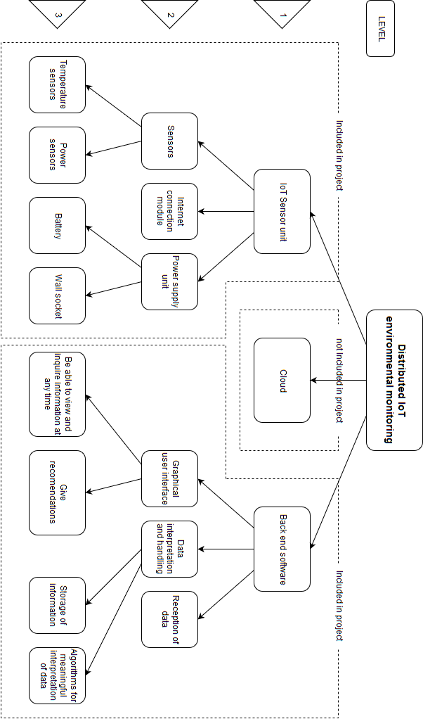

Figure 1: Project scope delimitation

Figure 1 above depicts the project scope delimitation. The figure shows what is within scope for this project and what is outside scope and also shows some of the levels of the project.

### Proposed Solution

Split type air-conditioning units are commonly used in commercial and domestic domains. At present, there is no commercially available solution to monitor whether the split type air-conditioning unit must be replaced or repaired. For the Distributed IOT Monitoring project it is required that the monitoring system shall be installed in a preinstalled split type air-conditioning unit therefore in the solution no alterations may be made to the split type air-conditioning unit that would so alter the design extensively.

The proposed solution for the Distributed IOT Environmental Monitoring project, is to develop a sensor console to monitor the split type air-conditioning unit as well as a back-end program to provide the measurements to the client. The sensor console will interact with the existing split type air-conditioning unit as well the existing IOT gateway. A back-end program will be developed that will interact with the existing gateway.

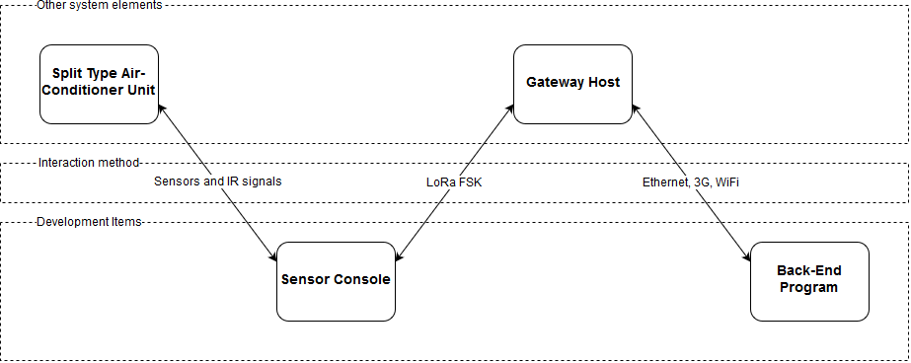

Figure 2: High-level system overview

Figure 2 system overview reflects what will be developed and how it will interact with the existing systems. There will be monitoring and communication between the existing split type air-conditioning units and the developed sensor consoles by means of sensors and IR signals. The developed sensor consoles will send and receive data to and from an existing gateway host by means of LoRa. Finally, the back-end program that will be developed will communicate with the existing gateway host in order to receive and send data to and from the sensor consoles.

### Project Testability

The following aspects must be verified in order to prove that the Distributed IOT Environmental monitoring project’s prototype accomplishes the objectives stated in section 1.4.2.

Project objectives.

* The Distributed IOT Environmental Measuring system should gather data from a split type air-conditioning unit and transfer the data to a given point.
* The system should be capable of getting a basic approximation of the performance of a split type air-conditioning unit, transfer it using IOT to a back-end program and display the data.
* The data should then be processed into information and displayed in a program that neatly and functionally shows the information to the operator.

### Project Deliverables

The Distributed IOT Environmental Monitoring project has certain deliverables that must to be present at the close of the project, namely:

* A sensor device to gather data from the split type air-conditioning unit.
* Data transition from the sensor to the back-end program using IOT.
* Basic approximation of the performance of the split type air-conditioning unit.
* Program displaying information to the operator.

### Project Limitations

Certain limitations were set for the project, namely:

* The project should be completed within the parameter of the set budget of R 3 000.00
* The device must be installable in a preinstalled split type air-conditioning unit.

### Project Safety

All projects must adhere to safety regulations, to prevent or limit any unacceptable safety risks or hazards.

In engineering, it is the responsibility of each participant of a project to ensure that safety is considered in every aspect of the project throughout its development. In the Distributed IOT Environmental Monitoring project sensors will be installed in a preinstalled split type air-conditioning unit. Therefore, it is paramount that the installation does not have any effect the safety of the split type air-conditioning unit, neither for passers-by nor for technicians responsible for maintenance and replacement of the split type air-conditioning unit.

The following standards shall be adhered to in the Distributed IOT Environmental Monitoring project:

|  |  |
| --- | --- |
| Document identifier | document description |
| ISO 5151:2017 | Non-ducted air conditioners and heat pumps -- Testing and rating for performance |
| STS 1 1998 ISSUE XII | DEPARTMENT OF PUBLIC WORKS: STANDARD SPECIFICATION FOR AIR CONDITIONING AND VENTILATION INSTALLATIONS |
| SANS 60335-2-40/ ICE 60335-2-40 | Electrical Safety of Air-conditioning. |
| SANS 1125:2004 | Room air conditioners and heat pumps |
| SANS 10147:2014 | Refrigerating Systems, including plant associated with air- conditioning systems |
| SANS 10142-1:2009 | The wiring of premises Part 1: LOW-Voltage Installation |
| IEC 61508 | Functional Safety of Electrical/Electronic/Programmable Electronic Safety-related Systems |

* The sensor console shall not cause risk or irritation to employees and staff in the office.
* The sensor console shall be housed inside a neat and safe casing with an IP rating of IP 31
* Wiring shall be done neatly and professionally, being tied together and placed inside cable housing where possible

## Project Plan

As part of the project plan, the methodology, work breakdown structure, and project feasibility are discussed below.



### Methodology

The engineering design process is followed as part of the methodology for this project to successfully complete the Distributed IOT Environmental Monitoring project.

* The first step in the engineering design process is problem identification and analysis. To ensure correct problem identification an agreement on the specification of the problem scope between the client and student is undertaken.
* The next step is to conduct research on existing solutions for the identified problem as well as the available resources. Therefore, all possible solutions for the problem are considered.
* A complete literature study of all the aspects regarding the project. This ensures a thorough understanding of the different parts of the project. It is of utmost importance to choose the correct technology for the Distributed IOT Environmental Monitoring project. The main components to be decided on for the Distributed IOT Environmental Monitoring are:
  + Communication device
  + Controller device to be used
  + Database to store and process the data.
* Next, a concept design is done of the proposed solution. In the concept design, a trade-off study is done for the different components based on cost, reliability, availability and development difficulty.
* From the trade-off studies, a detailed design of the proposed solution is done. In the detail design all the chosen components for the trade-off studies are provided.
* Once the detail design is complete the prototype can be constructed. The prototype must then be tested to ensure every part functions as planned.
* Next, the subsystems can be constructed and integrated to form the proposed solution.
* This is followed by testing of the integrated system to ensure all the subsystems integrated correctly. Final testing of the complete Distributed IOT Environmental Monitoring system must be done to test whether the product functions as set out in the requirements document for the project.
* During all phases of the project documentation of all work is done. The documentation will act as proof that the engineering design process was followed.

### Work Breakdown Structure

The work breakdown structure for the Distributed IOT Environmental Monitoring project can be seen in Appendix H.

### Project Feasibility

Factors such as the availability, budget, resources, complexity, and schedule of the project greatly influence the feasibility of a project. These aspects of the Distributed IOT Environmental Monitoring project is discussed.

**Schedule**



In Appendix F the high-level schedule is shown which was subject to change throughout the project period

**Budget**

The project budget is documented in Appendix D.

**Resources**

During the development of the Distributed IOT Environmental Monitoring project the following resources will be used:

* Human Resources

The following human resources are available for the project:

Prof. A. Helberg - Project Manager

Dr. M Ferreira - Project Manager

Mr. FJ Fourie - Engineering student

* Software Resources

Software resources will be used for documentation and simulation of the design for the project as well as for the database used in the project:

* + Microsoft Word ®
  + Microsoft Excel ®
  + MySQL ®
  + C++ ®
  + C ®
  + Python®
  + Atmel studio®
* Funds

For the Distributed IOT Environmental Monitoring project R 3 000.00 is allocated by the NWU to complete the project.

**Risk**

The main risk of the project is the difficulty to measure the efficiency of split type air-conditioning units. This is due to the difficulty in measuring the output energy of the split type-air-conditioning unit. The Anemometer could measure this output; however, an anemometer is outside the budget of the Distributed IOT Environmental Monitor, and, therefore, also too expensive to feasibly improve the split type air-conditioning unit. Time presents another risk in this project, however, with proper planning the risk can be mitigated.

## Conclusion

Chapter 1 of this document acts as an introduction to the Distributed IOT Environmental Monitoring project. In this project, a monitoring system should be designed that can be installed in a preinstalled split type air-conditioning unit. This monitoring system should be able to approximate the productivity of the split type air-conditioning unit by analysing data measured with its sensors. The data should be transmitted to a back-end program where the data will be processed and then displayed with a neat, easy to use program to the operator.

In this chapter, the project process is presented by providing the proof of planning, as can be seen in the planned schedule, budget, resources and risk review. This combined with the methodology of the project, the engineering process, supports the well-ordered process of the project.

In this chapter, a basic conceptual design is given for the Distributed IOT Environmental Monitoring project. There are currently no commercially available alternative solutions for split-type air-conditioner unit productivity monitoring. This chapter provides the scope and objectives set for the Distributed IOT Environmental Monitoring project. The conceptual design aspects are discussed in chapter two below, where a literature study was done on each aspect of the design.

# Chapter 2 – Literature Study



## Introduction

The Distributed IOT Environmental Monitoring project is about the lack of a reliable, cost-effective method with which the COP (Coefficient of Performance) of an already installed split type air-conditioning unit can be monitored. This has the consequence that air conditioning units are kept in operation despite performing less efficiently than expected. On the opposite end of the spectrum air conditioning units are replaced before it becomes a liability due to poor performance and, therefore, replacement becomes necessary. This results in loss of energy and capital for the company. In this project, the problem will be attempted to be solved by making use of IOT (Internet of Things) sensors. These IOT sensors will be fitted to existing installed split unit air-conditioners thereby making it a more cost-effective solution. These IOT sensors will be able to send data via the internet in order to calculate the COP of any air-conditioning unit at any given time. The data collected from the IOT sensors will be used to enable an estimation of when a unit needs to be repaired or serviced.

The literature study for the Distributed IOT Environmental Monitoring project is listed here in Chapter 2. A short overview of the problem will be presented in the problem statement section of the report below. The problem statement explains and substantiates the relevance of the project. A project overview briefly describes what will be done during the project and how it will be done to complete this project to satisfaction. The project scope is also included in the report. This shows what is included and what is excluded from the project, thereby giving a clear picture of what must be addressed in the project. The importance of this project will be addressed by identifying the unique aspects of the project as well as referring to the shortcomings of already existing solutions and why they are not applicable to this particular problem. This all will be followed by a complete in-depth literature survey that will look at all existing documentation and research on the different aspects of the project. Research on different possible solutions of the different aspects presented by the project will be performed in an attempt to identify the most applicable solution, for each aspect of the project.

## Previous Solutions

There is no commercially available system that can be permanently installed on already operational split type air-conditioning units to monitor their COP. Currently deciding when to replace split type air-conditioning units is based on either their age or when they break.

According to the official Energy Star website [2], it is time to replace an air conditioner when it is 10 years old or when the air conditioner needs frequent repairs and one’s energy bill starts going up. An article on Angie’s List [3] also corroborates this, stating that one should consider replacing an air conditioner if it is more than 10 years old. The article on Angie’s List [3] also gives frequent repairs as the other way to know when to replace a split type air-conditioning unit.

## Air Conditioner

The principle of an air conditioner is removing heat from one area and replacing it with cold air. The five main components of most air conditioners are as follows [4]:

* Compressor
* Condenser
* Evaporator Coil
* Blower
* Chemical refrigerant

A split type air-conditioning unit consists of an outside unit that includes the compressor, condenser, expansion valve, and a fan. Then the inside unit comprises a cooling fan and the cooling coil or evaporator [5].

The split type air-conditioning unit works by activating the outside compressor which starts to circulate the refrigerant gas. This circulation of the gas increases its temperature since it is compressed through a series of pipes. The refrigerant then moves to the condenser where a cooling system removes heat from the gas which then turns the gas into a chilled liquid. The chilled liquid is then transferred to the inside evaporator. At the evaporator, a fan collects warm air that is then passed through the chamber which contains the chilled liquid refrigerant. When the air leaves the chamber, it is cooled and is blown back into the room by means of the fan. This process is repeated until the split type air-conditioning unit’s thermostat detects that the correct temperature has been reached at which point the unit will switch off.

## COP (Coefficient of Performance)

The COP of a system is the measure of that system’s amount of output power compared to the amount of input power:

|  |  |  |
| --- | --- | --- |
|  | $$COP= \frac{power output}{power input}$$ | (1) |

The COP is a good indication of the efficiency of a split air-conditioner unit as it is independent of external variables, as can be seen in Equation (1) above. Another advantage of the COP is that it is instantaneous therefore it can be calculated at any point in time as power is measured in Watt [6].

Carnot’s theorem expresses the theoretical maximum COP for an air conditioning system [7]. Carnot’s theorem can be reduced to Equation (2):

|  |  |  |
| --- | --- | --- |
|  | $${COP}_{maximum}=\frac{T_{C}}{T_{H}-T_{C}}$$ | (2) |

In Equation (2) $T_{C}$ represents cold temperature and $T_{H}$ represents the hot temperature and both must be in Kelvin. In order to convert Celsius (°C) to Kelvin one adds 273.15 to the Celsius value. When using Equation (2) for space cooling the temperature inside the space will be the cold temperature and when using Equation (2) for space heating the cold temperature will be the outside temperature.

## Communication

LoRa is a wireless technology that is power efficient and enables low data rate communication over long distances. The key features of the LoRa wireless system are the following [8]:

* Long range: 15 – 20 km
* Millions of nodes
* Long battery life: in excess of ten years

LoRa is perfect for the Internet of Things as it has the features necessary for IOT. These requirements include secure bi-directional communication, mobility and localization abilities [9]. LoRaWAN is a LPWAN (Low Power Wide Area Network) specification.

LoRaWAN network architecture is usually a star topology that makes use of gateways as a transparent bridge to relay messages between the central network server and the end devices. The communication between the end devices and the gateways are spread between different data rates and frequency channels.

There are three main classes of endpoint devices which are [9]:

* Bi-directional end-devices (Class A)
* Bi-directional end-devices with scheduled receive slots (Class B)
* Bi-directional end-devices with maximal receive slots (Class C)

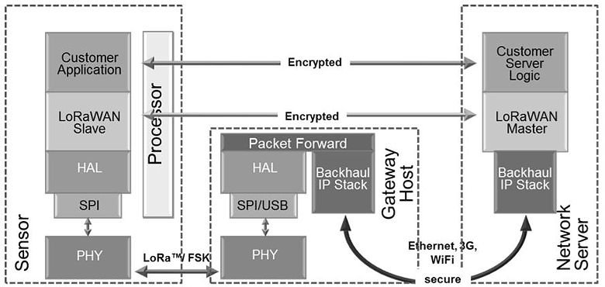

Figure 3: LoRa Network [9]

In Figure 3 [9] the structure of communication using LoRa is shown. The Sensor in Figure 3 communicates with the gateway that is connected to the internet so that the data can be sent to the Network Server.

## Sensors

Non-invasive AC Current Sensors are used to measure the real consumption without having to alter the electrical composition of the circuit. The sensors work by acting as an inductor that responds to a magnetic field around a current carrying conductor. By making use of the following equations the sensor can determine the current in the current carrying conductor [10]:

|  |  |  |
| --- | --- | --- |
|  | $$I_{secondary}= {CT}_{turnsRatio} × I_{primary}$$ | (3) |

Equation 1: Relationship between the current in the secondary and primary winding

As well as the CT turns Ratio calculation in equation (4).

|  |  |  |
| --- | --- | --- |
|  | $${CT}_{turnsRatio}= \frac{{Turns}_{primary}}{{Turns}_{secondary}}$$ | (4) |

Equation 2: CT turns Ratio calculation

In

|  |  |  |
| --- | --- | --- |
|  | $$I_{secondary}= {CT}_{turnsRatio} × I_{primary}$$ | (3) |

Equation 1 the relationship between the current in the secondary winding circuit ($I_{secondary}$) and the current in the primary winding circuit ($I_{primary}$) is given.

|  |  |  |
| --- | --- | --- |
|  | $${CT}_{turnsRatio}= \frac{{Turns}_{primary}}{{Turns}_{secondary}}$$ | (4) |

Equation 2 shows the Current transformers turn ratio (${CT}_{turnsRatio}$) in terms of the relationship between the number of turns in the primary (${Turns}_{primary}$) CT (Current Transformer) and the number of turns in the secondary (${Turns}_{secondary}$) CT.

## Controller

Arduino is an open source platform that is used for electronic projects as it is user-friendly. Arduino consists mainly of two parts: the physical programmable circuit board as well as the IDE (Integrated Development Environment) that is used to write and upload code to the board. Advantages of Arduino are the following [11]:

* Lower cost than other similar devices
* Cross-platform
* Simple, clear programming environment
* Open source and extensible software
* Open source and extensible hardware

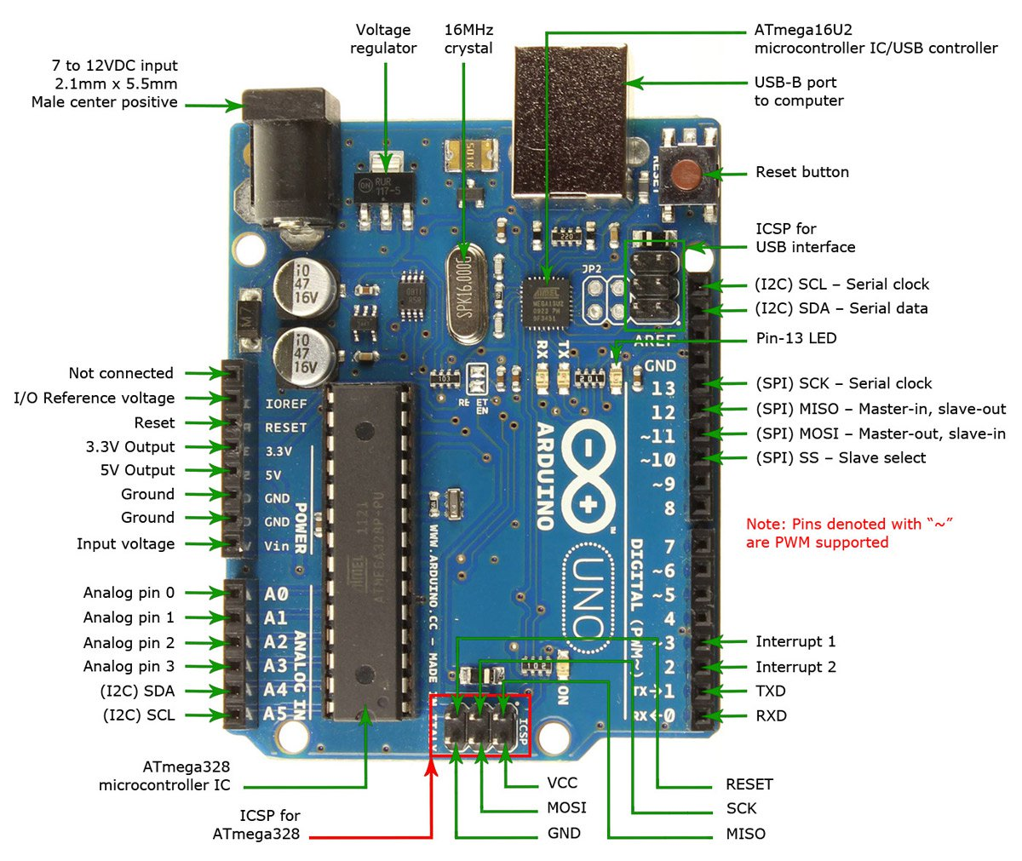

Figure 4: Arduino UNO ® pin layout [11]

In Figure 4 [11] an Arduino UNO ® is shown with its pin descriptions. Arduino® uses a simplified version of C++® making it easy to program for anyone with knowledge in programming C®. Due to the popularity of the Arduino®, they are easy to integrate and use with other components as there already exist libraries for a large number of components. There is an abundance of support online as well for the Arduino® to troubleshoot and find help if needed. There is a wide range of different Arduino® boards and expansion modules making it easy to find the appropriate combination of components for your application. Arduino® is readily available in South Africa at a reasonable cost and is, therefore, an ideal development board use for a project.

## Databases

The two main database servers that can be considered for this project are MariaDB® and MYSQL®. Both these database servers are open source and free to use. They also both use SQL (Structured Query Language) which is an easy to use and well-documented programming language with substantial support available online. These database servers both use a broad subset of ANSI SQL 99 [12]. These reasons made these two database servers the obvious choices for the project. The server of both is ‘mysqld’ and the command-line client is ‘mysql’ with the configuration file being ‘my.cnf’. This means that both MySQL and MariaDB are compatible [13]. The disadvantage of MariaDB is that MariaDB releases tend to lag behind MYSQL releases because the MariaDB developers need to merge the newly released MYSQL code into the MariaDB source trees. Advantages of the MariaDB software is that it has some added features, bug fixes, additional storage engines and performance improvements over MYSQL.

## Airspeed measurement

Anemometers are used to measure the speed or velocity of wind and other gasses. There are a wide variety of different types which are listed below [14]:

* Vane Anemometers
* Thermal Anemometers
* Thermal Anemometers with velocity / Temperature Profiling
* Cup Anemometers

The two main classifications of anemometers are constant-temperature anemometers and constant-power anemometers. Advantages of constant-temperature anemometers are their high-frequency response, immunity from sensor burnout if airflow drops rapidly, electronic noise levels are low and they can be applied to both liquid or gas flows.

It is difficult to implement anemometers in integrated circuits because of their relatively large size in comparison with other sensors such as temperature sensors. They are also quite expensive in comparison with other sensors. An anemometer that can measure CFM (Cubic Feet per Minute) can have dimensions: 181 x 70 x 35 mm (71⁄8 x 2¾ x 13⁄8") (handheld); 73 mm (27⁄8") diameter fan [15]. The anemometer costs R 3200.00. This makes such an anemometer impractical for use in this project.

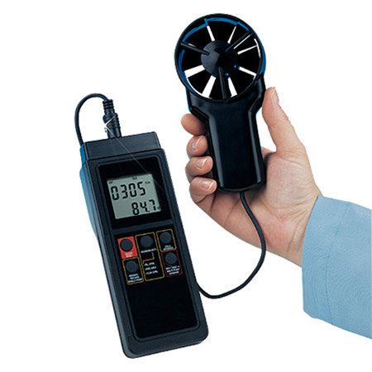

Figure 5: An HHF91 Anemometer that can measure CFM

In Figure 5 [14] he HHF91 anemometer is shown that can measure CFM, the dimensions and cost as described above.

## Expert consultation



### Air-conditioning unit experts

A consultation with air-conditioning unit experts at Sam’s Aircons on the most common aspects that affect the efficiency of split type air-conditioning units, made it clear that checking a split type air-conditioning unit involves the following aspects: the filter, gas, fan and temperature. Firstly, the filter is checked to ensure there is no blockage and that it is clear. The next test is to check if there is gas in the tank of the split type air-conditioning unit. Once that is checked, the operation of the fan of the air-conditioning unit is checked. Finally, the temperatures of the inlet and outlet gas lines are checked.

### Electronics Experts

In order to form a better understanding of the electronic components required in order to complete the project, a consultation was conducted with Marius Viljoen (Master’s in Electronics). In the consultation the following aspects of the project were discussed, namely PIC microcontroller, and ATmega328P, proper PCB layout, PCB schematics and homemade PCB. The consultation resulted in a better understanding of ADC and UART of ATmega as well as how to make a homemade PCB for the module.

### Electrical experts

In order to form a proper understanding of the legal aspects of the installation procedure of the split type air-conditioning unit a consultation with an electrician Leon van Aswegen took place. From the consultation the appropriate SANS standards and national guidelines for split type air-conditioning units were documented and implemented.



## Conclusion

In this report a definition of the project was given showing what is included in the project and what is excluded. From the research it is clear that there is no commercially available solution that offers a COP calculation to determine at which point a split type air-conditioning unit needs to be repaired or has reached the end of its life cycle. At the moment the most common solution for repairing and replacing split type air-conditioning units is by replacing them after 10 years or once they have gone through multiple repairs. The project overview section gave some detail on what methods will be used and how they will be used to complete the project.

The main focus of this report was the literature survey. The literature survey was done on the COP, LoRa, Non-invasive AC Current Sensors, Air Conditioner, Arduino, databases and the anemometer. These are all core components of the project. This project was researched in detail to ensure an in-depth level of comprehension of all these aspects and components and their working.

# Chapter 3 –Design



## 3.1 Introduction

The literature study that was done helped identify possible technologies that could be used to complete this project. For the conceptual design trade-off studies were used to determine which technologies will be used above others. How these technologies will be implemented and used are not given in the conceptual design section.

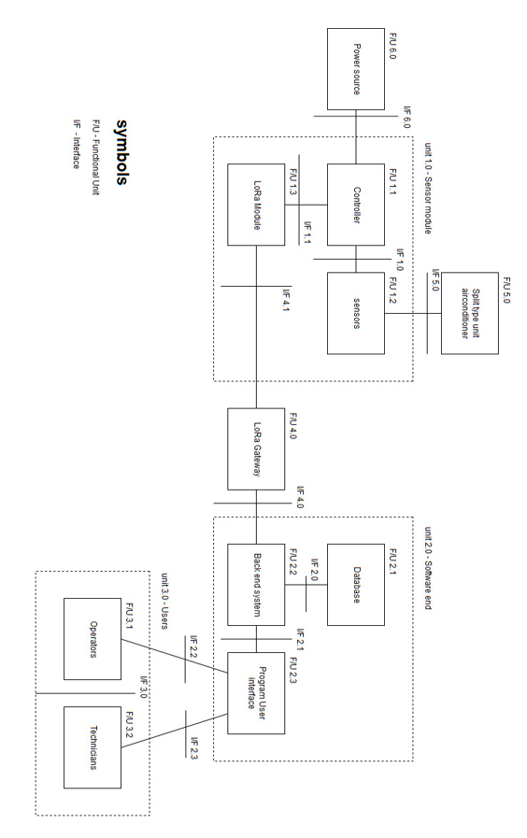

Figure 6: system architecture

In the above Figure 6 the system architecture is given of the Distributed IOT environmental monitoring system. Unit 1 of the system architecture shows the sensor module functional units, this includes the controller F/U 1.1, the sensor F/U 1.2 and the LoRa Module F/U 1.3. the sensor is connected to the split type air-conditioning unit with technical I/F 5.0, while the controller is connected to the power source with I/F 6.0. The Lora Module is connected to the LoRa Gateway functional unit 4.0, through the I/F 4.1, the distributed IOT environmental monitoring system is not responsible for the LoRa gateway F/U 4.0.

Unit 2.0 is the software end of the project this includes the database where all the information of the sensor measurements is stored, the backend system where the program will collect the sensor data send through LoRa via the LoRa gateway. The last part of the software end of the project is the user interface program, the program will be easy to understand and use for the operator F/U 3.1. Unit 3 is the user section- this consists of the operator of the program and any technicians that may be necessary for the project.

The major obstacle the project faced was the calculation of output power from the split type air-conditioning units. There is no existing solution to easily and effectively determine the output power of the split type air-conditioning unit at any point in time.

The detailed design for the distributed IOT environmental monitoring module was documented after the conceptual design is completed. For the detailed design Schematics of the PCB as well as 3D renderings of the PCB design is shown.



## Conceptual Design

For the conceptual design, trade-off studies were used to decide what technologies will be used for the project. The trade-off study is based on the functional units shown in the system architecture in Figure 6 above. Trade-off studies help the developer to make rational and accurate decisions between different technologies. The literature study in Chapter 2 of the detailed design document has been used in order to make informed decisions within the matrix rating system. Once the trade-off study matrix has been completed, a detailed decision was made regarding the component.

### Controller selection

Three different possible controllers for the sensor console were identified. These controllers are compared below in Table 1. From the first considerations in the trade off study it was determined that the PIC microcontroller was the most suitable controller for the project, using an Arduino Uno ® to develop the project before the PIC is implemented. However, it was later proposed to use the STM of the LoRa module in order to save space and cost by not adding an extra controller simply using the LoRa module controller. Investigating this option however proved that the STM unit of the LoRa module could not be programmed on without flashing the LoRa modules firmware thereby reducing it to an empty STM. This meant that the LoRa module lost all functionality. The final microcontroller decided on was an ATmega328P chip which is low cost, Reliable, readily available and has moderate development difficulty.

Table 1: Controller trade-off study

|  |  |  |  |  |  |  |  |  |  |  |
| --- | --- | --- | --- | --- | --- | --- | --- | --- | --- | --- |
| Controller | | Arduino Uno | | | Raspberry Pi | | | PIC Microcontroller | | |
| Criterion | **Weight (W)** | | **Rating (R)** | **W x R** | | **Rating (R)** | **W x R** | | **Rating (R)** | **W x R** | |
| Cost | 0.3 | | 7 | 2.1 | | 4 | 1.2 | | 10 | 3 | |
| Reliability | 0.3 | | 8 | 2.4 | | 6 | 1.8 | | 9 | 2.7 | |
| Available help material | 0.2 | | 9 | 1.8 | | 7 | 1.4 | | 9 | 1.8 | |
| Development Difficulty | 0.2 | | 10 | 2 | | 8 | 1.6 | | 5 | 1 | |
| Total Rating |  | |  | 8.3 | |  | 6 | |  | 8.5 | |

### Communication Selection

For the communication medium the two possible options that were considered is shown and compared below in Table 2. LoRa is chosen because of its main advantage over Sigfox being that LoRa does not require a subscription.

Table 2: Communication trade-off study

|  |  |  |  |  |  |
| --- | --- | --- | --- | --- | --- |
| Controller | | LoRa | | Sigfox | |
| Criterion | **Weight (W)** | **Rating (R)** | **W x R** | **Rating (R)** | **W x R** |
| Cost | 0.3 | 10 | 3 | 6 | 1.8 |
| Implementation Difficulty | 0.3 | 9 | 2.7 | 7 | 2.1 |
| Availability of help documentation | 0.2 | 8 | 1.6 | 7 | 1.4 |
| Power consumption | 0.2 | 9 | 1.8 | 8 | 1.6 |
| Total Rating |  |  | 9.1 |  | 6.9 |

### Database selection

The different databases that were considered for this project are compared and shown below in Table 3. The main advantage of the MYSQL is the easy to use software for the development of the database.

Table 3: Database trade-off study

|  |  |  |  |  |  |
| --- | --- | --- | --- | --- | --- |
| Controller | | MYSQL | | MariaDB | |
| Criterion | **Weight (W)** | **Rating (R)** | **W x R** | **Rating (R)** | **W x R** |
| Cost | 0.3 | 10 | 3 | 10 | 3 |
| Knowledge of language | 0.3 | 9 | 2.7 | 9 | 2.7 |
| Availability of help documentation | 0.2 | 9 | 1.8 | 7 | 1.4 |
| Implementation Difficulty | 0.2 | 9 | 1.8 | 8 | 1.6 |
| Total Rating |  |  | 9.3 |  | 8.7 |

### Back-end programming language selection

Different programming languages that could be used for the back-end program is compared below in Table 4.

Table 4: Back-end programming language selection matrix

|  |  |  |  |  |  |  |  |
| --- | --- | --- | --- | --- | --- | --- | --- |
| Programming language | | C++ | | C | | Python | |
| Criterion | **Weight (W)** | **Rating (R)** | **W x R** | **Rating (R)** | **W x R** | **Rating (R)** | **W x R** |
| Functionality | 0.3 | 9 | 2.7 | 7 | 2.1 | 5 | 1.5 |
| Development Difficulty | 0.3 | 9 | 2.7 | 7 | 2.1 | 10 | 3 |
| Available help material | 0.2 | 9 | 1.8 | 10 | 2 | 7 | 1.4 |
| Knowledge of language | 0.2 | 9 | 1.8 | 8 | 1.6 | 6 | 1.2 |
| Total Rating |  |  | 9 |  | 7.8 |  | 7.1 |

## Conceptual design summary

The following are the results of the trade-off studies showing the technologies chosen:

* Controller: PIC Microcontroller
* Communication: LoRa
* Database: MYSQL
* Back-end: C++

The final technology chosen after prototypes where made and design changes where made are:

* Controller: ATmega328P
* Communication: LoRa module
* Database: CSV
* Back-end: C and Python

## Conceptual design Conclusion

The literature study that was done helped identify possible solutions for the aspects of this project. These possible solutions were then further evaluated and compared in the conceptual design. Trade-off studies were used to compare the different possibilities and gave a clear indication of the best options. With the correct technologies now identified the process to create the detail design could start.

The choices that were made in the trade-off study will be implemented together. The PIC Microcontroller will gather the data from the sensors and then use the LoRa communication to send it to the back end. The back-end program will be written in C++ and will communicate with the MYSQL database.

After detailed designs were implemented some changes were made to the selected technology. These changes can be seen below in the detailed design section.



## Detailed design

In the conceptual design of the report, various solutions were listed for the components’ design problems. With the help of the literature study and trade off study matrixes, the components discussed below were chosen for the detailed design. The functional demonstration of the prototype will not feature all the below mentioned components as the demonstration is to provide a presentation of the functionality of the sensor module.

## Power supply detailed design

The split type air-conditioning unit has a voltage of 240 V AC where the current sensor will operate. However, the PIC microcontroller will require a simple step-down AC-DC power supply to operate at the required 3.3 V. LoRa Modules use 3.3 V as well and, therefore, will be powered by the PIC microcontroller. The database will be based on a server; therefore, the server will have the normal 240 V power supply. The temperature sensors are rated at 3 V to 5.5 V DC, therefore, the temperature sensor will work on the same voltage as the PIC microcontroller voltage of 3.3 V.

## Current sensor detailed design

For the distributed IOT environmental monitoring system project Non-invasive AC Current Sensors will be implemented. The current that must be measured in the project is the preinstalled split type air-conditioning units’ current. Therefore, the current sensor must be non-invasive as any other type of current sensor would create problems. Furthermore, as it is the split type air-conditioning unit’s current usage that is measured the current being measured will not be DC but AC. The split-type air-conditioning unit generally has an ampere rating between 7.5 A and 20 A according to [16]. From these aspects we can, therefore, specify that the current sensors must be:

* Non-invasive sensors
* AC sensors
* Able to measure up to 25 A

The non-invasive AC current sensors are generally produced as 30 Amp or 100 Amp sensors. For the distributed IOT environmental monitoring systems the 30 Amp non-invasive AC current sensor will be used from Micro robotics, as shown in Figure 7 below.

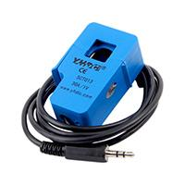

Figure 7: 100 Amp Non-invasive current sensor

Non-invasive AC current sensors are used to measure alternating current by simply clipping the sensor straight onto the neutral or live wire. The following Table 5 below shows the non-invasive AC current sensor that will be used as in [17].

Table 5: Current sensor information

|  |  |
| --- | --- |
| Current transformer SCT013-030 | |
| Provider | Digi-Key |
| Digi-Key Part number | 1597-1631-ND |
| Price | R 121,32 |

Specification:

* Turn ratio 1800:1
* Input Current 30 A AC rating
* Non-linearity Split-core
* Chassis mount type
* Rated output 0-1 V
* Operating temperature: -25 °C +70 °C
* Storage temperature: -40 °C +85 °C
* Open size 13mm x 13mm

**SCT013 current sensor**

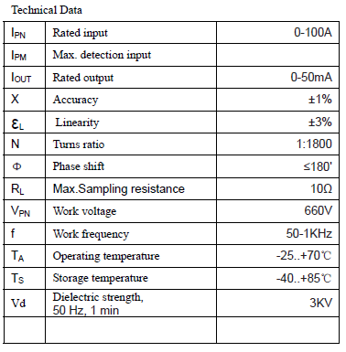

Figure 8: current sensor SCT013 specifications [18]

In the following Figure 9 below shows the currents sensor clamp schematic. In order to fit into the air-conditioning unit electric power panel, the current sensor clamp must be within size boundaries. Figure 9 shows clearly that the selected sensor will fit into the parameters.

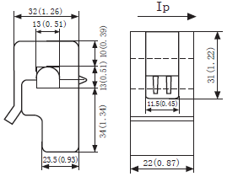

Figure 9 current sensor schematic [18]

The current sensor implemented in the design.

**Current sensor readings**

The current sensor has a voltage output that is used to read the current measured. The sensor has the following characteristics as taken from its datasheet.

Table 6: Current sensor characteristics

|  |  |  |
| --- | --- | --- |
| $$I_{PN}$$ | Rated input | 0-30 A |
| $$I_{OUT}$$ | Rated output | 0 – 1 V |
| X | Accuracy | ±1% |
| $$ε_{L}$$ | Linearity | ≤0.2% |
| N | Turns ratio | 1:1800 |
| $$V_{PN}$$ | Work voltage | 660 V |
| f | Work frequency | 50 – 1 KHz |
| $$T_{A}$$ | Operating temperature | -25 – +70 °C |
| $$T_{S}$$ | Storage temperature | -40 – +85 °C |
| Vd | Dielectric strength, 50 Hz, 1 min | 3 KV |

From the above table it can be seen that the rated input of the sensor is acceptable for this project, as air conditioning units usually use between 15 – 20 A and this sensor is rated to 30 A. The output voltage that was used to calculate the amount of current thru the sensor is low enough that it can be fed directly into the microcontroller. Furthermore, the operational temperature of the sensor is well within the ranges of an air conditioning unit and thus acceptable. The voltage reading which sampled multiple times over a short time span in order to get the average of the reading which will be a more accurate true indication of the current. The average Volt reading taken is multiplied with 30 $\frac{A}{V}$ to get the current that is flowing thru the sensor for that specific time interval.

## Temperature sensor Detailed design

In the first design the temperature sensors would have been placed at the inside and outside of the split type air-conditioning unit. However, after consulting with experts and considering the logistical difficulty of installing sensors inside an office as well as added changes to the design depending on how far the inside and outside part of the air-conditioning unit is from each other. It was determined that the most effective placing for the temperature sensor would be on the inlet and outlet gas pipes connected to the compressor on the outside of the building. Thereby working around the above-mentioned difficulties. The temperature sensor that was used for the project is the thermistor sensor as shown in the figures below the DS18B20 temperature sensor will be used.

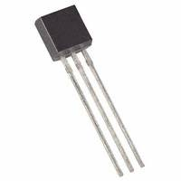

Figure 10: Photo of a DS18B20-ND temperature sensor

The figure above shows the temperature sensor; however, the project uses the waterproof temperature sensor as shown below. This is due to the modified design that allows for a more accurate reading with the metal probe that costs approximately R 50.

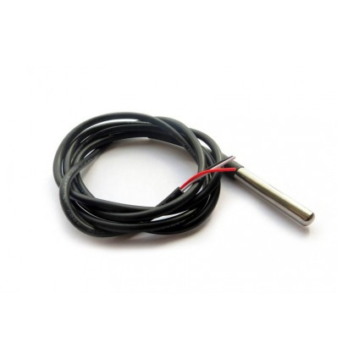

Figure 11: Waterproof DS18B20 – ND

The temperature sensor must be able to measure the general room temperature that can be assumed between -15 °C and 55 °C being the range extremes. The sensor should be able to operate in damp conditions as well as moisture dripping. Therefore, the waterproof temperature sensor will be the most applicable temperature sensor for the project.

The Waterproof DS18B20 temperature sensor has the following specifications:

* Temperature range of -55 °C to +125 °C
* Designed for temperatures between -10 °C to +85 °C with an error range of (+- 0.5 °C)
* 1-Wire Interface Requires Only One Port Pin for Communication
* Programmable Resolution from 9 Bits to 12 Bits
* Waterproof package with cable
* DC Supply voltage of 3 – 5.5 V
* Probe Diameter 7 mm
* Probe length 26 mm

The temperature sensor voltage rating is 3 to 5.5 V, therefore, the sensor will be able to operate with the PIC microcontroller at 3.3 V. From these specifications it is clear that the waterproof DS18B20 digital temperature sensor is the best choice for the project. The DS18B20 Block Diagram is shown in Figure 12 below.

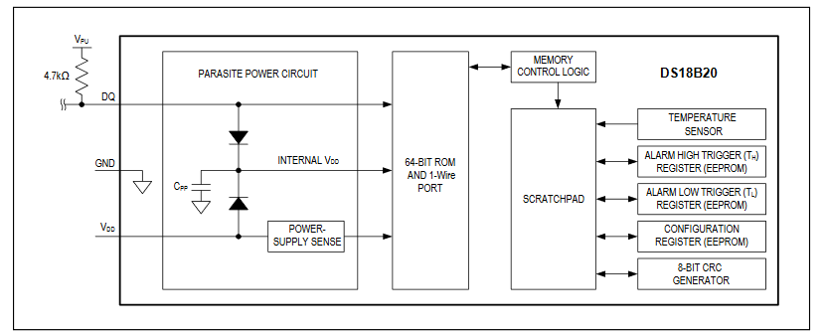

Figure 12: DS18B20 Block Diagram

## LoRa module Detailed Design V1.0

There are 3 different regions where LoRa is used, namely America, Europe and Asia. Each area has its own frequency range reserved, within which LoRa can be used. Africa, however, does not have a reserved frequency range; therefore, it is only required that the LoRa gateway and LoRaWAN work on the same frequency range. For this project the frequency range that will be used is the European frequency range as agreed upon by the applicable parties. The European LoRa module operates at a frequency of 868 MHz and a voltage 3.3 V. The LoRa module that would have been used in the project is the Microchip RN2483 Long Range LoRa. Table 7 shows the LoRa provider information.

Table 7: LoRa provider

|  |  |
| --- | --- |
| Microchip RN2483 Long Range LoRa | |
| Provider | Micro Robotics |
| Product code | RN2483-I-RM101 |

“The RN2483 Integrates a Baseband Controller and an Application Programming Interface (API) processor, simplifying the integration of LoRa™ technology into products.” As stated in [17]. The LoRa microchip has the following specifications

General specifications

* Class A on-board LoraWAN protocol stack
* ASCII command interface
* Device Firmware Upgrade (DFU)
* 14 GPIO for control, status, and ADC
* Highly integrated module
* European R&TTE Directive Assessed Radio Module

RF Features

* 868 MHz operating frequency
* Programmable RF communications
* High receiver sensitivity
* TX Power: this is adjustable up to +14 dBm high efficiency PA
* FSK
* GFSK
* IIP3 : -11 dBm
* Suburban environment: > 15 km coverage
* Urban environment: > 5 km coverage

## LoRa module Detailed Design V2.0

In order to make use of public gateways the LoRa module RN2483-I-RM101 could not be used as it is not certified and all modules making use of public gateways must be certified in order to safeguard public devices in use on the gateway. Due to this requirement the LoRa module selected is the LoRa module iM880B of which the certification can be seen in the Appendix E: LoRaWAN™ Certification.

The iM880B module operates on the European frequency range as required for the distributed IOT environmental monitoring project.

Near Schaephuysen, Neukirchen-Vluyn and Kamp-Lintfort, the cities, the iM880B range test was performed at a distance of 7.72 km as documented in the Application notes AN011 [19]. In Figure 13 below the distance and elevation profile between A and B can be seen on Google earth where the test was conducted.

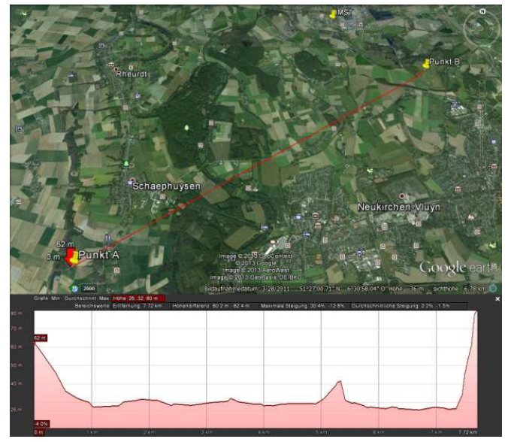

Figure 13: Distance and elevation profile between point A and B from Google Earth from [19]

The range test conducted in [19] was done under the test setting tabulated in Table 8 below.

Table 8: Test settings LoRa range test iM880B [19]

|  |  |
| --- | --- |
| Test Settings |  |
| LoRa Signal Bandwidth | 125 kHz |
| Devices | iM880A_B101_Nr.1 @Point A; iM880A_B101_Nr.2 @Point B |
| Distance | 7,720 m |
| Frequency Band | 869.525 MHz |
| Payload | 22 Byte |

The results of the range test conducted in [19] are shown in Figure 14 and Figure 15 below.

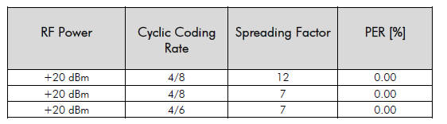

Figure 14: Results PER of the Range Test 7720 m with +20 dBm [19]

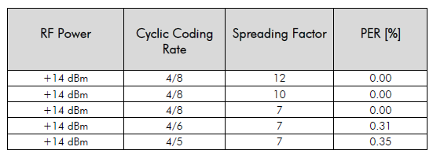

Figure 15: Results PER of the Range Test 7720 m with +14 dBm [19]

The project does not require the operation of the LoRa module at a distance above 7,720 m, therefore, from the results it is clear that the LoRa iM880B will be sufficient for the design purposes of the project.

The RF gain of the iM880B-L Radio module configured in EU868 Band can be seen in Figure 16 below as documented in the WiMod LoRaWAN endNpde modem feature Spec document [20].

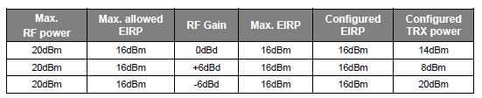

Figure 16: Example of RF Gain settings - iM880B-L & EU868 [20]

## Enclosure Detailed design V1.0

The enclosure for the sensor module design will have an IP of 31, therefore, the enclosure will have a solid protection of level 3. Level 3 has a larger than 2.5 mm protection against tools and thick wires. The second rating is the rating against liquid at level 1, therefore, the enclosure must protect against dripping water, specifically vertically falling drops. For the IP 31 rating there is protection against condensation.

## Controller detailed design V1.0: Arduino Uno ®

The Arduino Uno ® was selected as the controller for the distributed IOT environmental monitoring system as it is a moderately low-cost controller and is easy to use as well as being readily available. The Arduino Uno® also has several libraries available for coding purposes that makes it an attractive design. The circuit schematic of the Arduino Uno ® can be seen in Figure 17 below.

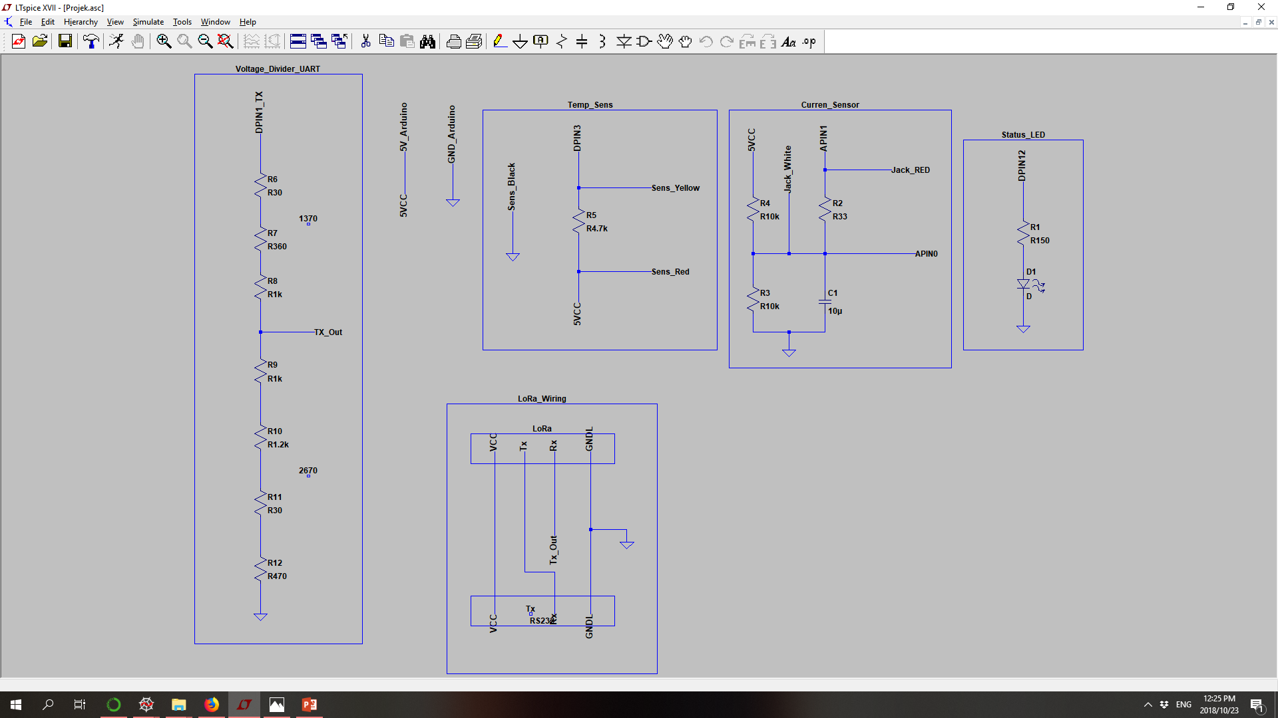

Figure 17: Controller detailed design V1.0 Arduino Uno ® circuit schematic

In Figure 17 circuit schematic the UART voltage divider circuit for the LoRa module can be seen as well as the LoRa wiring scheme, the temperature sensor circuit, the current sensor circuit and the status LED. The status LED will show when the module is in operation by blinking at a frequency of 1 Hz. When the LED is on for a longer period than 1 second it is collecting data and packaging it to send the data to the gateway.

## Controller detailed design V1.1: PIC Microcontroller

The PIC microcontroller was selected for the project as it is a low-cost and reliable solution. The PIC microcontroller must be compatible with LoRa and 16-bit. The PIC microchip chosen is the DSPIC33EP128GM304 PIC microchip which is 16Bit 128KB Flash 44TQFP. The number of I/O points is 35, RAM size is 16K x 8 and a 44-TQFP case. The PIC microcontroller operates for a power supply between 3 V to 3.6 V.

Table 9: PIC microcontroller provider information

|  |  |
| --- | --- |
| DSPIC33EP128GM304-I/PT PIC Microcontroller | |
| Provider | Digi-Key |
| Product code | DSPIC33EP128GM304-I/PT |
| Detailed description | dsPIC dsPIC™ 33EP Microcontroller IC 16-Bit 70 MIPs 128KB (43K x 24) FLASH 44-TQFP (10x10) |
| Price | R 65,35 |

The PIC microcontroller has the following specification:

* Operating Temperature is between -40°C ~ 85°C (TA)
* Speed - 70 MIPs
* FLASH type program memory
* Internal oscillator type

During the functional demonstration however, for simplicity, the Arduino Uno will be used to demonstrate the functionality of the sensor module. However, the final working model have had the PIC microcontroller implemented in the design.

The following figure below shows the very early rough concept circuit diagram for the sensor model. In the design there is a DC voltage source of 3.3 V and a common ground for all the components in the circuit. The LoRa module is connected to the voltage source with one pin, the next pin is connected to the common ground and the last pin is the data connection that is connected to the PIC microcontroller. The two temperature sensors are connected similarly: the data pin, namely the DQ pin is connected to the PIC microcontroller, the Vdd pin connection to the DC power supply and GND pin is connected to the common ground. The current sensor is clipped onto the ground wire and the data output pin is connected to the PIC microcontroller.

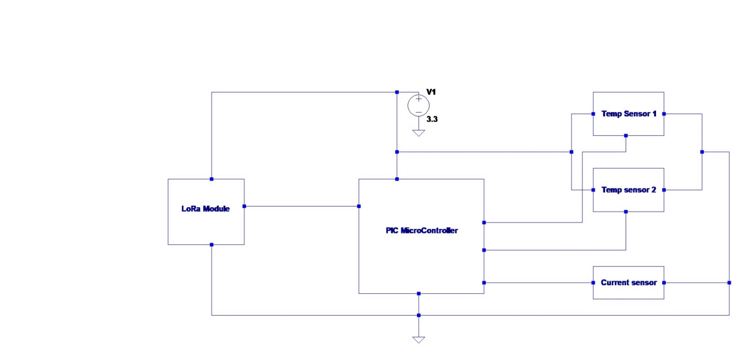

Figure 18: early circuit schematic

## Controller detailed design V1.2: ST MCU

The St MCU was selected in an attempt to consolidate the controller and the LoRa module. However, before the designs should be made of the ST MCU, it must first be attempted to put a code on the STM. The STM already has LoRa proprietary code on it and this code is required to operate the LoRa module functionality. To program the ST MCU a ST programmer is connected to the ST MCU, this can be seen in Figure 19 below.

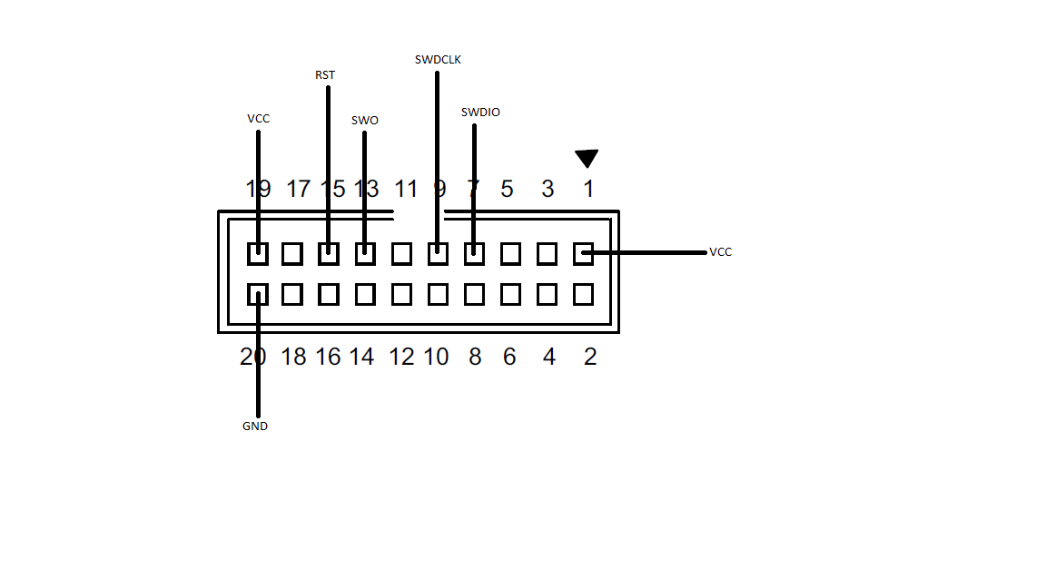

Figure 19: schematic programmer connection to ST MCU

From test and evaluation, it was determined that in order to place the code on the ST MCU the STM had to be flashed thereby removing the LoRa module operational program. The program could not be replaced on the LoRa module, therefore, new code would have been necessary to operate the code. However, this could not have been done either as the gateway requires the LoRa module to be certified and writing the code would mean that it would not be certified. Therefore, the ST MCU design was discarded and a new controller had to be designed.

## Controller V2.0: Development board design

The development board for the distributed IOT environmental monitoring module was based on the design of an Arduino Uno which is open source. The design was based on the Arduino Uno® (which can be seen in Appendix G) firstly because of its functionality and ease of use. Secondly, as the development board can be used as a programmer and, therefore, removes the necessity of an Atmel Programmer, therefore, the design is much more cost efficient. Implementing elements of the open source schematic, the development board is designed to fit with the PCB module.

Based on the design an ATmega328P was used as a controller for the project as it improved the functionality and ease of use of the module as well as being much more cost effective than the first design V1.0 of the controller. In Figure 20 below the simplified circuit schematic for the development board design with an ATmega328P can be seen.

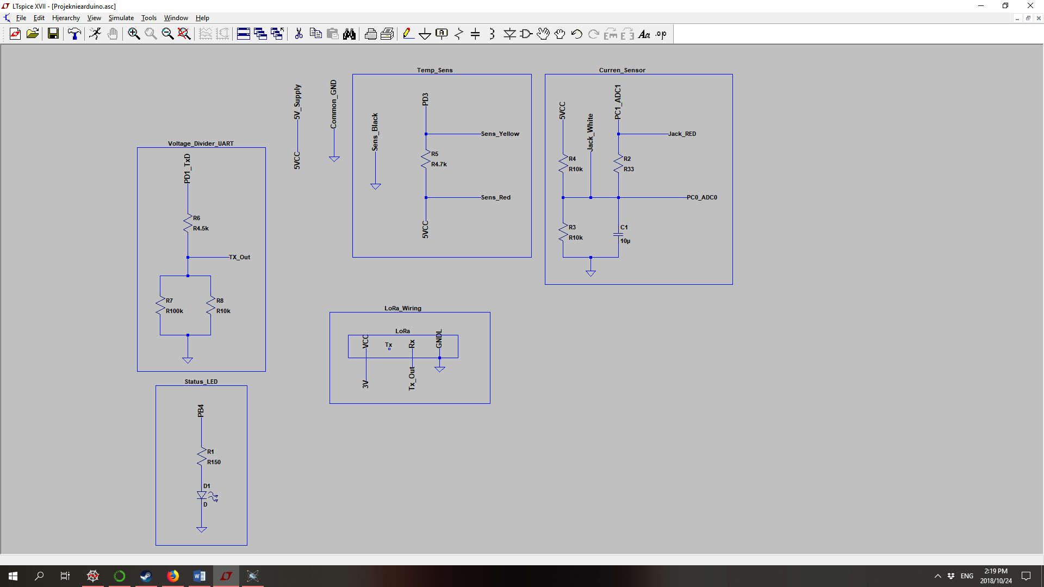

Figure 20: ATmega328P simple circuit schematic

The complete design of the circuitry for the ATmega328 can be seen in the PCB layout section of the report.



## Data storage design V1.0: MYSQL Database

For the project the database will be created using MYSQL. The MYSQL workbench will be used to design the database that will be used. The database will be hosted on the back-end system making use of the localhost with the default IP address is 127.0.0.1. The back-end system program will communicate with the database making use of SQL statements. In the figure below the database design is shown that will be used for the back-end system. The two figures below show the database structure design for the air-conditioner database.

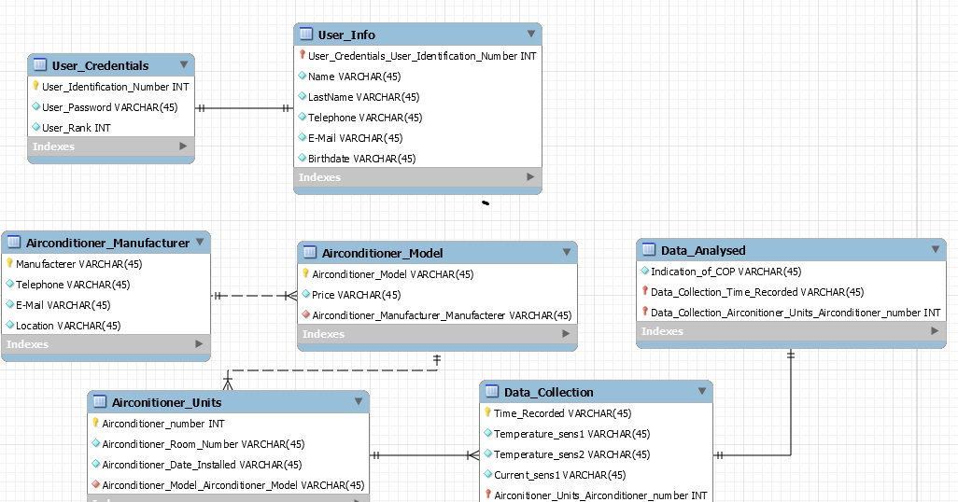

Figure 21: Database structure design part 1

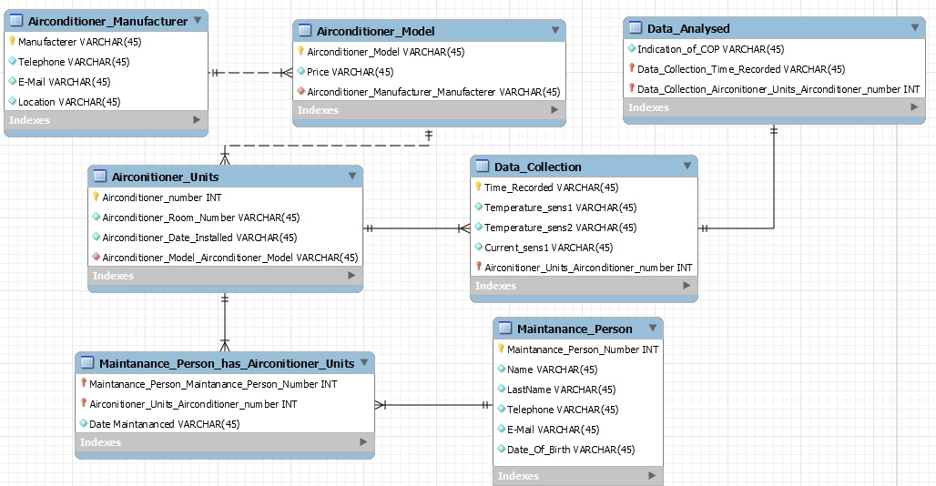

Figure 22: Database structure design part 2

The database design that would have been used for this project is shown above in the structure design part 1 the user credentials and the user info tables are shown. In the user credentials table, the usernames and passwords of the registered users are saved so that users can be verified when logging in. The user credentials table also stores the rank of the user to identify allowed access. In the structure design part 2 figure, the remainder of the database is shown. It would have stored information on the air-conditioning units’ manufacturers as well as the specific models used. Each air conditioning unit is then linked to its specific model. The Maintenance Person table that stores information on all maintenance staff that works on the air conditioning units. Each time an air conditioning unit is serviced, the relevant detail is entered into the databases and a link between the unit and the maintenance person attending to the service and its date is recorded. Data collection is done on each unit which is linked to the unit and stores all the collected data. The last table is used to store the analysed results of the collected data on the air conditioning units.

## Data storage design V2.0: CSV file

Re-evaluation of the problem statement of the distributed IOT environmental management project revealed that over specification was done in the V1.0 of the data storage design. This is in two-part form, firstly the purpose of the human machine interface is to show the user when errors occur such as a dirty filter and faulty cooling of the compressor. Not to manage the access of the users logging into the program. Therefore, the user management suggested in the database was unnecessary and not within the scope of the project. Secondly, the database proposed in data storage design V1.0 was a management of the heating, ventilation and cooling system. This was once more over specification as the project scope is to add value to the heating, ventilation and cooling system of the building and not to replace it. Considering these factors, a new data storage design was formed, the data is now stored in a CSV file which is simple to handle and meets all the requirements set in the scope of the project. Therefore, the CSV file is a more appropriate storage method. The CSV file will be in the following form:

Device EUI,Local time,Freq[MHz],Data rate,RSSI,SNR,Seq #,Port,Payload,Current,Highest Current, Lowest Current, Temperature1, Temperature2, Environmental Temperature

Each value is separated by a comma in the CSV file in order to indicate a next data value. The Device EUI, Local time, Frequency in MHz, Data rate, RSSI, SNR, Seq #, Port and Payload is data received from the distributed IOT environmental monitoring module. The current, highest current, lowest current, Temperature1, Temperature2, environmental temperatures are the data calculated in the python program using the sensor specifications.

## Programming language V1.0: C++

The programming language that would have been used for the Distributed IOT environmental monitoring system is C++. The QT programming environment would have been used to write the C++ code in. QT would have been used to generate the GUI for the program and the C++ code will connect directly to the database in order to query the information inside it as well as to add more information.

## Programming language V2.0: Python

In the V2.0 programming language Python was selected as Python is the only programming language that has a WebSocket library. The WebSocket library was required in order to connect to the WebSocket and obtain the data from the gateway. Therefore, the program that collects the data from the gateway had to be written in Python. To consolidate the data analysis program with the data collecting program the data analysis program must be written in Python as well.

## Human machine interface V1.0

For this project the human machine interface will be the program user interface, which is the simple program the operator will use to see the data results of the measurements taken with the sensor module. The user interface would have been made in the QT programming environment making use of the C++ programming language. The user interface would have been created to be easy to use and understand. The GUI that would have been created to be give the operator the power to view the results of the sensors and the analysed results will be easily accessed through the GUI.

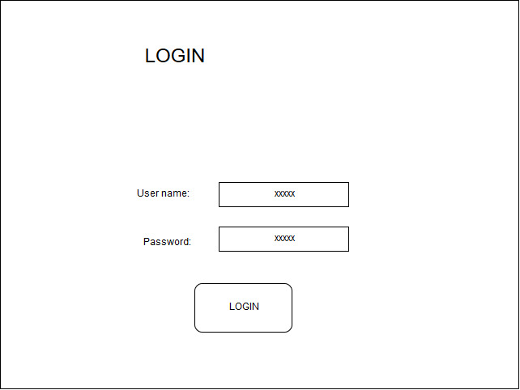

Figure 23: Login screen

In the figure above the login screen design is shown, where the operator types in their user name and password to login to the database. The figure below shows the air-conditioner status screen where the operator can view or edit the status of the air-conditioned selected from the drop-down menu.

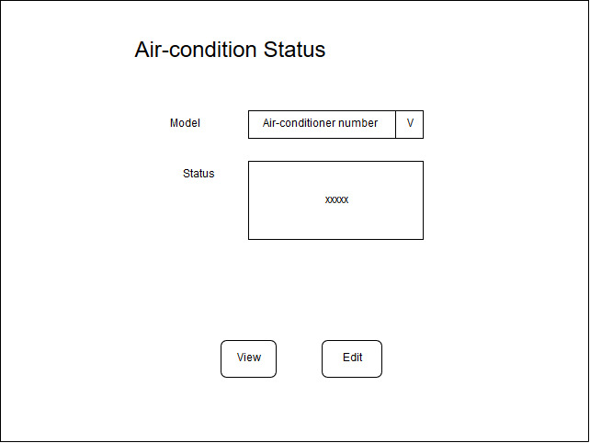

Figure 24: Air-conditioner status screen model

## Human machine interface V2.0

Analysing the project scope, it was determined that the data storage would be changed to a CSV and that creating a login facility for the program data would fall outside the scope of the project. The Human machine interface V2.0 will be a simple user interface program where the user can see the following displayed in order to assess if the air-conditioning unit requires maintenance:

* Aircon times on as a function of time
* Current measured as a function of time
* Delta temperature measured as a function of time
* The filtered measured current as a function of time
* The filtered delta temperature measured as a function of time
* The current boxplot
* The delta temperature boxplot
* The times the module identifies a dirty filter
* The times the module identifies that no cooling occurs

The GUI interface of python cannot be modified as much as other programming languages; therefore, a simple GUI will be created. The schematic for the GUI can be seen in Figure 25 below

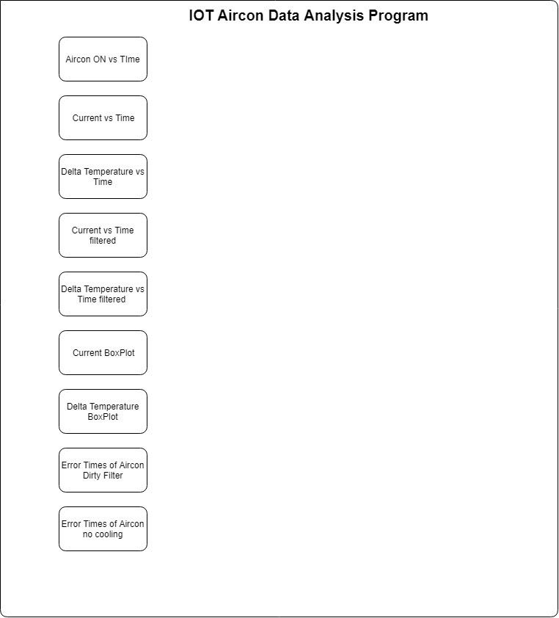

Figure 25: Python HMI GUI schematic

Each of the rectangles represents a button which when pressed will provide the user with a graph of the pressed button’s data.

## PCB design (Final module design)

The module design was done using Proteus software. In order to master the ability to use Proteus successfully independent learning was done with the help of online tutorials, help functions and trial and error. In the following Figure 26: Module schematic below, the distributed IOT environmental monitoring module schematic can be seen.

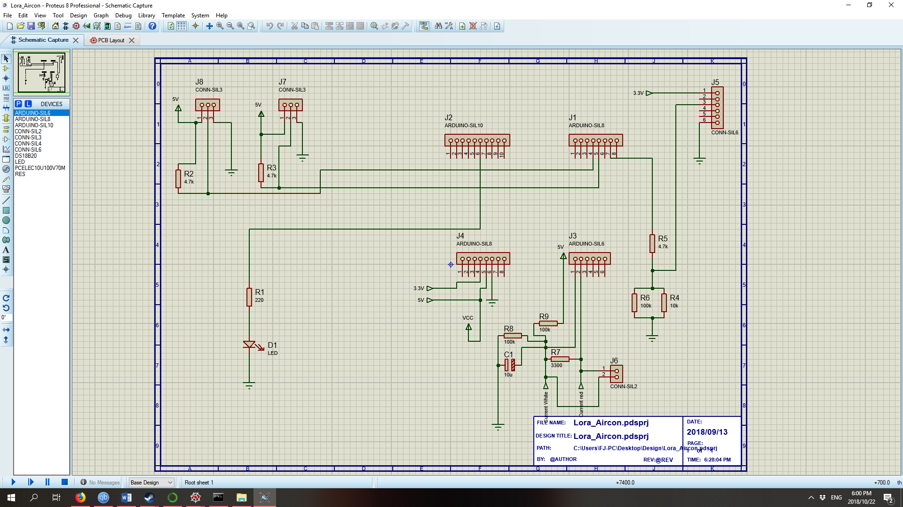

Figure 26: Module schematic

Using Proteus software, the following PCB layout schematic was created as shown in Figure 27: Module PCB layout below. The PCB houses the ATmega328P, status LED, two Temperature sensors and the voltage divider circuit for the LoRa module. Due to the simple design a single sided board is designed for the module.

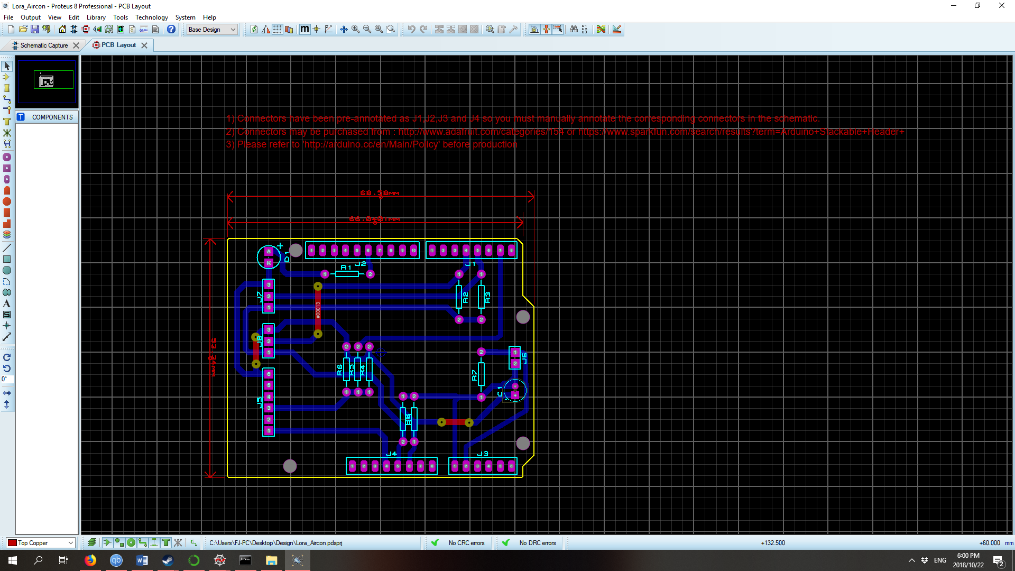

Figure 27: Module PCB layout

The PCB layout of the module is defined in Figure 28: PCB below. Each reference letter number combination e.g. C1 is described according to type value and package as can be seen in the figure below. The PCB layout was done in such a manner as to clip neatly into the development board for the module.

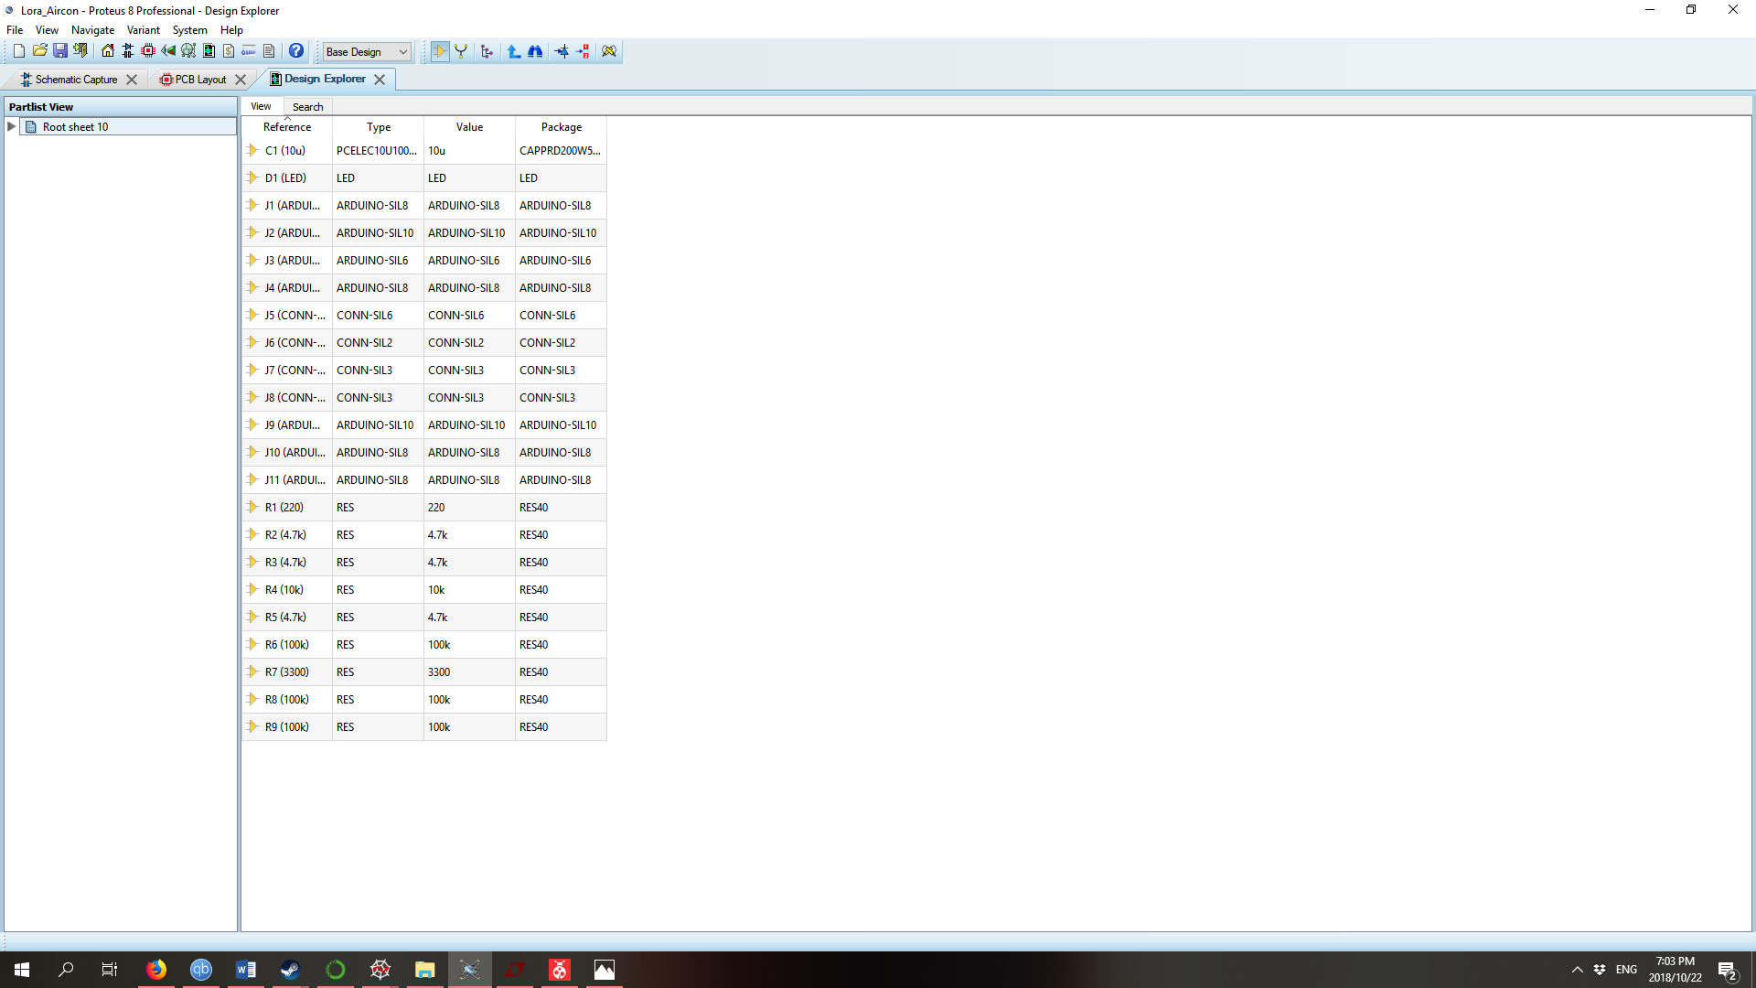

Figure 28: PCB Bill of materials (BOM)

The PCB layout of the distributed IOT environmental monitoring module was rendered in 3D using Proteus software as can be seen in Figure 29: PCB 3D render top view below. In the figure the top view of the PCB can be seen.

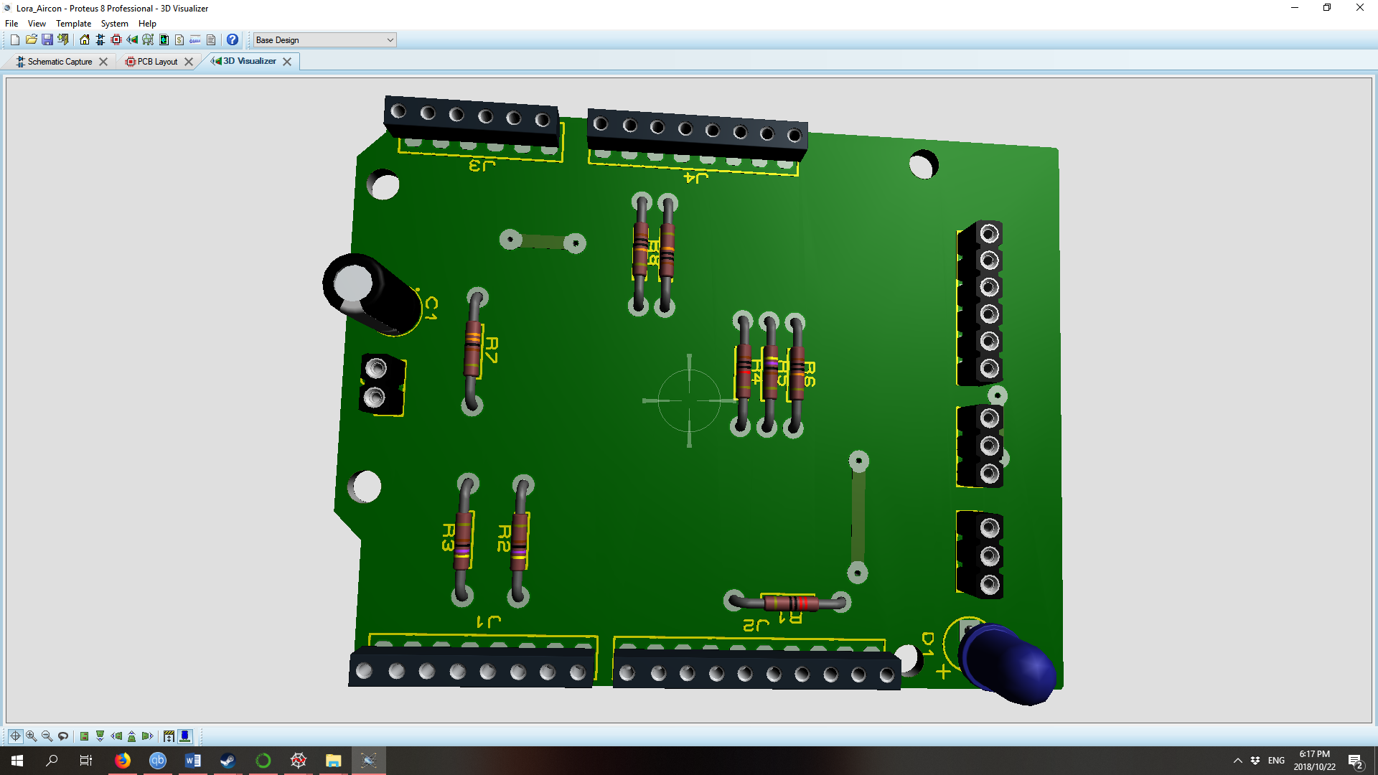

Figure 29: PCB 3D render top view

The lines of the PCB layout can be seen on the bottom view of the single sided PCB layout shown as a 3D render in Figure 30 below.

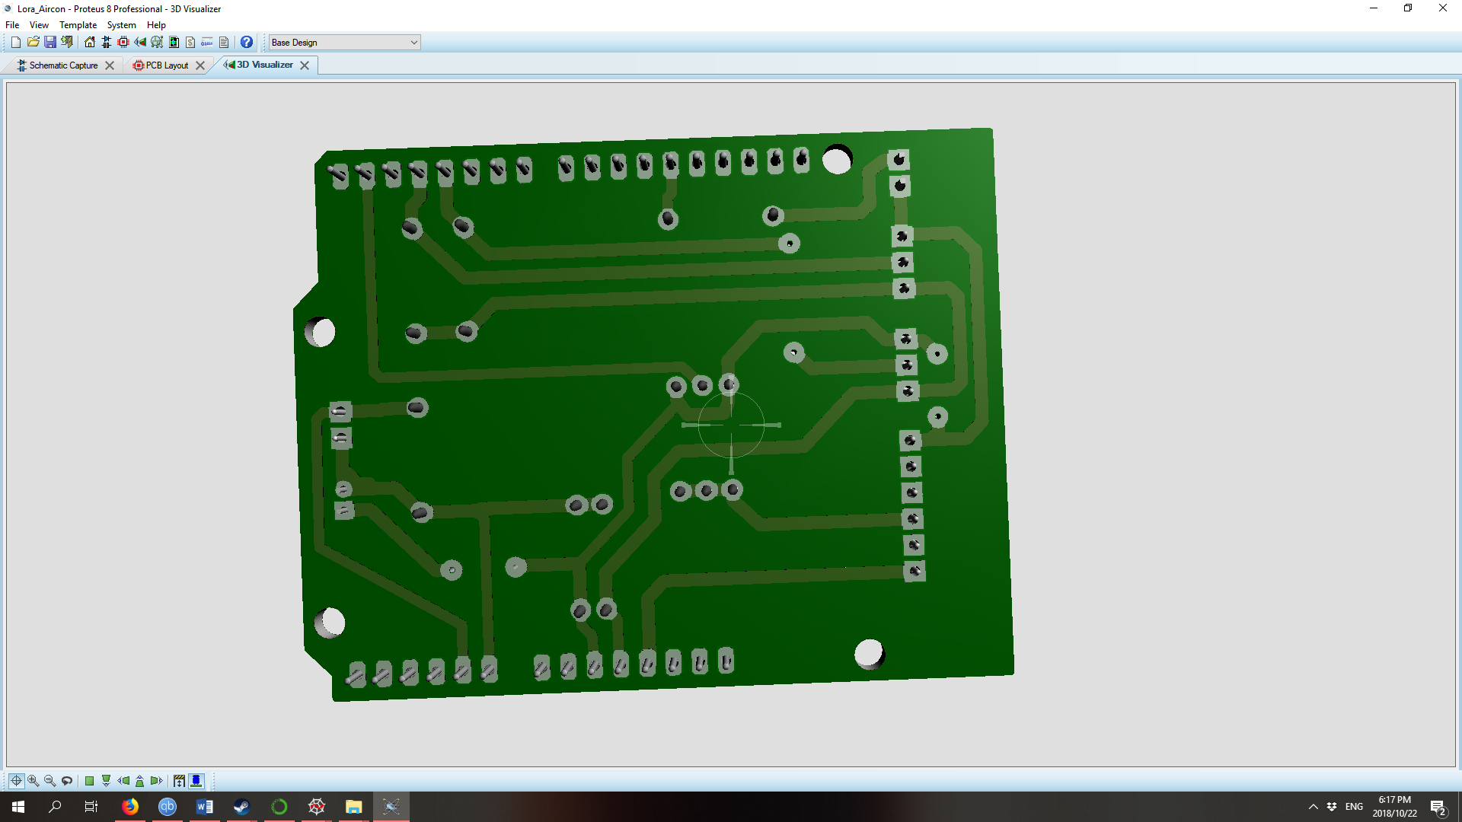

Figure 30: PCB 3D render bottom view

The isometric view of the 3D rendered model of the PCB module can be seen in Figure 31 below, as well as in Figure 32 from a different isometric perspective.

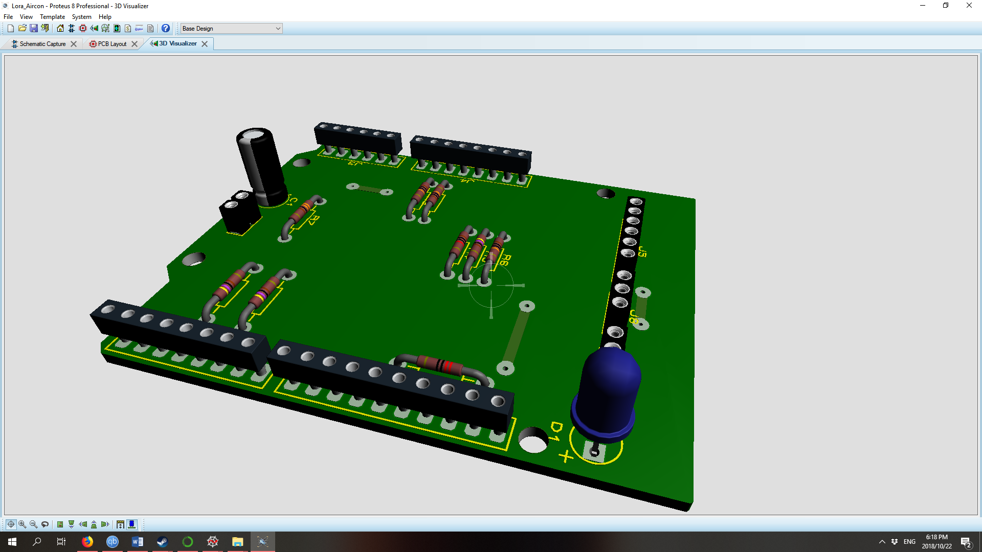

Figure 31: PCB 3D isometric render 1

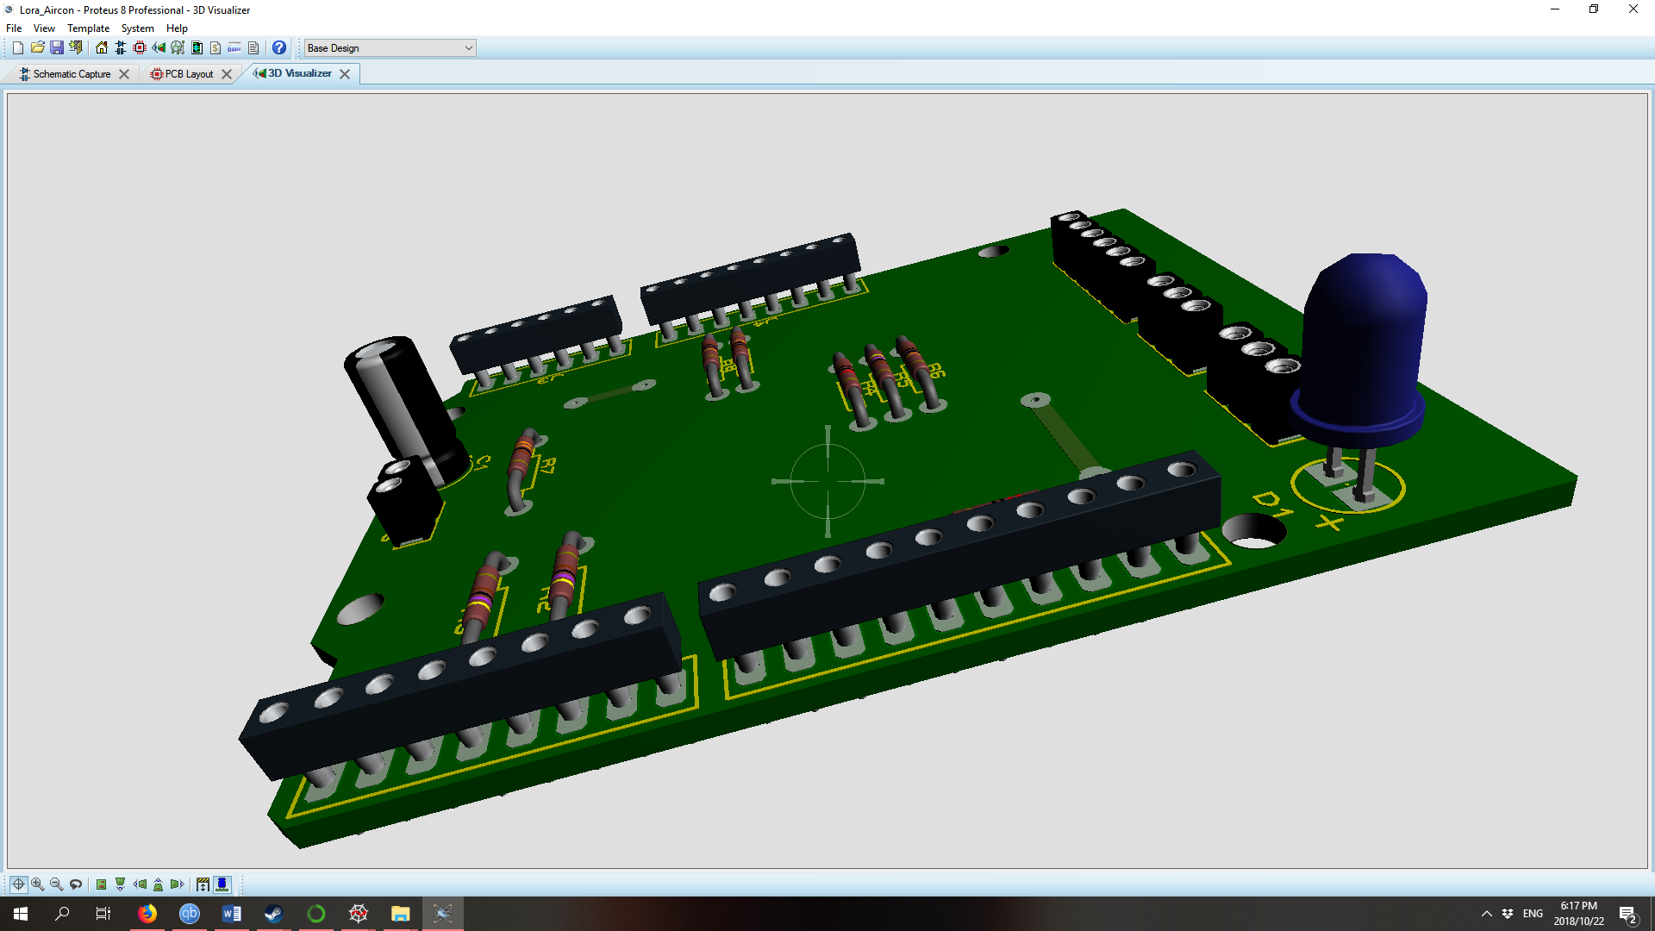

Figure 32: PCB 3D isometric render Pin layout

In Table 10: ATmega328P pin layout below the ATmega328P pin functions can be seen. This is the pin layout for the development board of the distributed IOT environmental monitoring module, as designed for the PCB.

Table 10: ATmega328P pin layout

|  |  |
| --- | --- |
| Atmega328P Pins | Function |
| PD1(TXD) | Communication with LoRA Module |
| PD3(PCINT19/OC2B/INT1) | Temperature Sensor 1 |
| PD4(PCINT20/XCK/T0) | Temperature Sensor 2 |
| PB4(MISO) | Status LED |
| VCC | 3.3 V supply voltage |
| GND | 0 V ground voltage |
| PC0(ADC0) | Current Sensor Reference |
| PC1(ADC1) | Current Sensor Voltage |

The LoRa communication module pin layout can be seen in Table 11: IM880B pin layout below. The connections for the Pin layout are as seen in the PCB layout shown above.

Table 11: IM880B pin layout

|  |  |
| --- | --- |
| IM880B Pins | Function |
| VDD(PIN17) | 3.3 V supply voltage |
| GND(PIN16) | 0 V ground voltage |
| RxD(PIN18) | Communication with ATmega328P MCU |

## Mobile Air-Conditioning Test Jig

In order to conduct testing on the distributed IOT environmental monitoring module a mobile split type air-conditioning unit test jig was designed. The design includes a functioning split type air-conditioning unit connected to an isolator in a small DB box. The design for the mobile split type air-conditioning unit Test Jig can be seen in Figure 33 below. The mobile Test Jig was designed in order to transport the test module around depending on the necessity of the test environment for example in such cases as moving the test from one laboratory to another. This mobile split type air-conditioning Jig will contribute immensely to the test and evaluation aspect of the Project.

The Mobile split type air-conditioning Test Jig consists of the following components shown in Table 12 below.

Table 12: Mobile split type air-conditioning test jig

|  |  |
| --- | --- |
| Number in Figure 33 | Component |
| 1 | Main supply power |
| 3 | Isolator Switch and 5V Transformer |
| 5 | 5V supply voltage to the IOT module |
| 6 | Current senor clamp |
| 7 | Temperature sensor 1 |
| 8 | Temperature sensor 2 |
| 9 | Distributed IOT environmental monitoring module |
| 10 | Split type air-conditioner compressor (outside unit) |
| 11 | Split type air-conditioner inside unit |

The design shown in Figure 33 below for the split type air-conditioning test jig can be used as a template for the installation procedure of the distributed IOT environmental Monitoring module in stationary split type air-conditioning units. The 220V main power supply (1) is connected to the Isolator switch and 5V transformer (3) through the air-conditioning main power supply line (2). The Isolator Switch and 5V Transformer (3) are connected to the Split-type air-conditioner compressor unit (10) through the air-conditioner main power supply line (4). The 5V transformer (3) supplies 5V voltage to the IOT module through (5) to the distributed IOT environmental monitoring module (9). The Distributed IOT environmental monitoring module (9) measures the current to the split type air-conditioning unit compressor (10) with the current sensor clamp (6) over the live wire from the main power supply (4). The temperature sensor 1 (7) of the distributed IOT environmental monitoring module (9) is connected to the Gas line 1 (Gas from the compressor to the inside unit) (12) with thermal isolation tape in order to measure the gas line temperature. The temperature sensor 2 (8) of the distributed IOT environmental monitoring module (9) is connected to the Gas line 2 (Gas from the inside unit to the compressor) (13) with thermal isolation tape in order to measure the gas line temperature.

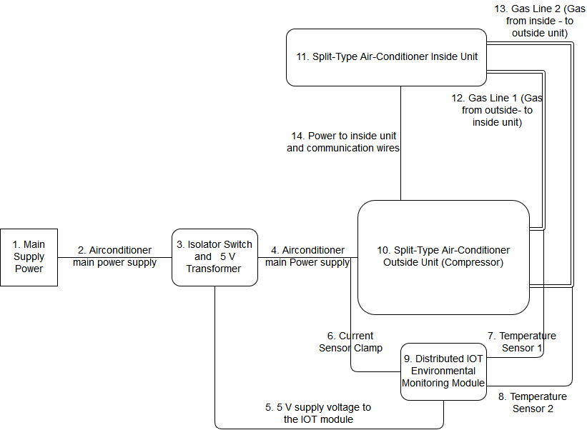

Figure 33: Mobile split type air-conditioning unit Test Jig

## Website: Loriot

The data collected by the distributed IOT environmental monitoring module is sent to the LoRa module and the LoRa module in turn sends the data to the Gateway. It is necessary to store this data sent to the gateway, and this is done by way of a website. The website selected for this purpose is the Loriot website as it was provided by the NWU. The network application from Loriot to provide the data output was the WebSocket. The WebSocket is in basic terms a protocol on top of a HTTP, initiated by a HTTP upgrade request. The WebSocket API was chosen as it is cloud-friendly, it has a bi-directional, real time interface, it is easy to implement and it already supports all major web browsers and is supported by most programming languages.

## Enclosure

The enclosure of the device including the PCB and the LoRa module must have an IP rating of IP31 in order to successfully protect the device. The enclosure must be able to contain the PCB with the diameters 90mmx60mmx90mm as well as the LoRa module making provision for the LoRa module’s antenna. In order to compensate for the wires protruding from the module, the enclosure is made to fit loosely around the module.

## COP Estimation

The original aim of the project was to find a way to estimate COP and use that to determine when the air-conditioning unit needs to be serviced or replaced. It was determined that it would not be possible to determine the precise COP due to issues such as budget constraints and equipment constraints. In order to determine COP of an air-conditioning unit, it is required to measure the air flow of the air-conditioning unit which requires an anemometer. Due to budget constraints, it would not be practical to have an anemometer part of every module. The other problem is that in order to accurately measure airflow you need a fixed area through which the air must flow, for example a duct of a large HVAC system.

In order to get around this problem, it was decided to rather calculate an estimation of COP. Since COP is simply the coefficient of performance what was needed was to find another way to estimate the performance of an air conditioner that could reliably be used to check for errors. The 2 main factors that indicate how effective and well an air-conditioning unit is working is the amount of current it is using and how much it is cooling down the gas traveling thru the compressor unit.

With the 2 factors in mind, it was investigated how they could be measured and what is needed to measure them. It was then found that one current sensor is needed to measure the current consumption and two temperature sensors are needed to measure the temperature drop in gas temperature over the compressor unit.

Using these measurements and getting an average of a specific air-conditioning units’ measurements over an extended period of time, it is possible to identify when the air-conditioning unit starts acting outside normal ranges. By investigating different common air-conditioning problems and identifying the trends of certain errors; it is possible to match the abnormal behaviour of an air conditioning unit to the established trends and determine what is wrong with the air-conditioning unit.

## Conclusion

In this chapter the detailed design of the project is provided using the functional architecture of the project shown in Chapter 3. The project requirements are given as well as the design solution. For the hardware section of the chapter the temperature sensor, current sensor, PIC microcontroller, LoRa, enclosure and circuit design have been finalised. The temperature sensors that will be used in this project are the waterproof thermistor sensor. The waterproof thermistor sensor is easy to incorporate into the circuit design. It is furthermore shielded from water damage that may occur if the air-conditioning unit creates condensation or leaks. The temperature sensors have three pins, GND, DQ and Vdd. The GND pin is connected to the common ground of the circuit as can be seen in the circuit design, the DQ pin is connected to the PIC microcontroller and the Vdd is connected to the DC power supply. The current sensor is rated to 30 A and has two connections: the one connection is a split core clip that clips over the common ground while the connection pin connects to the PIC microcontroller to send the data of the measurements taken to the PIC microcontroller. The current sensor has an output voltage of 0 V to 1 V. This is sent to the PIC microcontroller and is then converted to usable information on the current measurement.

The PIC microcontroller is used as it is a basic and reliable controller. In the circuit design the PIC microcontroller is connected to the DC power supply of 3.3 V and the common ground with the other components. For the sensors connected to the PIC microcontroller the ADC pins are used to convert the incoming measurements from analogue to digital data points. The PIC microcontroller is then connected to the LoRa module that will send the data through the LoRa gateway through the backend program to the database. The LoRa gateway is not within the scope of the distributed IOT environmental monitoring system project.

The software section contains the human machine interface, MYSQL, current sensor reading and C++ components of the design. In the human machine interface, the basic operator program layout is shown as well as the aspects that will be featured in the program. The database of the projected is created using MYSQL to communicate between the backend program and the database. In the section of the chapter the database structure design for the project is depicted. The code of the programming aspect of the project would have been done in C++ using QT programming environment. Finally, the current readings would have been done using the method described in section 4.3.2 above.

Once implementation of the design V1.0 had started some issues arose with the design. They were addressed and design changes were made to both the hardware and software design of the distributed IOT environmental monitoring system project.

The changes made to the design included changing the PIC microcontroller to a development board design using an ATmega328P, as well as the design of the end user program. Once the issues in using a PIC microcontroller became clear, a new design was created for the module. The new design consisted out of a development board with an ATmega328P due to its functionality and ease of use as well as the added benefit that the development board would be used as a programmer for the module.

The back-end programme design was changed as it was not required that the user of the program should login or any such functionality. The back-end program design changed to a design that displays the results of the analysed data in graphs and displays when malfunctioning such as dirty filter or broken fan occurs.

The final programming language decided on for the project was Python as it provided the functionality necessary for the project. Python provides a WebSocket library to connect the WebSocket and collects the data from the gateway. The data storage changed from a MYSQL database to a csv file as the database was outside of the scope of the project, and the CSV data storage provided a more appropriate data storage solution for the project.

# Chapter 4 – Implementation



## Introduction

This chapter shows the implementation process of the distributed IOT environmental monitoring project. A prototype of the product was built using a breadboard with components and an Arduino. Testing was done on the prototype in order to assess whether the prototype behaves as required. Once the operation of the prototype was satisfactory a PCB (Printed Circuit Board) was created of the prototype.

The final distributed IOT environmental monitoring product was implemented in September 2018 in order to start testing of the final product. The testing and evaluation are shown in Chapter 5, Chapter 4 only shows how the system was implemented.

## Temperature sensor

As discussed in Chapter 3 the temperature sensors implemented in the module was the DS18B20 waterproof model. One of the temperature sensors can be seen in Figure 34 below.

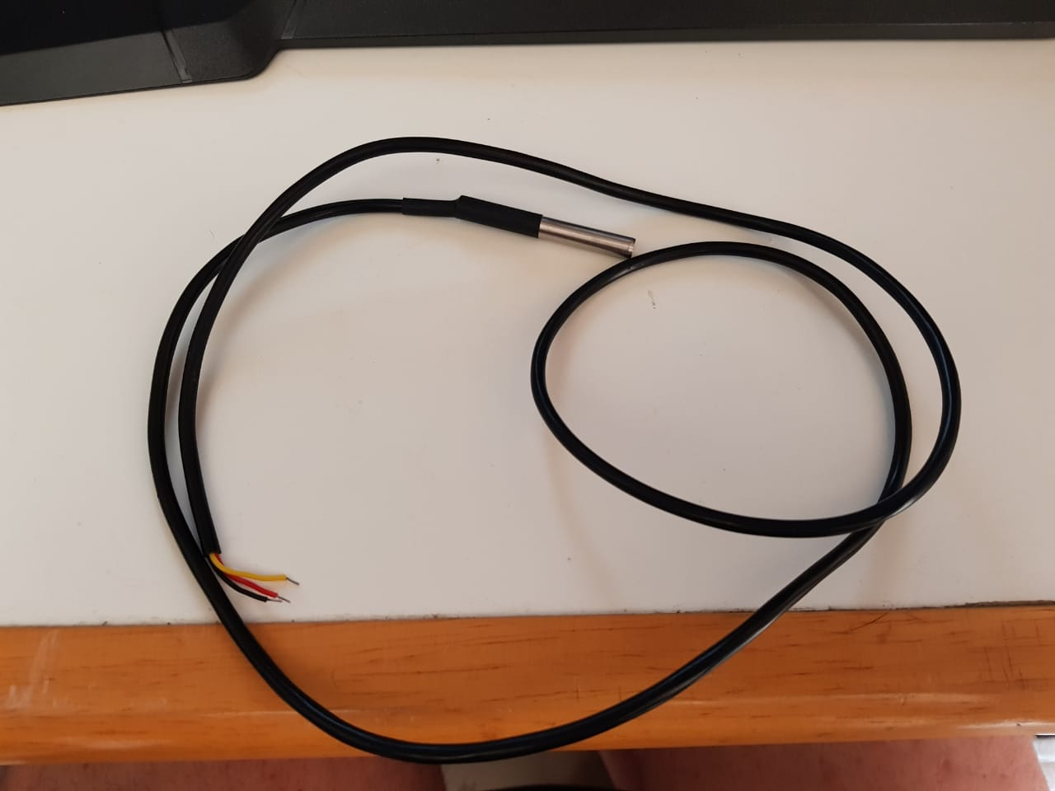

Figure 34: Photo of implemented waterproof temperature sensor

The temperature sensors were connected to the distributed IOT environmental monitoring module and the probe connected to the inlet and outlet gas lines of the split-type air-conditioning unit respectively. The gas line temperatures were then measured using these temperature sensors and the data collected through the module.

## Current sensor

As discussed in the design chapter of the report the current sensor implemented in the design of the distributed IOT environmental monitoring module was an inexpensive current sensor with a clamp in order to be non-invasive. However, due to logistics the exact model selected in the detailed design could not be located, therefore, a similar device was acquired with the same specification. The current sensor used in the project can be seen in Figure 35 below.

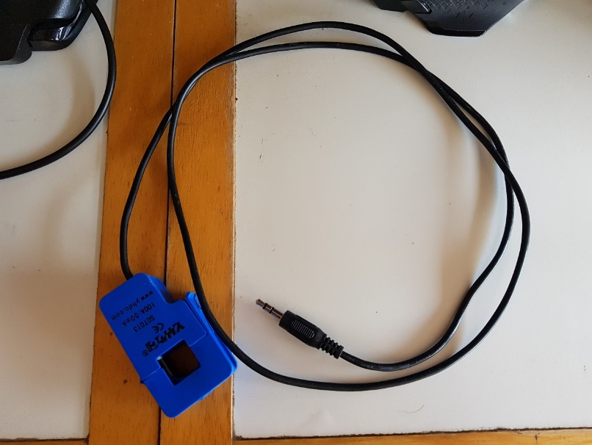

Figure 35: Photo of implemented Current sensor

The current sensor used in the project was the SCT013 from YHDC patent no ZL 2015 3 0060067.X

## LoRa Module V1.0

The LoRa module V1.0 was implemented with the controller V1.0, that is with the Arduino design. The LoRa module V1.0 can be seen in Figure 36 below.

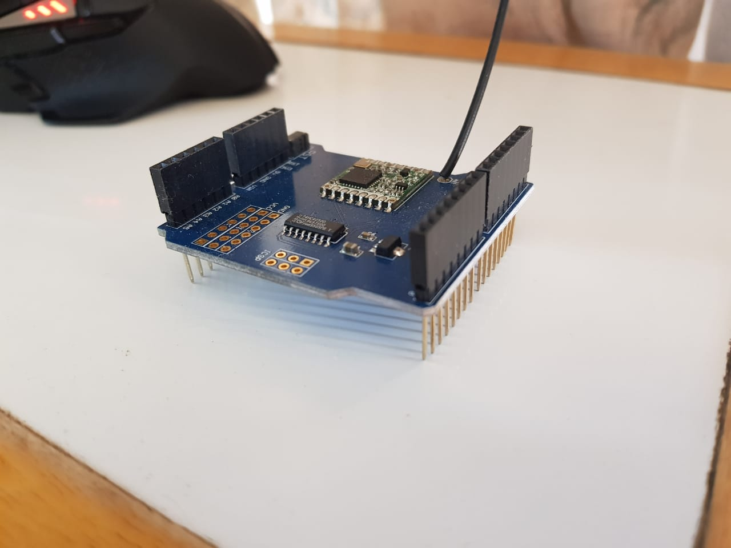

Figure 36: LoRa module V1.0 photo

The module functioned as expected, however the design no longer called for a LoRa module that communicated just locally. The LoRa module needed to communicate with the gateway. In order to connect to the gateway, the LoRa module needed to be certified. The LoRa module V1.0 was not certified and, therefore, a LoRa module V2.0 had to be acquired.

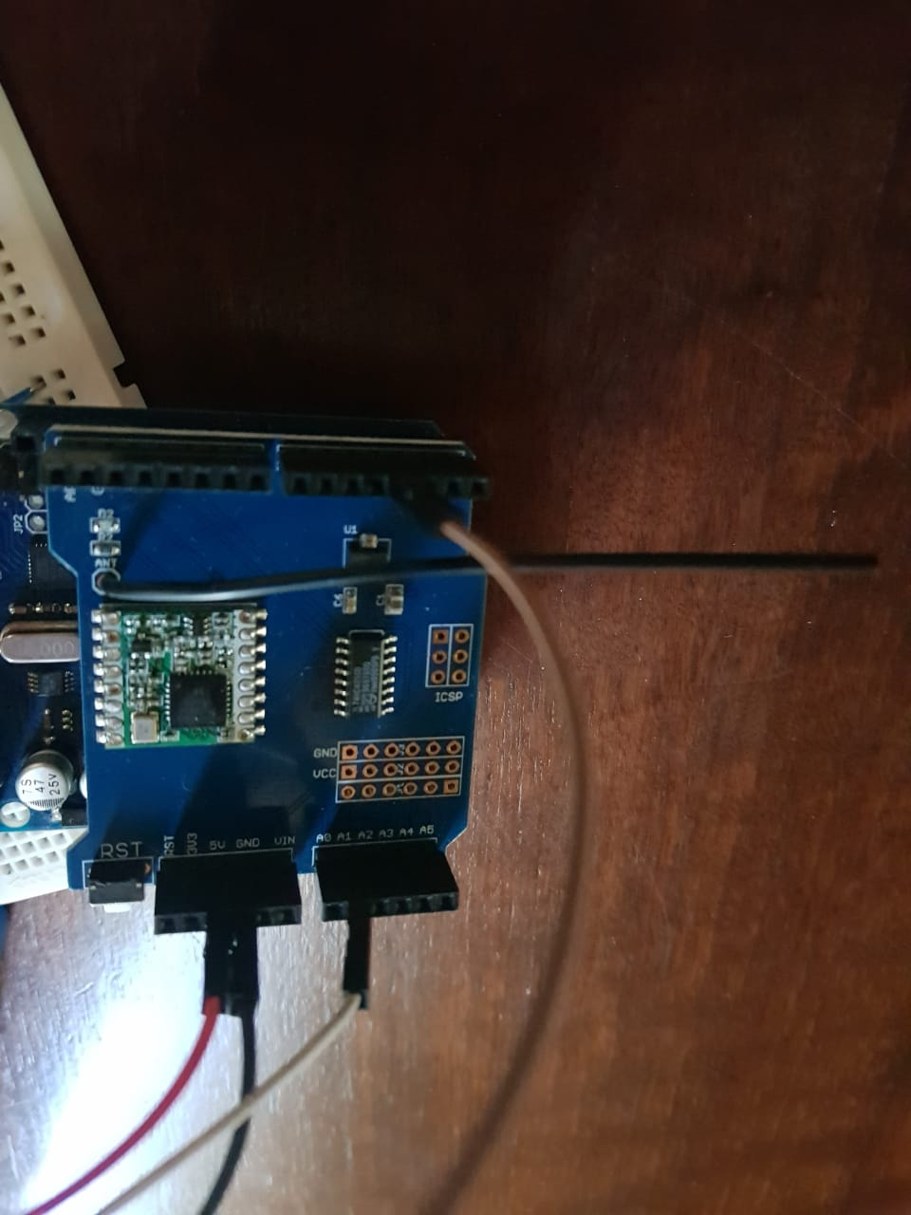

Figure 37:LoRa module V1.0 connection with Arduino

## LoRa Module V2.0

The LoRa module V2.0 used in the project is the WiMOD iM880B on a breakout board. The LoRa module V2.0 is shown in Figure 38 below. The LoRa module operates on the 868 band as per European standards.

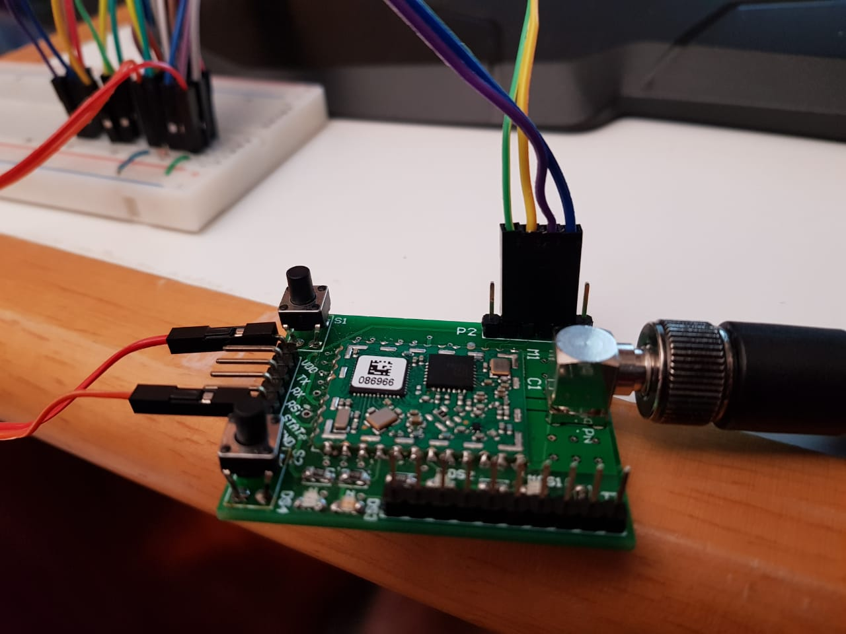

Figure 38: photo of LoRa module V2.0

The certification for the LoRa module can be seen in Appendix F. The certification enables the LoRa module iM880B to be implemented in the project as it is certified to communicate with the gateway. The LoRa module is connected to a voltage divider on the PCB of the distributed IOT environmental monitoring controller module. The distributed IOT environmental monitoring controller module collects the sensor data from the air-conditioning unit. The distributed IOT environmental monitoring controller module then packages the data and sends the data to the LoRa module through jumper cables. The LoRa module then sends the packaged data to the gateway. The Python program then receives the data from the gateway.

## LoRa module Message Composition

For the LoRa iM880B module the following message format is used for communication purposes from the application notes of the iM880B [21]. The destination address information, Destination Group Address and Destination Device Address must be included in the first 24 Bits of the user payload according to [21].

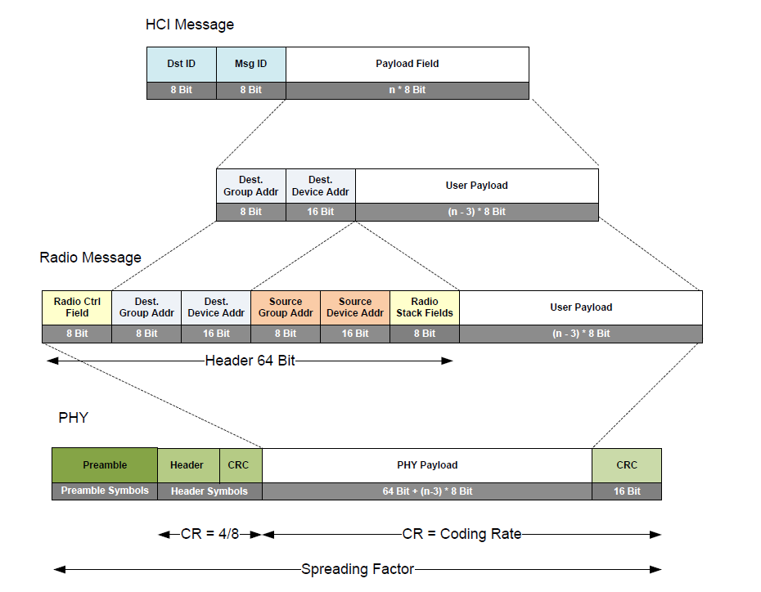

Figure 39: Schematic of iM880B packet structure [21]

## Controller Prototype V1.0: Arduino Uno®

In the first iteration of the Controller prototype V1.0 an Arduino Uno® was implemented as the controller for the distributed IOT environmental monitoring module. The implemented Arduino Uno ® can be seen in Figure 40 below. In Figure 40 the Arduino Uno® is connected with Jumper cables

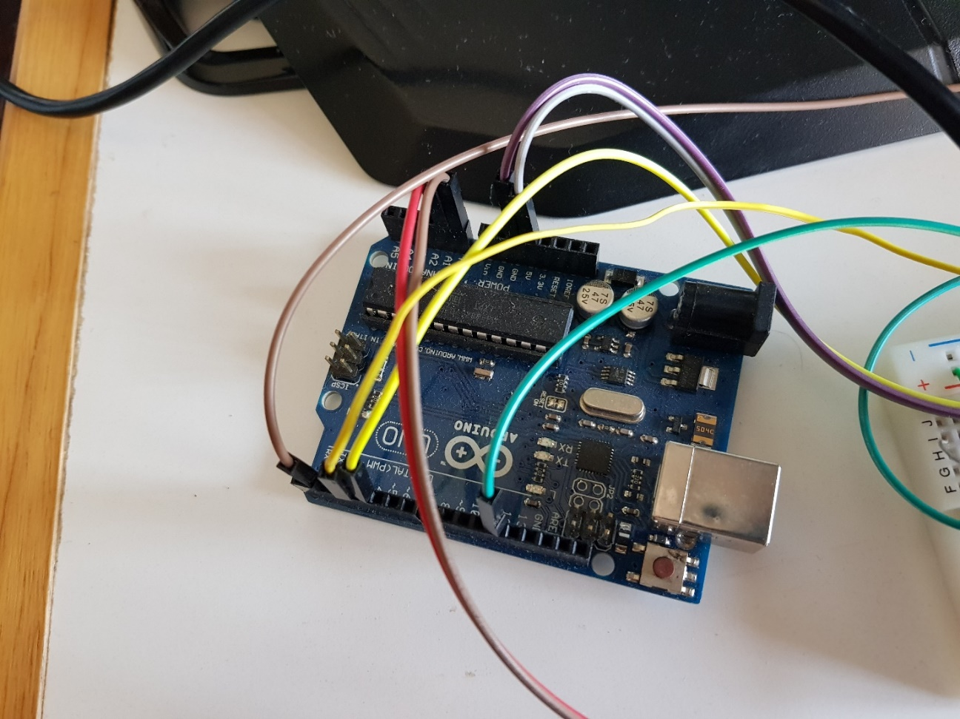

Figure 40: Photo of the Arduino Uno ® of the V1.0 controller prototype

In Figure 41 below the breadboard circuit of the controller can be seen. The circuit includes connection to the Arduino Uno® module, the temperature sensors and the current sensor. In the circuit a red LED is used to show the circuit is operational by blinking at a constant rate of 1s. If the LED is off for more than one second the circuit is not on. If the LED is on for longer than one second the module is collecting data.

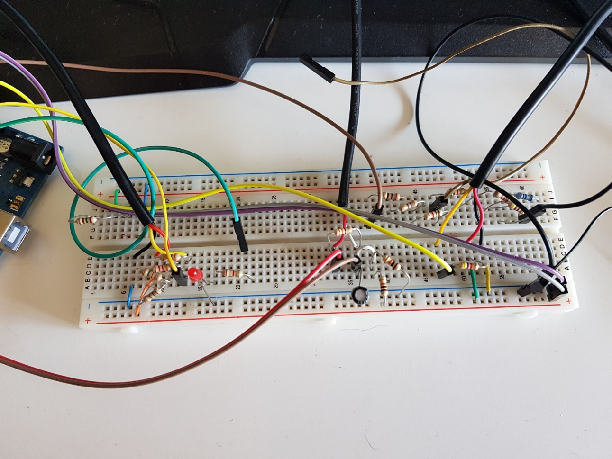

Figure 41: Photo of the breadboard of the V1.0 controller prototype

In the Figure 42 below the breadboard can be seen connected to the Arduino Uno® with jumper cables to complete the circuit.

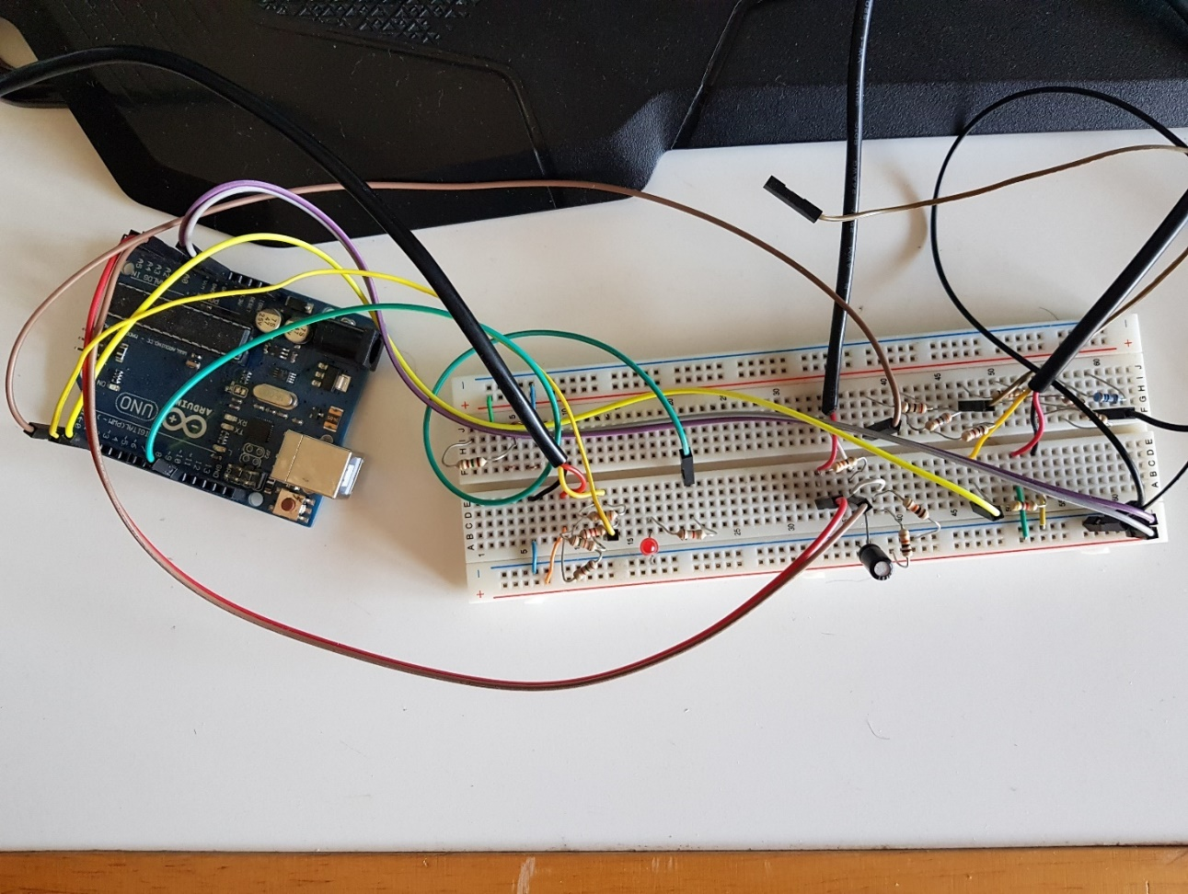

Figure 42: Photo of the breadboard and Arduino Uno® connection of the V1.0 controller prototype

## Controller Prototype V1.1: PIC microcontroller

In order to simplify the design and to minimize the cost and size of the module an attempt was made to integrate the controller code and the antenna code onto the LoRa module’s MCU which is a STM MCU. Therefore, the PIC microcontroller was abandoned for an STM.

## Controller Prototype V1.2: ST microcontroller unit

Following the PIC microcontroller design an STM32L151CB unit was implemented. This was due to the added minimization possibility of the design and cost of the module if the controller code and the antenna code could be integrated on the LoRa module’s MCU. However, ST MCU’s are not in common use in South Africa and the student had no prior knowledge or access to individuals with knowledge of the STM units. The ST MCU was implemented through self-study and research. Figure 43 below shows the LoRa module with the STM unit connected for testing.

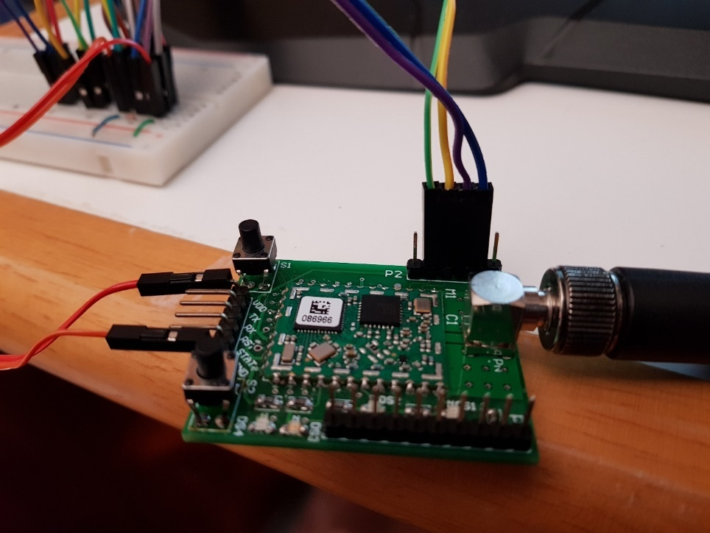

Figure 43: Photo of LoRa module connections during Prototype V1.2 STM iteration

The STM unit required a ST programmer in order to place the code on the STM unit. The programmer used in the project can be seen in Figure 44 below with jumper cables that were connected to the STM unit.

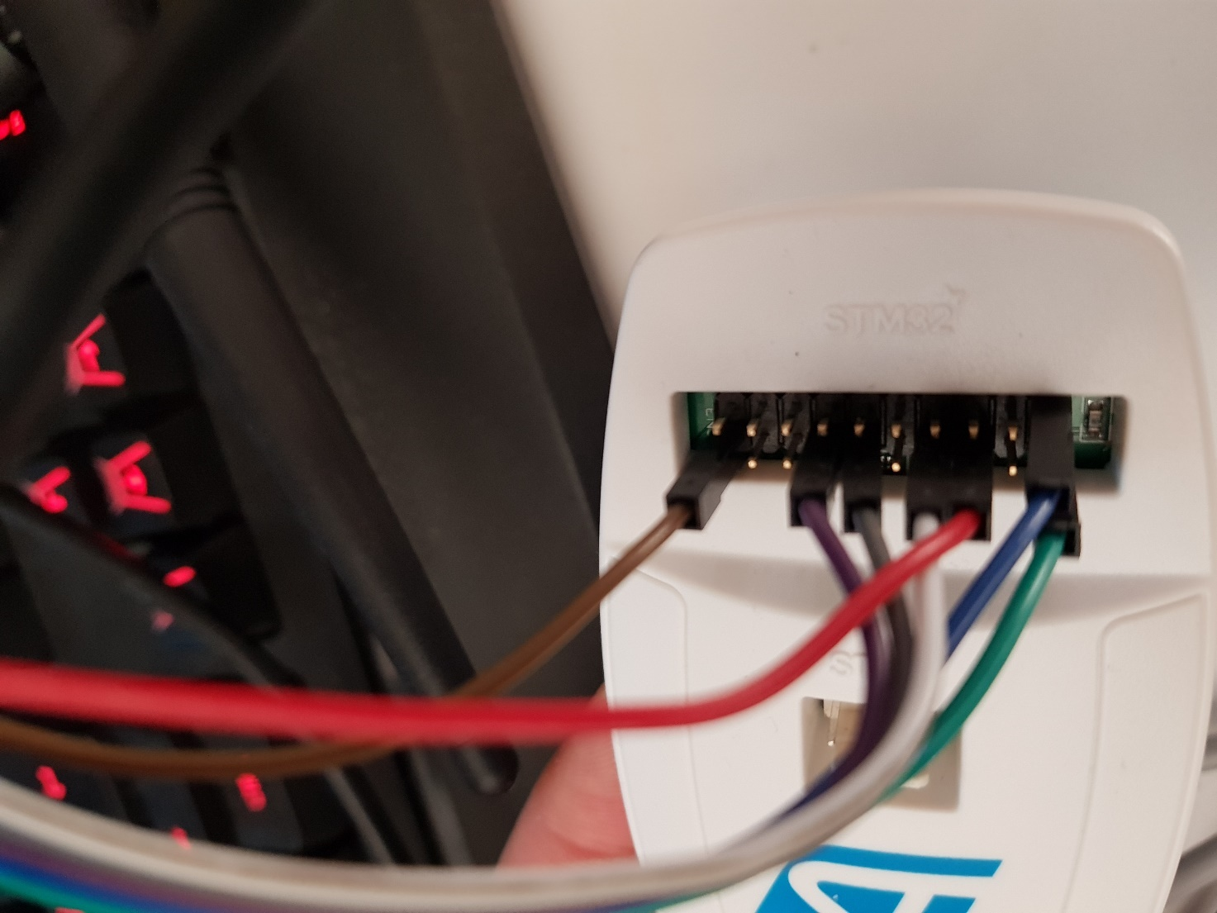

Figure 44: Photo of ST microcontroller programmer

In order to place the written code for the distributed IOT module on the ST MCU the LoRa module operation code had to be flashed. If that code is flashed the LoRa module loses all functionality as a LoRa module and is simply a ST MCU. Within the scope of the project the LoRa module functionality is required. A program could be written to operate the module, however, that would also not be a viable solution as the LoRa module must be certified in order to access the gateway and writing a program to operate the LoRa module would not be certified. Therefore, a new design for the controller had to be created.

## Controller Prototype V2.0: Development-Board (ATmega328P)

A prototype was constructed of the design, implementing a breadboard as the base for the components connected to an Arduino Figure 45. A simple program was written on the Arduino in order to assess if the prototype design would work.

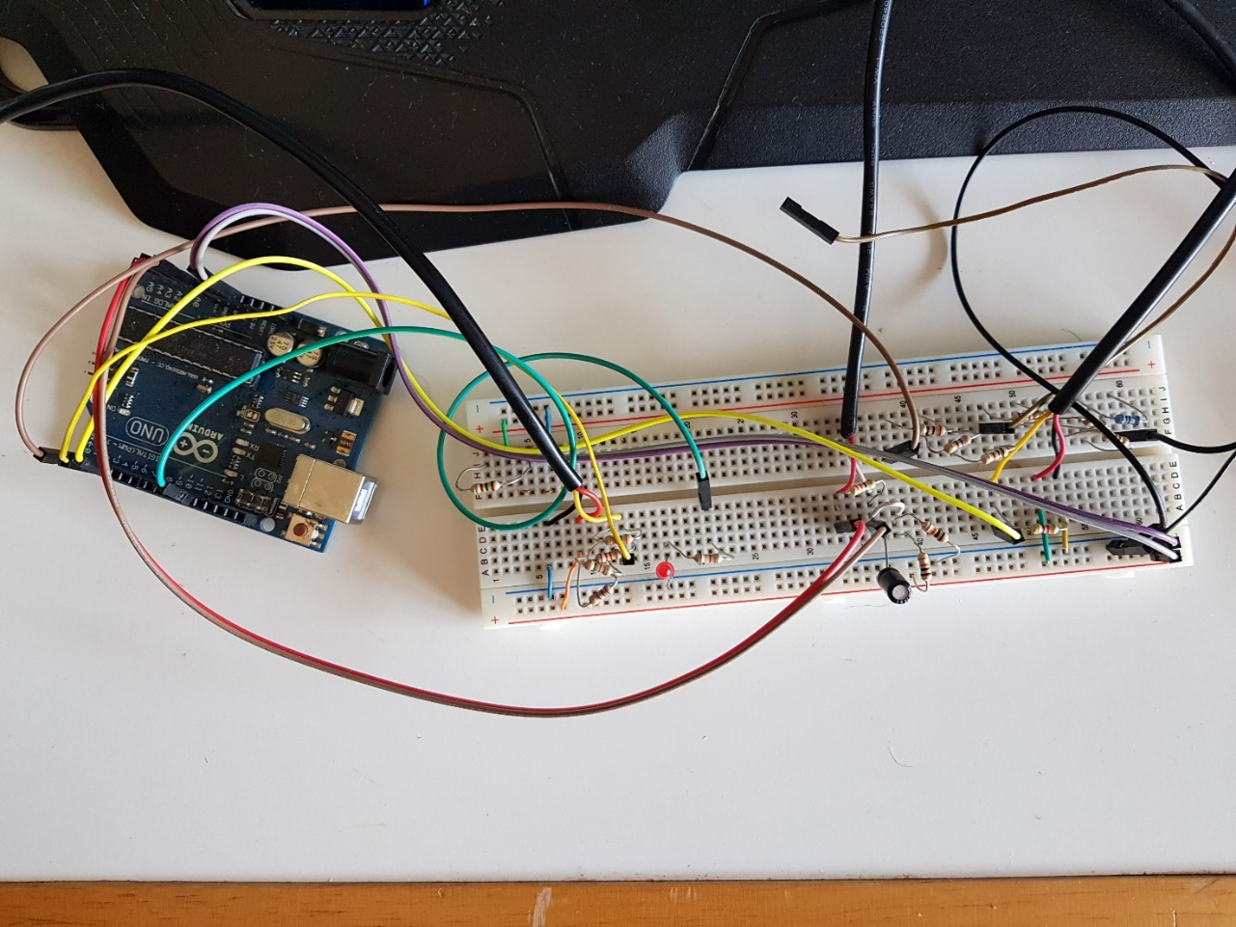

Figure 45: Test connection V2.0 breadboard

Once the design was evaluated the ATmega328P was implemented with a PCB layout. The PCB used for this project was home-made PCB.

When the project came to the phase where a PCB was required the opportunity arose to obtain additional skills to manufacture a PCB as part of the project rather than buy a ready-made one.

The first step was gathering the necessary components which are a copper plate, heat transfer paper, swimming pool acid and peroxide. Tools and equipment used were steel wool, an iron, scissors and an empty ice cream container.

The process started by printing the PCB layout on the heat transfer paper and cleaning the copper plate with the steel wool. Thereafter the heat transfer paper was placed on the copper plate and a hot iron used to iron the PCB layout onto the copper plate. The copper plate was then submerged in hot water, the paper removed and the PCB cleaned. The subsequent step was to place the copper plate with the printed PCB design in the ice cream container and pour in swimming pool acid and peroxide. The final process was to slowly move the container around until the copper was completely removed from the plate.

This resulted in a self-manufactured PCB that only required the component holes to be drilled and the necessary components to be soldered on to the board.

The completed home-made PCB can be seen in Figure 46.

The components on the PCB are two resistors: one for each temperature sensor, as well as a burden resistor for the current sensor and two high-value resistors for the voltage divider that is much larger than the burden resistor in order not to affect the divisor. The current sensor also makes use of a single capacitor - this finishes the non –invasive current sensors circuitry required on the PCB. There was the need for a voltage divider to be constructed in order to step down the 5 V logic levels received from the ATmega328P to 3.3 V logic levels that could be understood by the LoRa transceiver. The PCB also holds an LED that is used to indicate the state of the module and this LED also requires a resistor. The soldered in components and connected PCB can be seen in Figure 47. A Pin header was also soldered in to simplify the process of connecting the LoRa transceiver to the PCB as can be seen in **Error! Reference source not found.**.

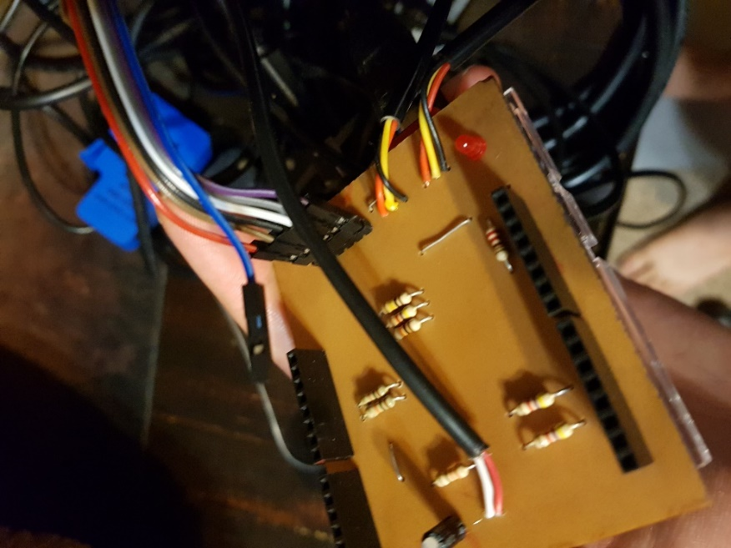

Figure 46: Photo of homemade PCB top view

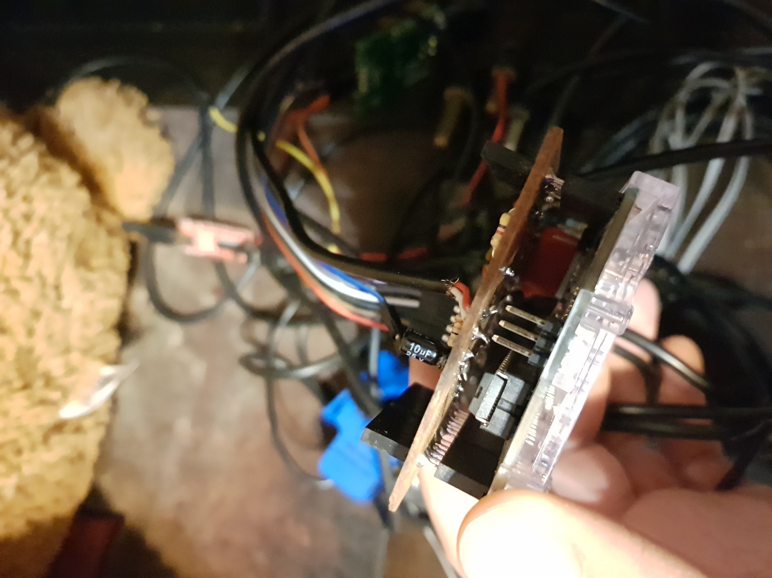

Figure 47: Photo of homemade PCB clip in

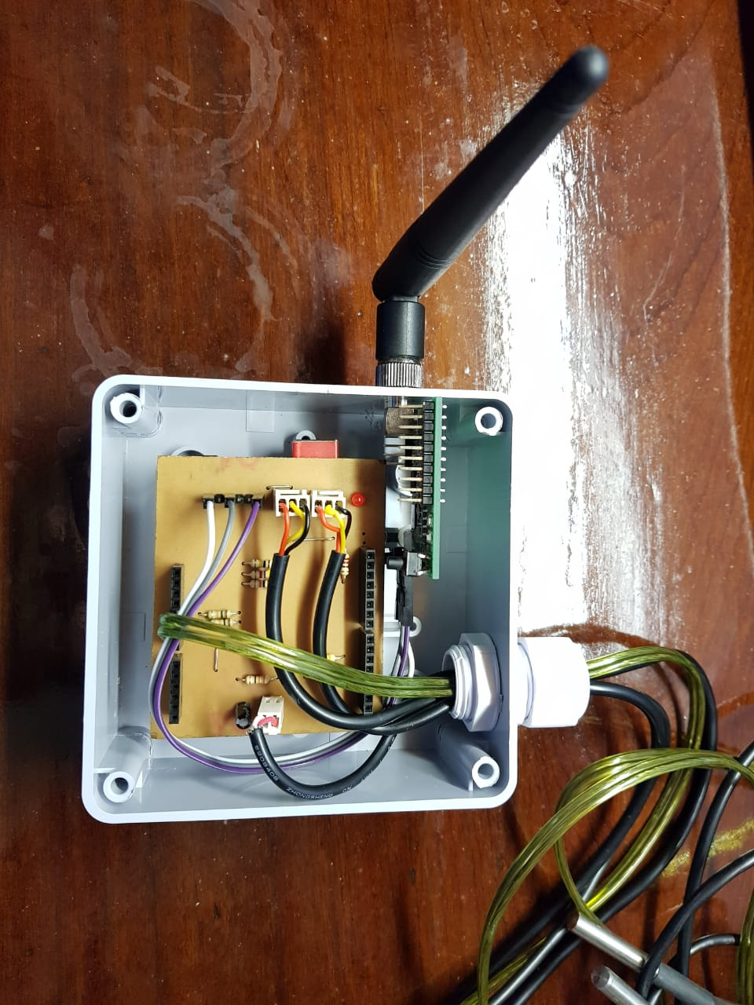

Figure 48: Photo of controller V2.0 in enclosure

## Human machine interface V1.0

The human machine interface including the login in functionality in the QT programming environment with the use of C++ programming language was not implemented. The design changed for the human machine interface to V2.0 and this was implemented in the section below.

## Human machine interface V2.0

For this project the human machine interface V2.0 implemented was a program user interface, which is a basic program the user will use to see the data results of the measurements taken with the sensor module. The program is written in Python using Spider programming platform. The implemented user interface is uncomplicated and easy to understand. In it the user can see it is created to be easy to use and understand. In the Figure 49 below the GUI of the IOT aircon data analysis program can be seen.

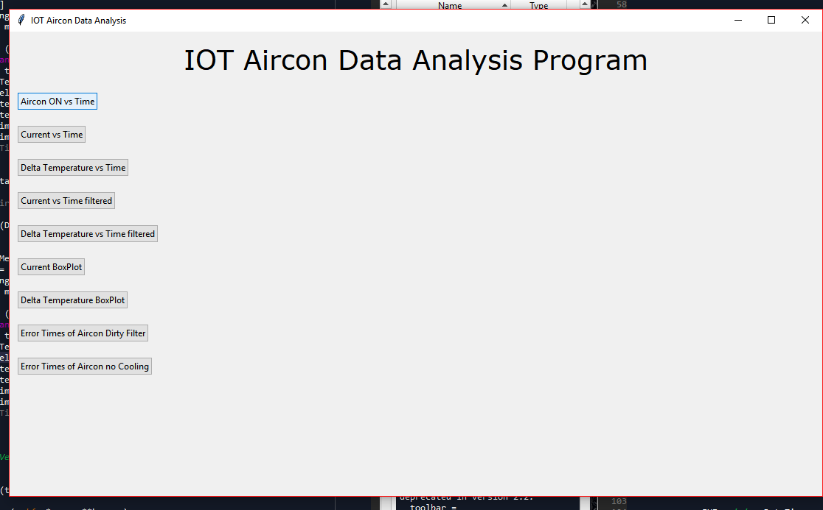

Figure 49: GUI screenshot IOT aircon data analysis program

The program provides the user with the capacity to see the air-conditioning unit on time as a function of time, the current as a function of time, the delta temperature as a function of time, the current as a function of time in a filtered format, the filtered delta temperature as a function of time, the current box plot, the delta temperature box plot, the error times when the air-conditioning unit identified a dirty filter and the error times identified where a broken fan was picked up, therefore, no cooling occurred.

In Figure 50 below the display screen is shown for the on-time of the aircon.

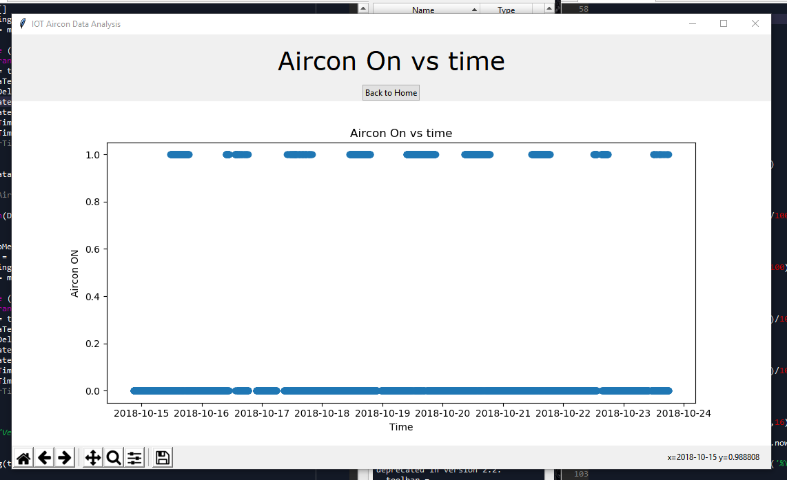

Figure 50: Screenshot of aircon on times display

In Figure 51 below the current measured is shown as a function of time.

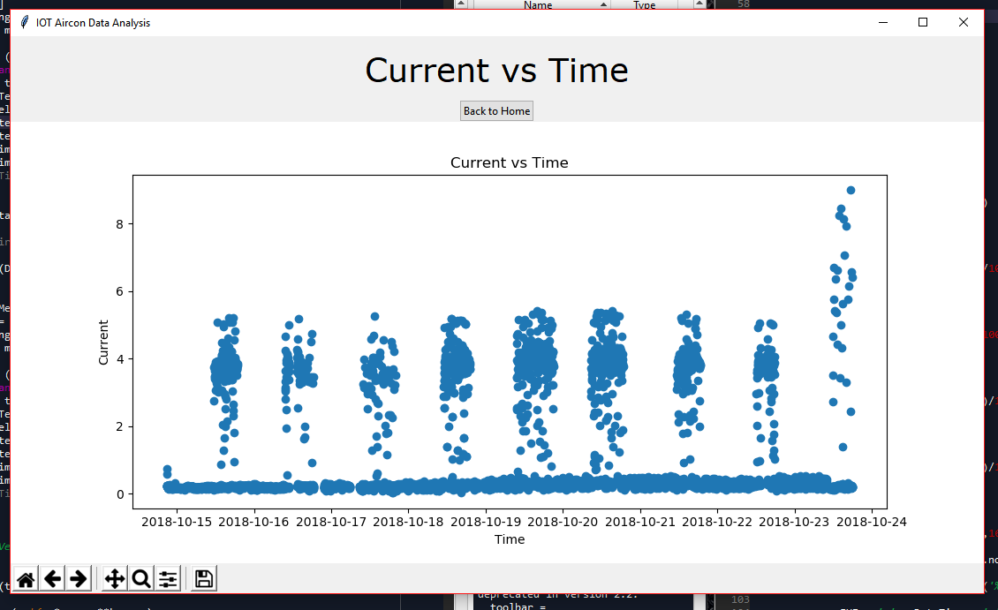

Figure 51: Screenshot current vs time graph of program

In Figure 52 below the times the air-conditioning unit did not cool as it was supposed to cool is reported.

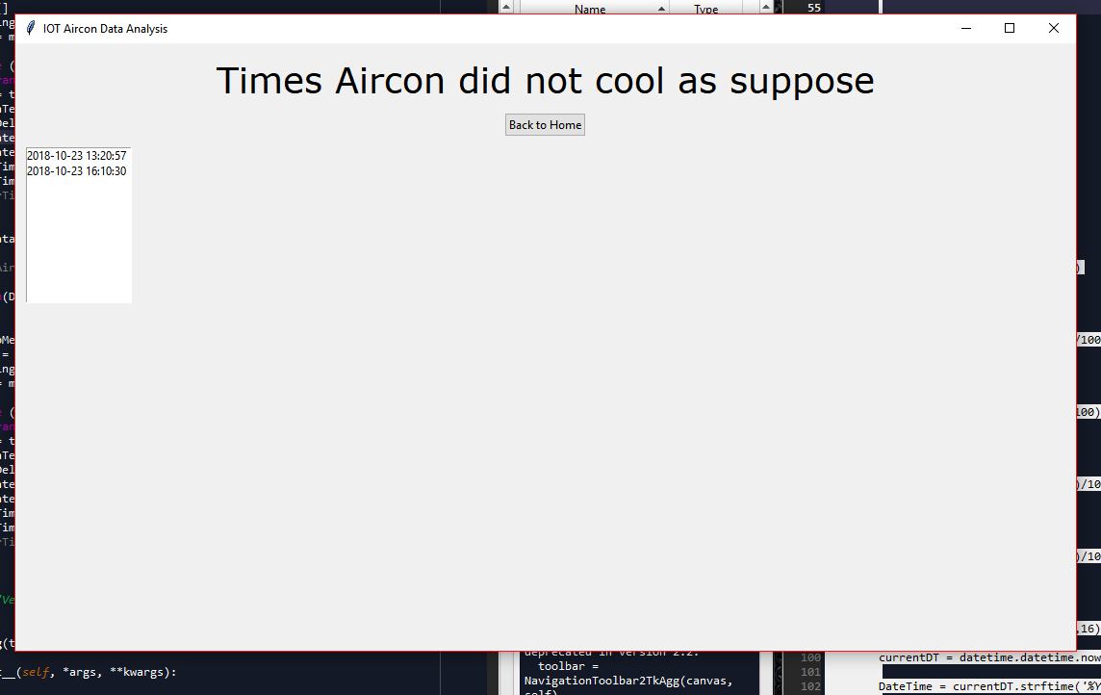

Figure 52: Screenshot program detected air-conditioning not cooling

In Figure 53 below the screen shot of the times the analysis identifies a dirty filter.

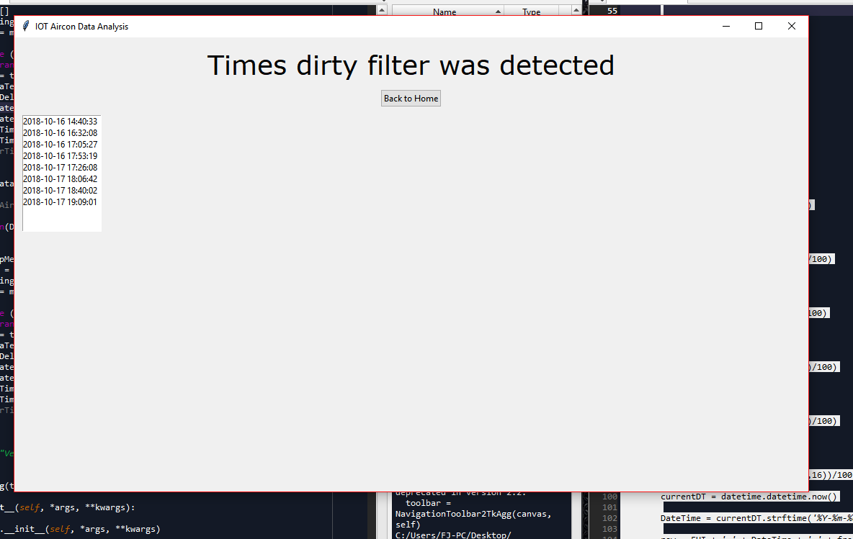

Figure 53: Screenshot program displayed times a dirty filter was detected

In Figure 54 below a box plot can be seen of the filtered delta temperature data as displayed for the user.

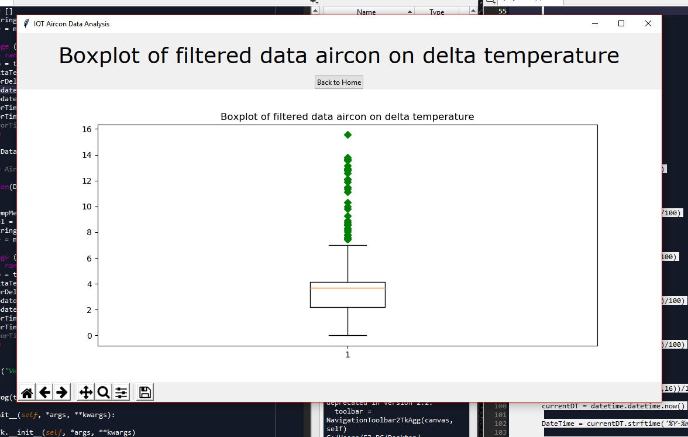

Figure 54: Screenshot of program displaying box plot of filtered delta temperature data

In Figure 55 below a box plot of the filtered current measurements of the air-conditioning unit can be seen as it is displayed by the program to the user.

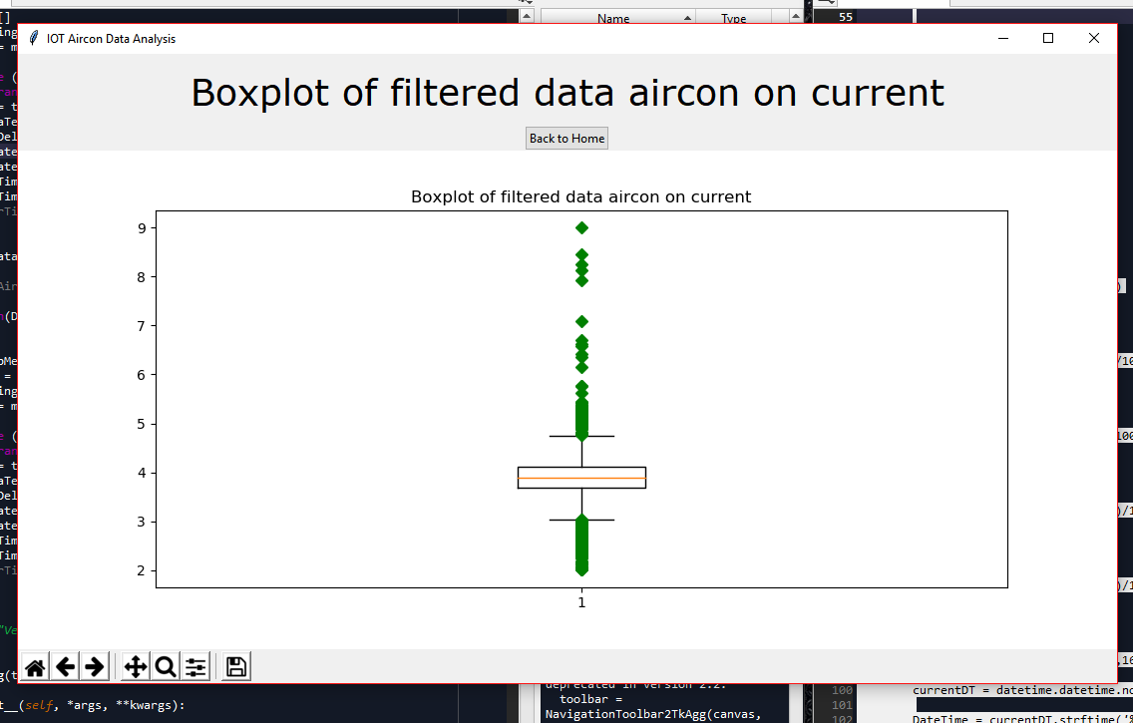

Figure 55: Boxplot of filtered aircon data of the current

In Figure 56 below the program filtered delta temperature measured of the air-conditioning unit can be seen as it is displayed to the user.

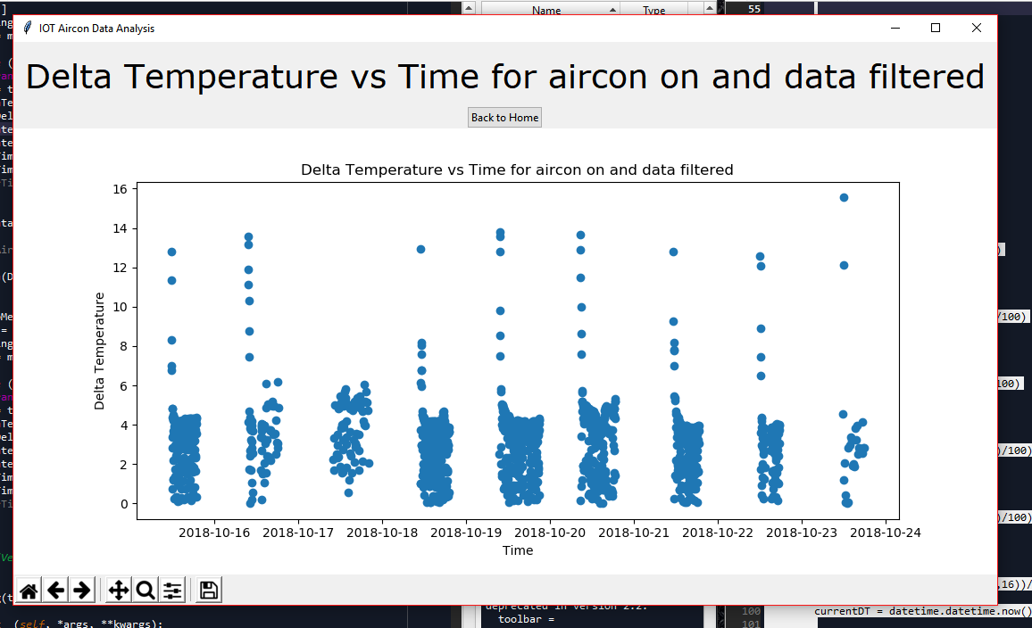

Figure 56: Screenshot of program displaying temperature vs time of the aircon on and filtered data

In Figure 57 the program filtered current measurements of the air-conditioning unit can be seen.

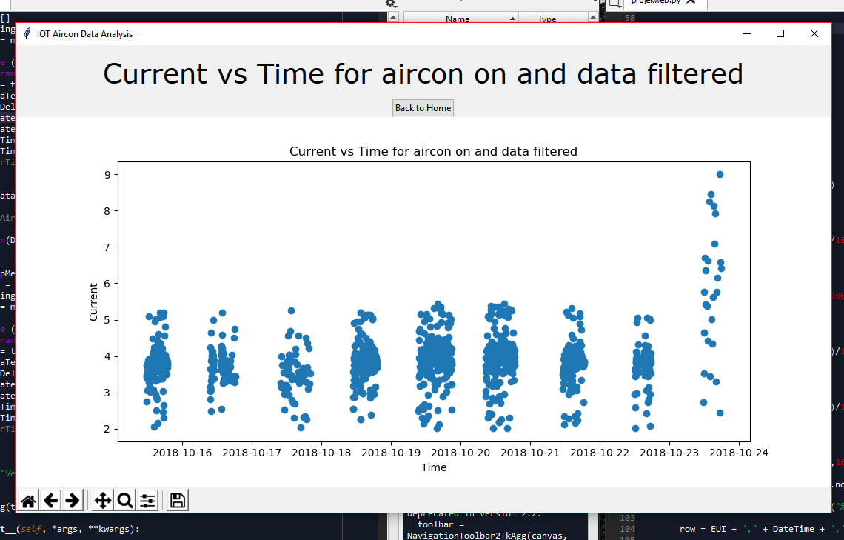

Figure 57: Screenshot of program displaying current vs time for the aircon on and data filtered

In the following Figure 58 below the measured delta temperature of the air-conditioning unit can be seen.

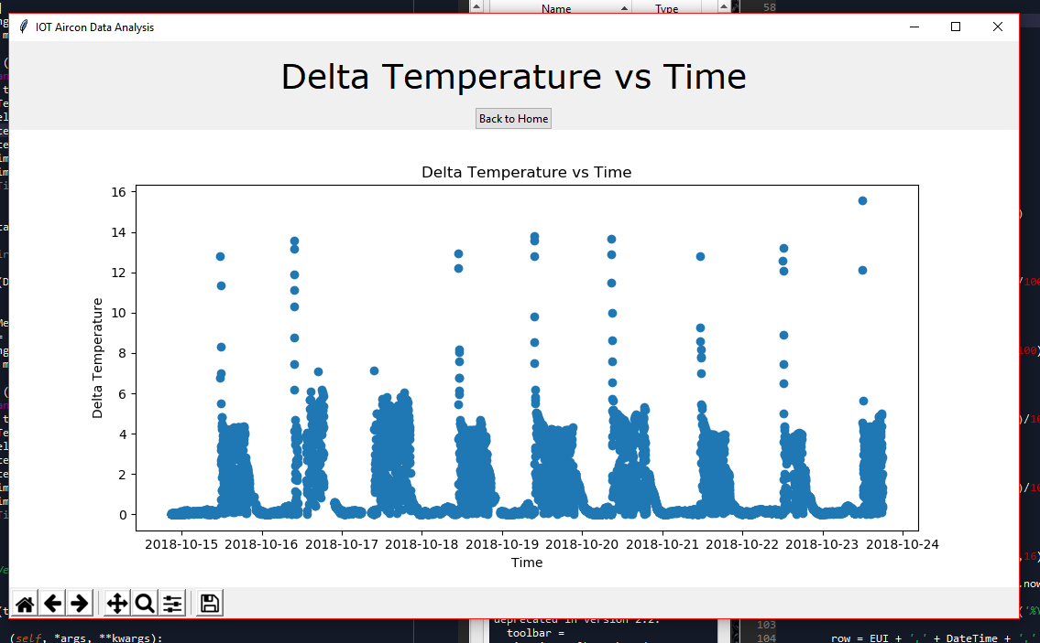

Figure 58: Screenshot of the program displaying the delta temperature vs time

The program testing is shown in Chapter 5.

## Website: Loriot

The web service that was used is the Loriot web service, this was chosen because it was supplied by the university. The implementation of the web service consists of registering the gateway on the service which then allows all the data the gateway receives to be transferred via the internet to the web service. With the data on the web service there are multiple options to choose from in order to obtain the data from the web service. These options are for example WebSocket, TLS Socket, HTTP Push, Amazon AWS IoT and Azure IoT Hub.

From these WebSocket was chosen on the basis of its ease of implementation and comparative low overheads. The Loriot service provides a target URL that can be used to get the data from the WebSocket. The following is the template of the URL: wss://af1.loriot.io/app?token={token}. The project’s personalised URL from the Loriot service is the following.

wss://af1.loriot.io/app?token=vgEAIQAAAA1hZjEubG9yaW90Lmlv1t1Cv77m8k4w3fnB6ci9gw==

Once the WebSocket URL was in place implementation in python could take place and the data could be obtained from the module via the WebSocket.

## Mobile split type air-conditioner Test Jig V1.0

The first iteration V1.0 of the mobile split-type air-conditioning unit Test Jig can be seen in Figure 59 below. For V1.0 of the Jig design a wood structure was built to support the split type air-conditioning unit and the DB box including the isolator for the split-type air-conditioning unit, as prescribed in the SAS prescriptions.

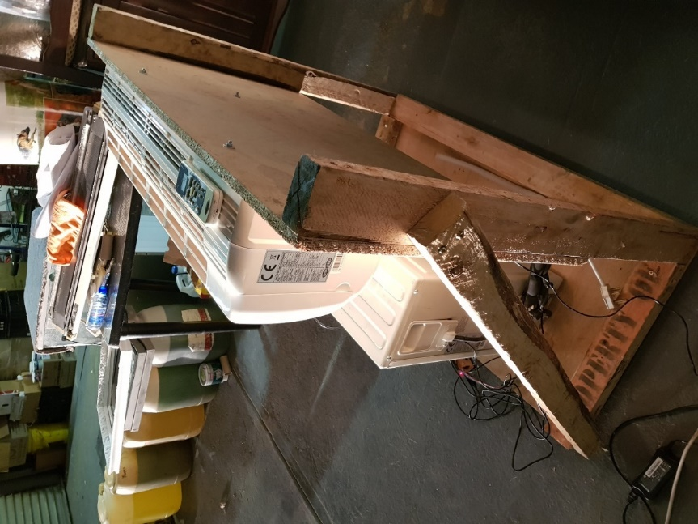

Figure 59: Photo of wood mobile air-conditioning test structure

In Figure 60 the photo of the wood test jig can be seen with the distributed IOT environmental monitoring module.

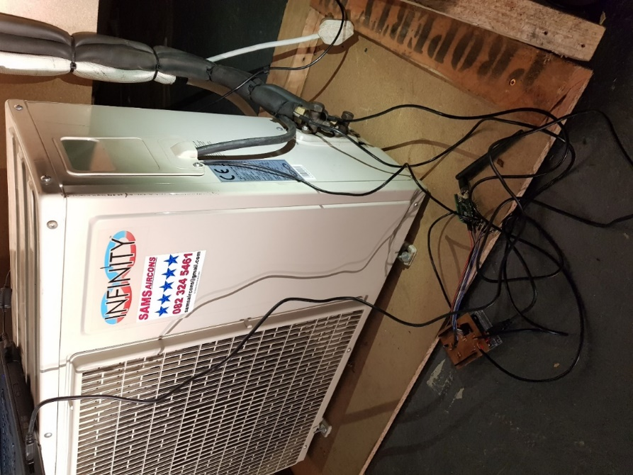

Figure 60: Photo of wood mobile air-conditioning test Jig connected to IOT module

In Figure 61 below the test Jig computer set up can be seen.

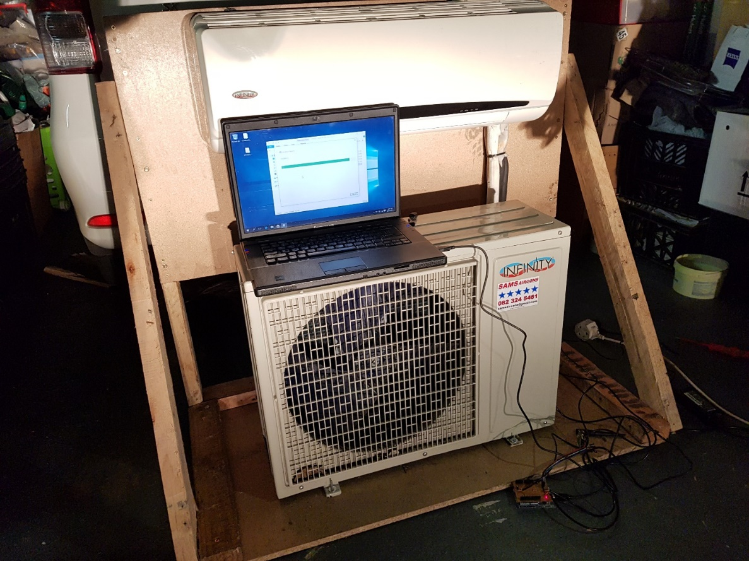

Figure 61: Photo of wood mobile air-conditioning test Jig with computer set up

## Mobile split-type air-conditioner Test Jig V2.0

In the second iteration of the mobile split type air-conditioning unit test Jig the Jig was constructed out of steel to replace the wooden support in order to strengthen the test jig structure. In Figure 62 below steel framework for the mobile split type air-conditioning unit can be seen.

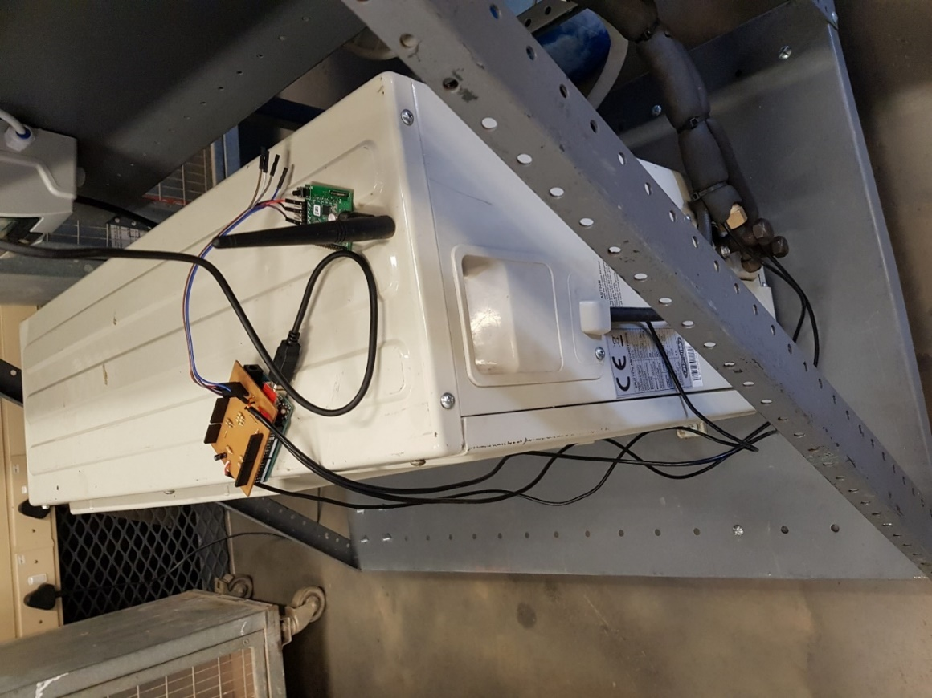

Figure 62: Photo of steel framework of test jig

In Figure 63 below a photo of the Photo of DB board connected to the steel frame Jig can be seen. The DB board consists out of an isolator for Split type air-conditioning unit and a 5V transformer for the distributed IOT environmental monitoring module which requires a 5V power supply.

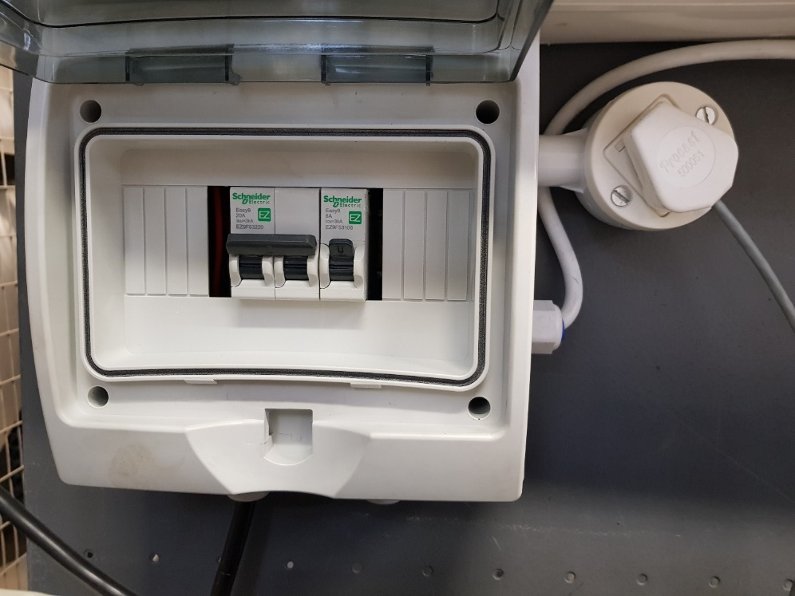

Figure 63: Photo of DB board with isolator and 5V transformer for Split type air-conditioning unit

In Figure 64 below a photo of steel mobile air-conditioning unit test Jig can be seen as it is set up in the NWU heavy current laboratory.

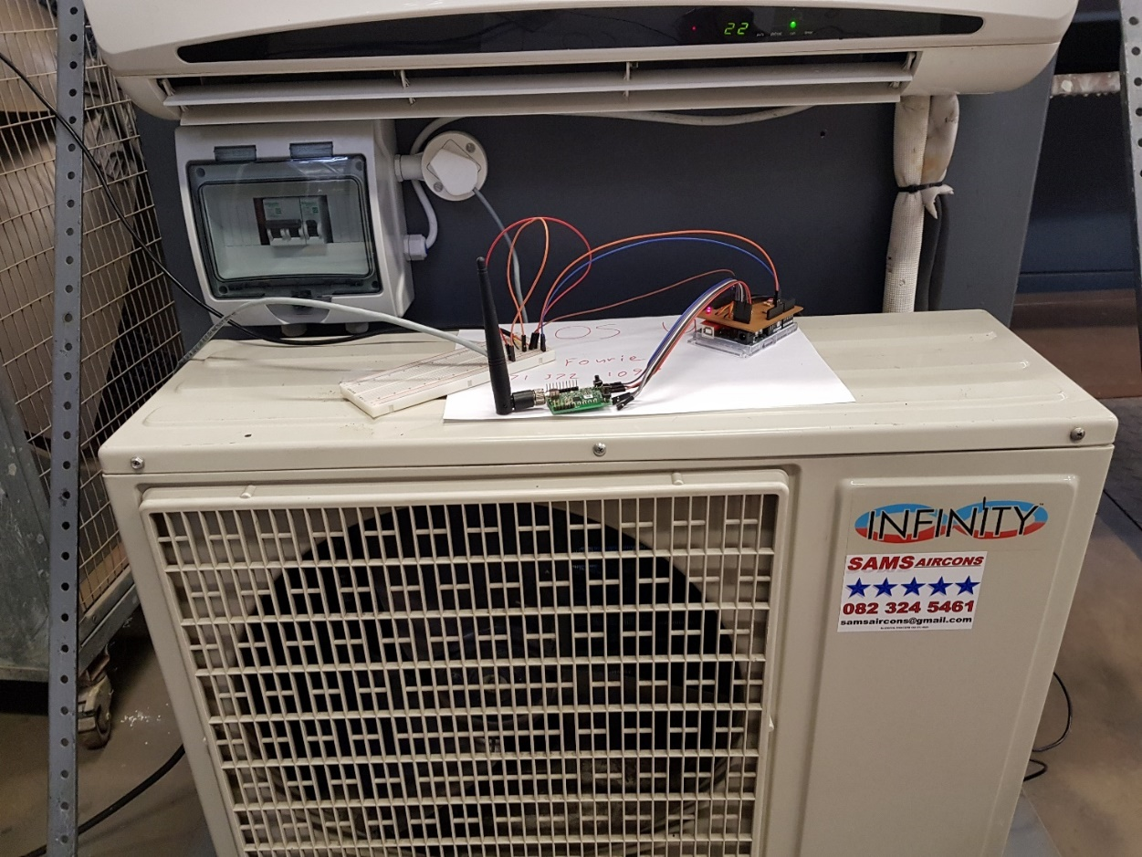

Figure 64: Photo of steel mobile air-conditioning unit test Jig laboratory set up

In Figure 65 below a photo of the steel mobile split type air-conditioning unit test jig set up can be seen. Where the current sensor is clamped over the live wire of the compressor unit of the split type air-conditioning unit. The current sensor wire protrudes from the split type air-conditioning unit main power supply wire opening, and connects to the distributed IOT environmental monitoring module.

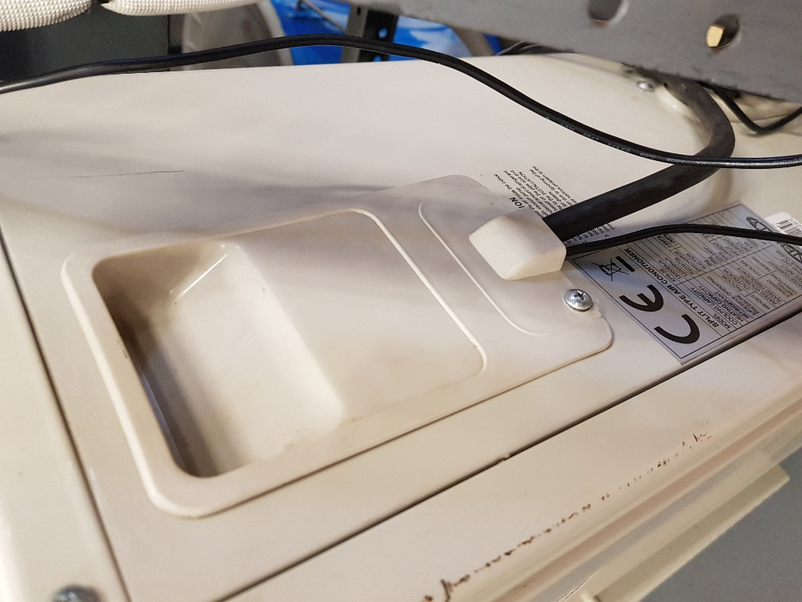

Figure 65: Photo of steel mobile air-conditioning unit set up current sensor clamped over the live wire of the compressor of the air-conditioning unit

The current sensor clamp was connected where the main power supply 220V for the split type air-conditioning unit splits the neutral and live wire as the current sensor should only measure the live wire current. This can be seen clearly in Figure 66 below where the electrical panel of the compressor unit of the air conditioning unit is open thereby displaying the live wire of the main power supply.

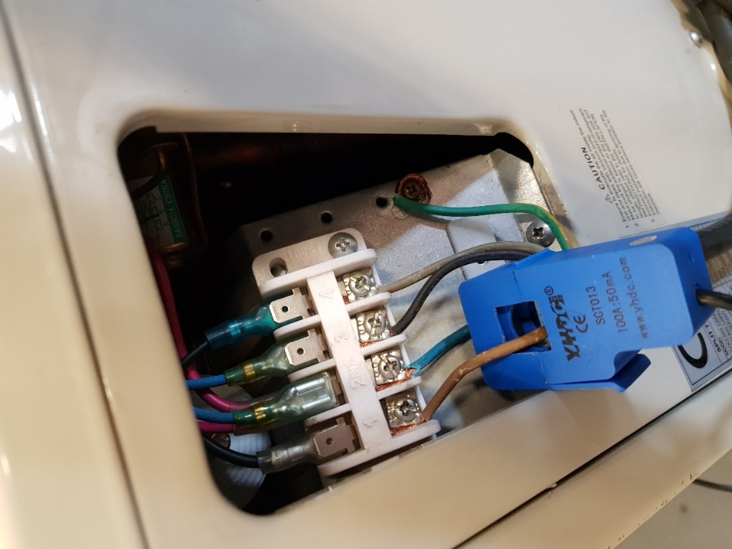

Figure 66: Photo of current sensor clamped over live wire

In Figure 67 below the inlet and outlet gas lines are shown. The two temperature sensors are connected to the inlet and the outlet gas lines respectively. These temperature sensors are waterproof and connected to the gas lines with thermal insulation tape and then insulated thoroughly with the gas lines normal insulation material.

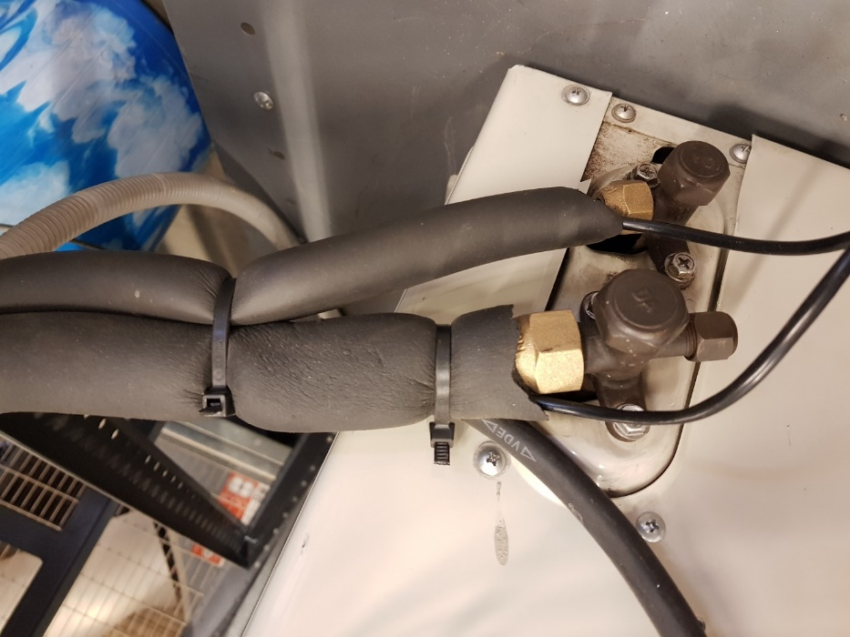

Figure 67: Photo of steel mobile air-conditioning unit set up temperature sensors connected to the inlet and outlet gas lines respectively of the air-conditioning unit

## Distributed IOT environmental monitoring module Installation Procedure

For the project the distributed IOT environmental monitoring device was installed on a mobile air-conditioning split type unit. However, for general installation the following procedure should be followed. The first iteration of the installation procedure was to place the temperature sensors on the inside air-conditioning unit and the current sensor on the outside unit (compressor.) However, this may cause a strain between the module and the sensors as well as the added difficulty of installing the module in office buildings where access to offices may be difficult. Furthermore, the increase in installation time due to the logistical problems compounded by the inside unit caused increased cost in man hours.

The two temperature sensors must be connected to the inlet and outlet gas lines respectively of the compressor of the split type air-conditioning unit. The temperature sensor must be secured to the gas lines with thermal isolation tape to ensure the readings are accurate. The current sensor must be clamped over solely the live wire of the compressor. This is done by removing the electric panel of the split type air-conditioning unit’s compressor and connecting the current sensor clamp over the live wire once it is separated from the neutral wire. Once complete, the electric panel should be restored with only the current sensor wire protruding from the compressor box.

## Enclosure

The enclosure implemented in the final prototype can be seen in below.

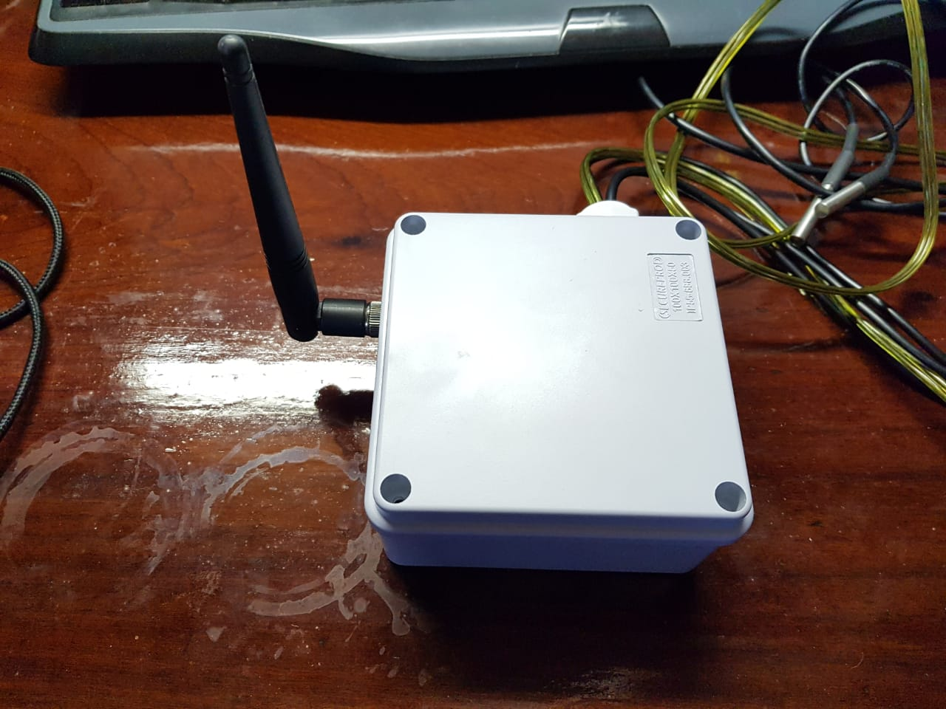

Figure 68: Photo of IOT module enclosure

The enclose meets the IP31 requirements that are necessary for the protection of the PCB and LoRa module in the enclosure. The ATmega328P circuit board is secured to the protective casing with screws. The LoRa module antenna connects on the outside of the casing to the inside LoRa module STM chip on its breakout board. The LoRa module is secured in place in order to prevent damage to the module.

## Conclusion

In this chapter the detailed design developed in chapter 3 was implemented in order to create prototypes of the different aspects of the design. Due to changes in design and requirements there were several iterations of the detailed designs as well as the implementations of the design. Each implementation went through evaluation in order to assess the functionality of the design. After each prototype was implemented and evaluated, improvements were made to the detailed design and documented in chapter 3 of the report. The new detailed design was then implemented. In the final implementation of the design an ATmega328P was used as the controller. This was implemented on the home-made PCB in order to form the base of the distributed IOT environmental monitoring module. The LoRa module implemented on the final module was the iM880B which was chosen as it has certification necessary in order to connect to the Gateway. The website used to get the data from the gateway is Loriot. The back-end program was written using Python programming language and the data collected from the Loriot website is stored in a CSV file. The CSV file data is used by the back-end program to analyse the air-conditioning unit operational measurements. The analysed data is then compiled in a useful simple selection of graphs and time stamps for the user. The final iterations of the implementations of the project were the most effective iterations that could be provided given the scope of time and finances available to the project.

# Chapter 5 – Testing and Evaluation



## Introduction

In the following chapter the testing and evaluation of the different aspects of the design was done. The testing and evaluation were conducted in order to assess to what extent the module and back-end program function. From the results of the test evaluation is conducted in order to assess whether the components are functioning sufficiently in order to adhere to the requirements set for the project.

## Current sensor Test

The current sensor used in the project is a non-invasive current sensor clamp. In order to measure the current of the given scenario, the current sensor clamp must be clamped over only the live wire of the circuit current that must be measured. Therefore, the following split wire plug type in Figure 69 was used in order to test the measurements taken by the current sensor.

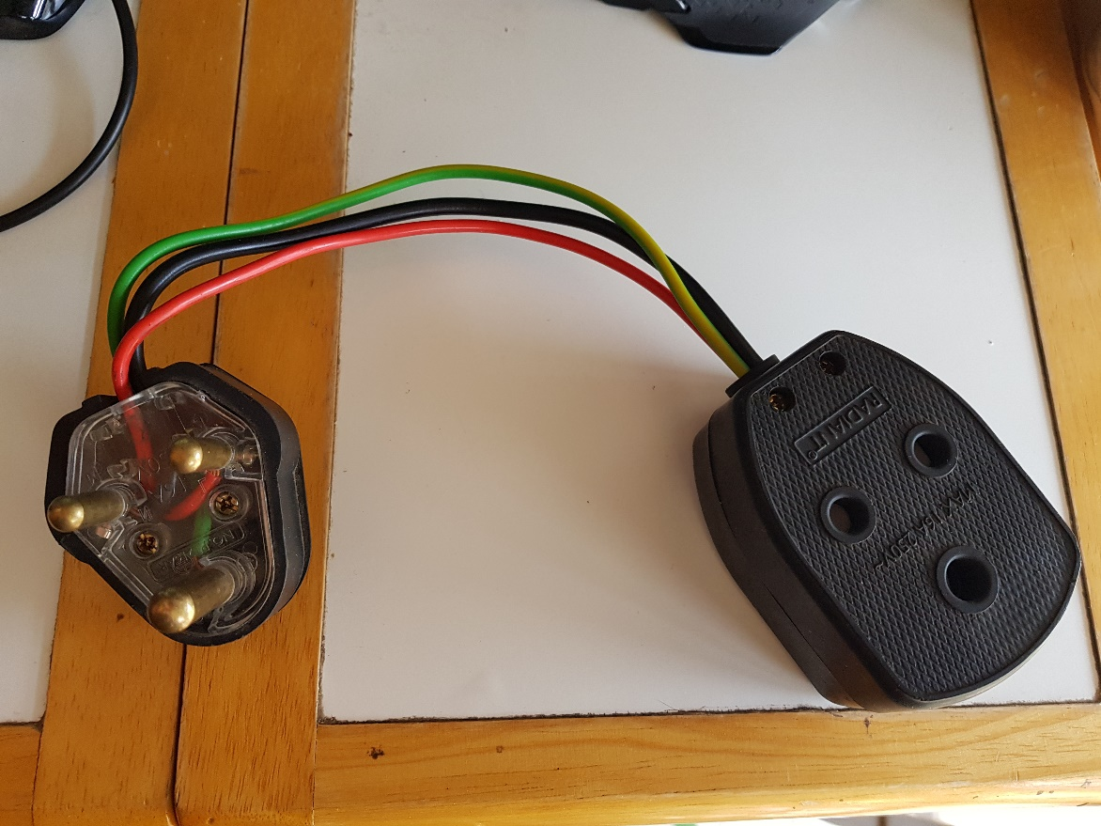

Figure 69: photo of split type 3-point plug wire

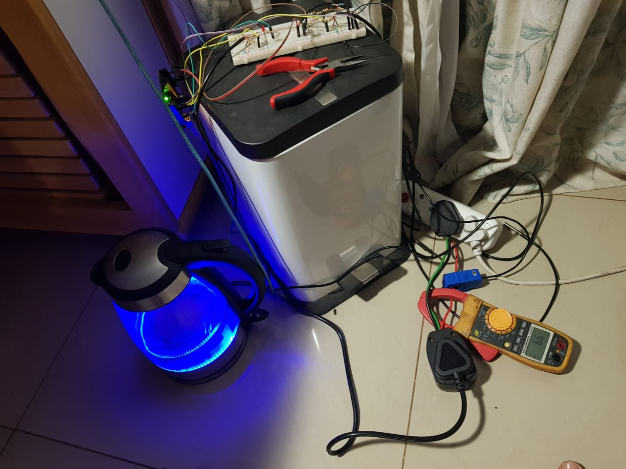

Figure 70: Current sensor kettle current measurement test

The measurements of the current sensor clamp were compared with the measurements taken with a multimeter with a current clamp as can be seen in Table 13 below where experiment 1 is documented.

Table 13: Current sensor measurements vs multimeter measurements experiment 1

|  |  |  |
| --- | --- | --- |
| Measurement number | Current sensor measurement (A) | Multimeter measurement (A) |
| 1 | 6.71 | 6.7 |
| 2 | 6.59 | 6.6 |
| 3 | 7.42 | 7.4 |
| 4 | 7.79 | 7.8 |
| 5 | 7.88 | 7.9 |

In Figure 71 below the current sensor clamp and the multimeter clamp is clamped over the live wire of the supply power for the kettle.

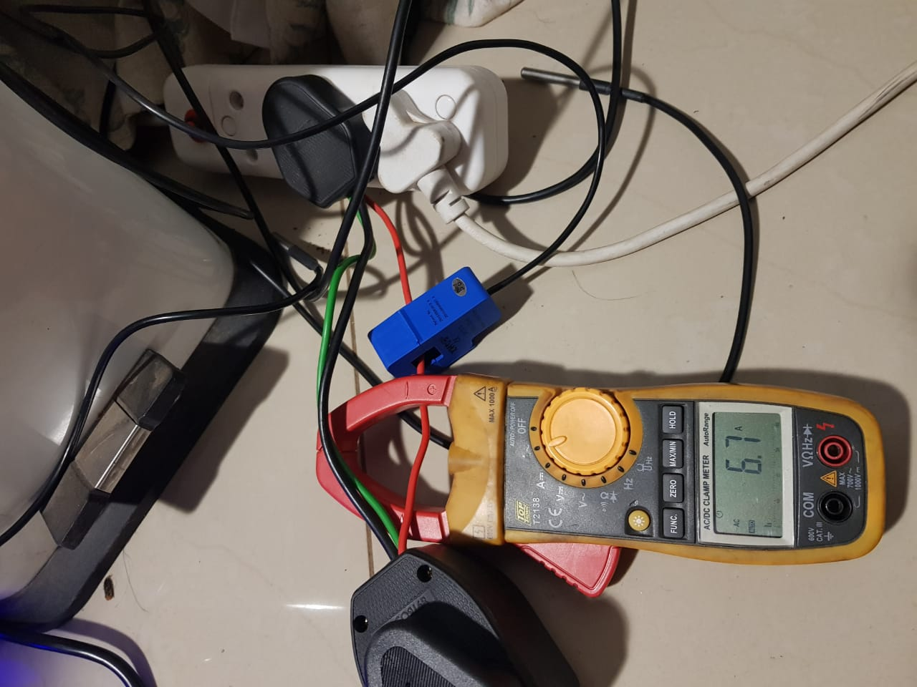

Figure 71: Current sensor clamp and multi-meter clamp during kettle current measurements

The current sensor measurements were also tested on the air-conditioning unit by placing the current sensor clamp over the live wire of the air-conditioning unit power wire. This was then compared to the measurements taken with a multi-meter with a current clamp measured at the same location. The current sensor clamp over the live wire can be seen in Figure 72 below.

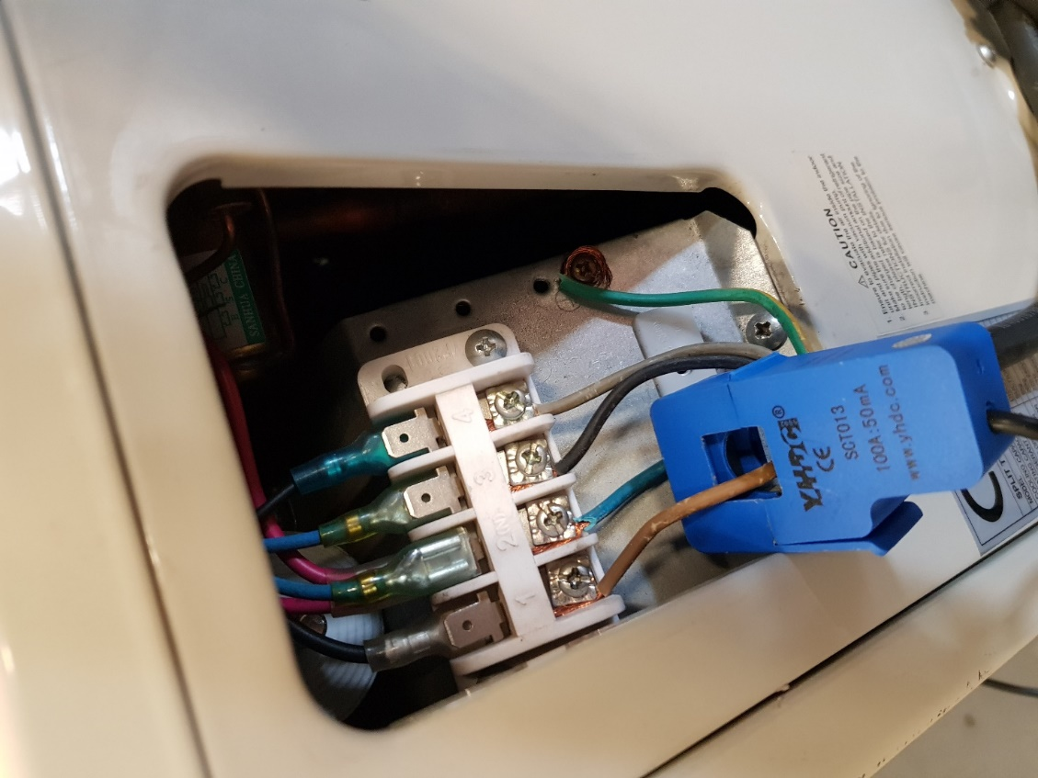

Figure 72: Photo of Current sensor clamped over the live wire of the power cable for the air-conditioning unit

In Table 14 below the experiment data for three measurements of the current sensor clamp data compared to the measurements taken with a multi-meter equipped with a current clamp.

Table 14: Current sensor measurements vs multimeter measurements experiment 1

|  |  |  |
| --- | --- | --- |
| Measurement number | Current sensor measurement (A) | Multimeter measurement (A) |
| 1 | 3.84 | 3.8 |
| 2 | 3.92 | 3.9 |
| 3 | 4.06 | 4.2 |
| 4 | 3.82 | 3.8 |
| 5 | 4.29 | 4.4 |
| 6 | 3.74 | 3.7 |

From Table 13 and Table 14 above it is apparent that the current sensor is functioning as expected.

## Temperature sensor Test

The temperature sensors were tested in two ways, firstly with the hot bucket, cold bucket test and secondly comparing the temperature sensor measuring the ambient temperature with the split type air conditioning unit ambient temperature.



### Hot bucket, cold bucket test

The simplest and widely accepted test of a temperature sensor is the hot bucket, cold bucket temperature test. In this test the temperature sensor is placed in a cup of ice water for which measurements are recorded. The temperature sensor is then placed in a cup of boiling water for which the measurements are recorded. These measurements are then compared in order to check whether the temperature sensor operates as expected.

The first experiment conducted in the hot bucket, cold bucket test is the hot bucket test for which the sensor data readings were recorded and tabulated in an excel file. However, the sensor temperature measurement data is over 200 data points, therefore, only the maximum data points measured by the temperature sensor was recorded. The hot bucket test was conducted by placing the temperature sensor in the kettle just after boiling as can be seen in the Figure 73 below.

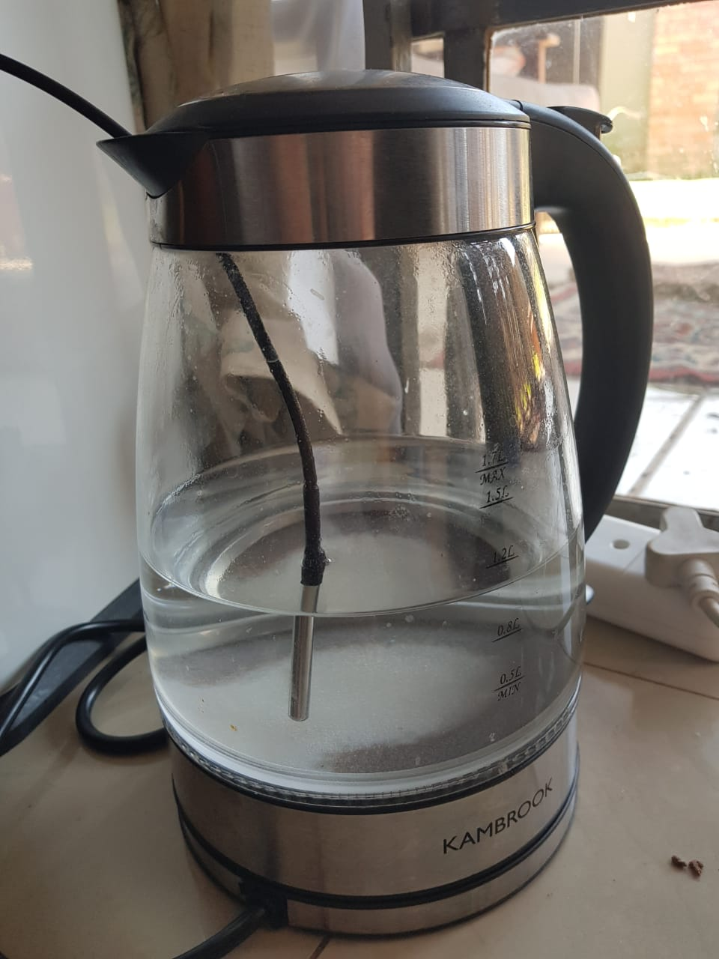

Figure 73: Hot bucket test temperature sensor probe

The maximum and minimum measured temperatures of the hot bucket test are recorded in the Table 15 below.

Table 15: Hot bucket cold bucket measurements

|  |  |  |
| --- | --- | --- |
| Measurement number | Maximum Measured Temperature Hot Bucket Test (degrees Celsius) | Minimum measured temperatures Cold bucket test (degrees Celsius) |
| 1 | 95.62 | 0.44 |
| 2 | 95.56 | 0.55 |
| 3 | 95.62 | 0.48 |

The cold bucket test can be seen in the Figure 74 below where the temperature sensor probe is submerged in a bowl of icy water.

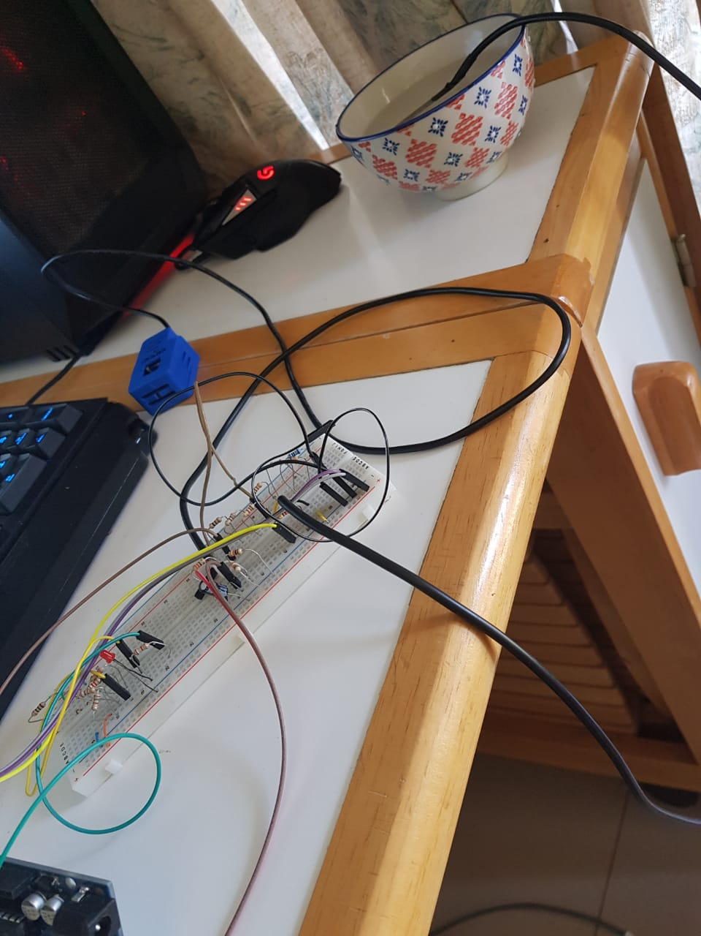

Figure 74: Cold bucket test

Comparing the results of the hot bucket and cold bucket test it is reasonable to assume the temperature sensor operates as planned.

### Ambient temperature test

The second test that was conducted in order to test the temperature sensor operation was comparing the measured ambient temperature of the temperature sensor with the ambient temperature sensor of the air-conditioning unit, assuming the temperature of the air conditioning unit is accurate.

Table 16:Ambient temperature sensor test

|  |  |  |
| --- | --- | --- |
| Day Measured | Air-conditioning unit ambient Temperature (degrees Celsius) | Temperature sensor Ambient temperature (degrees Celsius) |
| 15-10-2018 | 22 | 22.31 |
| 16-10-2018 | 22 | 22.06 |
| 17-10-2018 | 22 | 22.93 |
| 18-10-2018 | 22 | 22.12 |
| 19-10-2018 | 22 | 22 |
| 20-10-2018 | 22 | 22.06 |
| 21-10-2018 | 22 | 22.25 |
| 22-10-2018 | 22 | 22.43 |

From the test data collected on the ambient temperature, the conclusion was that the temperature sensor operates as assumed.

## Dirty Filter Test

The objective of the dirty filter test is to place an obstruction over the split type air-conditioning unit filter and identify the change in data through data analysis. In order to simulate a dirty filter for the test a towel was placed over the air-conditioning unit filter as can be seen in the Figure 75 below.

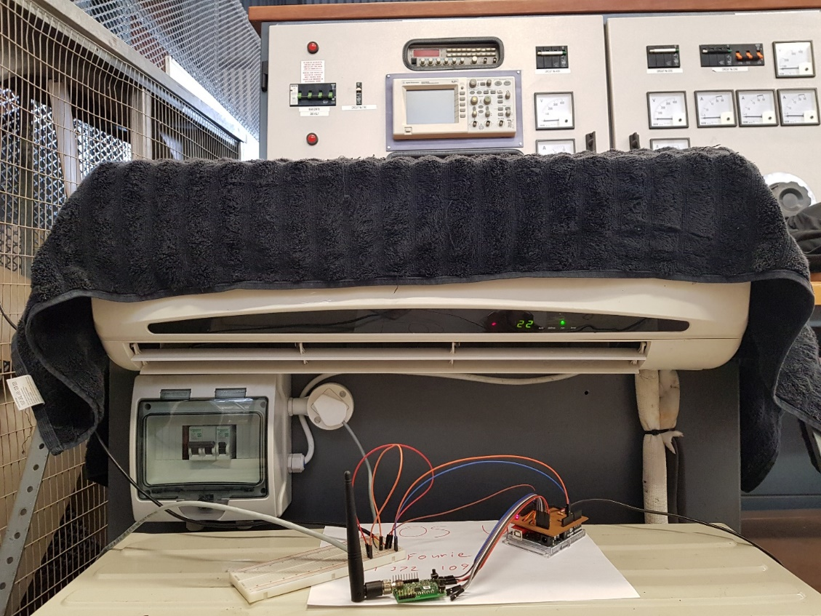

Figure 75: Photo of dirty filter test

From the data analysis in the program the delta temperature of the data was higher. Using this occurrence, the IOT analysis program was used to identify and record instances where the filter was dirty (when the towel was placed over the filter).

## Compressor Fan Test

The objective of the test is to identify when the compressor fan of the split type air conditioning unit is not working. The test was conducted by disconnecting the fan wire shown in Figure 76 below with the red arrow.

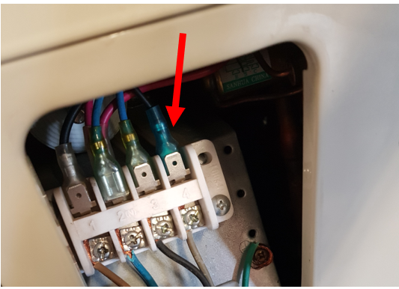

Figure 76: Photo of compressor fan test

The air-conditioning unit was left running throughout the day to collect data for the data analysis. As was expected the current measured increased significantly in the time the fan was not connected. The inside air-conditioning unit switched on fewer times than the air-conditioning unit would have switched on under normal circumstances even though the outside unit was switched on. This is due to the increase in time the compressor took to cool down the air without the help of the compressor fan. Analysing the data in the Python program the times at which the compressor fan was not working could be identified and displayed to the user.

## Compressor decoupled Test

The object of this test was to simulate the event of the air-conditioning units’ compressor completely stopping to work. This was done by disconnecting the compressor completely and then leaving the air-conditioning unit powered in that state for a day. After the data had been gathered over the course of a day, it was clear from the data that the expected results was obtained. This was, that in the occurrence of a complete compressor failure, the total current consumption would be a much lower value than in normal circumstances but not to a value of nil. This indicate that the inside unit was still functional but the outside unit had stopped working. This drop in current consumption was also accompanied by the fact that the delta temperature fell to nearly zero while the air-conditioner was powered. This is not a normal occurrence but was also expected as, without the compressor, the gas cannot be circulated and consequently cannot cool the pipes.

After the data had been logged and data analysis with Python it was possible to identify these cases and display to the user when there is a complete compressor failure.

## Package Test

The following is an example of the package taken from the Loriot website that the data collection program received via a WebSocket:

{"cmd":"rx","seqno":34198,"EUI":"70B3D58FF003543C","ts":1540406281763,"fcnt":386,"port":3,"freq":868100000,"rssi":-93,"snr":9.5,"toa":61,"dr":"SF7 BW125 4/5","ack":false,"bat":255,"data":"110070000000bd0821093408"}

____________________________________________________

Below is an example of the raw serial stream that is sent from the ATmega chip to the LoRa transceiver.

____________________________________________________

00 C0 C0 C0 C0 C0

C0 C0 C0 C0 C0 C0 C0 C0 C0 C0 C0 C0 C0 C0 C0 C0 C0 C0 C0 C0 C0 C0 C0 C0 C0 C0 C0 C0 C0 C0 C0 C0 C0 C0 C0 C0 10 05 BE 01 00 00 00 00 00 21 93 E1

C2 36 87 98 E0 BE 0E F7 1B 32 D6 60 6C D5 5F A9 C0

C0 C0 C0 C0 C0 C0 C0 C0 C0 C0 C0 C0 C0 C0 C0 C0 C0 C0 C0 C0 C0 C0 C0 C0 C0 C0 C0 C0

C0 C0 C0 C0 C0 C0 C0 C0 C0 C0 C0 C0 C0 10 09 17 07 C0

_______________________________________________________

Below is an example of a “set join parameters” request sent from the LoRa to the gateway.

---------------------------------------------------------------------------------

8:36:23 PM RX -> LoRaWAN-HCI-Frame

Dst: 10 [LoRaWAN]

MsgID: 05 [SetJoinParam Req]

Pay: [024] BE 01 00 00 00 00 00 21 93 E1 C2 36 87 98 E0 BE 0E F7 1B 32 D6 60 6C D5

AppEUI-Part1 : [4] BE 01 00 00

AppEUI-Part2 : [4] 00 00 00 21

AppKey-Part1 : [4] 93 E1 C2 36

AppKey-Part2 : [4] 87 98 E0 BE

AppKey-Part3 : [4] 0E F7 1B 32

AppKey-Part4 : [4] D6 60 6C D5

CRC 5F A9 [OK]

Raw-Frame: [028]: 10 05 BE 01 00 00 00 00 00 21 93 E1 C2 36 87 98 E0 BE 0E F7 1B 32 D6 60 6C D5 5F A9

Slip-Frame: [030]: C0 10 05 BE 01 00 00 00 00 00 21 93 E1 C2 36 87 98 E0 BE 0E F7 1B 32 D6 60 6C D5 5F A9 C0

_________________________________________________________________

Below is another example of “a join network” request sent from the LoRa transceiver to the gateway.

---------------------------------------------------------------------------------

8:36:23 PM RX -> LoRaWAN-HCI-Frame

Dst: 10 [LoRaWAN]

MsgID: 09 [JoinNwk Req]

Pay: [000]

CRC 17 07 [OK]

Raw-Frame: [004]: 10 09 17 07

Slip-Frame: [006]: C0 10 09 17 07 C0

From the data package test it was found that all the packages were sent correctly.

Table 17: Test results of packages

|  |  |
| --- | --- |
| Package sent Test | Operational |
| ATmega chip to LoRa transceiver | Yes |
| Loriot to data collection program | Yes |
| LoRa transceiver to gateway | Yes |

## Conclusion

In this chapter, the performance of the components of the distributed IOT environmental monitoring project was tested and evaluated. The temperature sensors were tested in two ways namely the hot bucket, cold bucket test and a test comparing the measured ambient temperature to the air-conditioning unit’s measured ambient temperature. The hot bucket, cold bucket test is a basic, acceptable manner to test the temperature sensor functionality as the temperature sensors are pre-calibrated, therefore, it is only necessary to ensure that the program used to calculate the measured data from the temperature sensors is correct. The ambient temperature test assumes the ambient temperature sensor of the split-type air-conditioning unit is measuring the temperature correctly. From the test results of the temperature sensor test it is clear that the temperature sensors were operating as expected.

The current sensor test was done by comparing the current sensor measurements taken to that of a multimeter with a current clamp measuring the same current. From this test it was clear that the current sensor operated as required. The dirty filter test was done by placing a towel over the air-conditioning unit filter and analysing the data under blocked filter simulation. From the data analyses it was clear that there was a significant increase in the delta temperature. This increase in delta temperature was identified by the data analysis program and thereby the instances a dirty filter was detected is displayed to the user.

During the compressor fan test, the air-conditioning unit’s compressor fan was disconnected in order to simulate conditions under which the fan is broken or blocked. During this test it was clear that the current of the air-conditioning unit picked up drastically and the inside unit of the air-conditioning unit did not switch on as often as under normal operating parameters. Using these aspects, the data analyses program was modified in order to identify and display occasions when the compressor fan was not functional.

The package test done in the test and evaluation section was a simple binary checklist to see if the packages were sent and operational. From the test and evaluation all aspects of the project scope were addressed and proved adequately functional.

# Chapter 6 – Conclusion and Recommendation



## Introduction

The following chapter gives an overview of the distributed IOT environmental monitoring project including a short discussion on the chapters 1 to 6 of the report followed by an evaluation of the strengths and weaknesses of the project. The overall recommendation based on the results and review of weaknesses of the project is also discussed. The ECSA ELO’s are defined and demonstration is given on how the project met the ELO’s throughout its duration.

## Project Overview

The aim of the distributed IOT environmental monitoring system project was to develop a module that would be able to predict whether a split type air-conditioning unit should be repaired or replaced due to inefficient operation. This goal was reached by firstly interpreting the project problem and defining the project scope. From the project scope possible solutions for the project could be formed.

From the possible solutions trade-off matrices were constructed in order to form a conceptual design for the project. From the conceptual design a detailed design was created of the solution. The detailed design was implemented by the implementation of several components of the design. It was clear that amendments would be necessary for the project to adhere to the requirements and stay within the scope of the project.

Once the new detailed designs were created, the new design versions were implemented. From some of these implementations it was once again apparent that improvement in design was necessary and the detailed design was amended accordingly. The new designs were then implemented and once implementation proved adequate in evaluation, further tests of the products where conducted.

# ****Summary of strengths****

The main strengths can be summarised as follows: cost, deploy-ability, non-invasive design and robustness. These strengths create an excellent solution for large buildings with a large number of offices or small rooms each fitted with one or more separate split type air-conditioning units. Because a large number of these modules can be bought at low cost, be installed in currently installed air conditioner units without disruption or access to the individual offices or rooms, it is an ideal solution for commercial and domestic situations where productivity, safety and security are concerns.

# **Cost**

The module consists of inexpensive parts and sensors, with no specialised or expensive equipment and skills required, resulting in a low-cost module. By optimising the data gathered from the sensors and doing extensive data analysis with the available data, it was possible to obtain the same quality results that would have been acquired by the use of more expensive sensors.

# **Deploy-ability**

The module was designed and made with deployment in mind thus the module was designed so that it could be easily and swiftly installed. Therefore, the installation process consists of creating a power connection and then simply taping two temperature sensors to gas pipes and hooking a non-invasive current sensor onto the power cable over the live wire of the air-conditioning unit. This allows for mass activation enabling a company to install such modules on all the air-conditioning units in a building in a day.

# **Non-Invasive**

A major problem with installing sensors in large office buildings is gaining access to all the offices due to business operation requirements as well as safety and security concerns. This reality drove the design of the module so that the installation of the module does not require access to the inside part of the air conditioning unit but rather that the entire module is installed outside. This allows the installation of the modules to take place during business hours without disturbing occupants, interrupting work or causing delays or increasing costs for installation after hours.

# **Robustness**

The module is constructed with longevity in mind thus there are no moving parts or extreme heat generating components used in the module design. The module sends packages to the gateway in short increments and the packages are then checked for validity before being added to the database. If a package is lost or there is a power or internet failure and the database receives no data, the time period for which there is no data is simply filtered out in the data analysis. Since the first module was deployed it has not broken down and there have been no errors. This enables the modules to be installed and used without any need for regular maintenance or check-ups.

# ****Summary of weaknesses****

The project has a few weaknesses which, if addressed, would improve the value of the module. These weaknesses are Server reliability, Gateway reliability, bi-directional communication and limited data. In the manner the project is currently set up, it can happen that the failure of a specific component in the chain of communication may cause the loss of data. Currently lost packages are ignored which could be solved using bi-directional communication. The data analysis program currently used was trained on all the available data that has been gathered to this point which is not enough data to create a rock-solid model.

# **Server reliability**

In order to receive the data from the module a server needs to be running at all times to receive and save the data. This leads to gaps in data due to occurrences such as server crashes, server power loss and server-side internet downtime. This was not addressed due to the cost and lack of the equipment needed.

# **Gateway reliability**

The gateway suffers from many of the same issues as the server meaning that if the gateway is down no data can be logged. The gateway can be down due to reasons such as power or internet connection loss. This was not addressed in this project due to lack of the equipment and it being too expensive to purchase.

# **Bi-directional communication**

In the current design of the project there is no communication from the gateway to the module, the only communication is from the module to the gateway. This means that if an error occurred with the data transmission and the gateway discards the packages, the module will be unaware and will not resend that data. This is not a major problem due to the short intervals in which data is sent, so missing one package is not a major concern. However, it is still a weakness that could be addressed in future versions of the module. The reason this was not addressed in this version is due to the limited UART capabilities of the MCU that is being used.

**Limited Data**

Due to the time allowed for the completion of this project being less than a year data could only be gathered over a short period leaving the data analysis model vulnerable. With the limited data being used to create the data analysis model the model could not be tested to see if it will hold up throughout the year as the seasons change. All the data gathered was also in the same place in the same room thus it is unclear if the model will stand up in varying environments. This could be solved by gathering data over a longer period of time and over multiple air-conditioning units and then revisiting the data analysis model and adapting it to be more robust to hold up for all the data gathered.

## Recommendations

As with any project there is room for improvement with this project. The first recommendations that will be given are recommendations aimed at strengthening the projects weaknesses and eliminating them where possible. The next set of recommendations will be general recommendations where there is believed to be some room for improvement in the project. A large aspect of this project was the estimation of COP and thus there is a dedicated recommendation on COP estimation section in order to state how the estimation could be improved in future.

# **Recommendations for weaknesses**

The first weakness to be addressed is server reliability, which is one of the first things that should be addressed in future iterations of the project. There are a couple of possible solutions to this problem such as renting a server or making use of an in-house server that has backup power and that it is connected to multiple internet lines. Secondly is the improvement of gateway reliability which has a similar possible solution as the first weakness. The solution to this problem is to have a backup power source connected to the gateway as well as connecting it to multiple internet lines. These issues can easily be solved if this is deployed in a large company which already has the necessary infrastructure to connect the gateway too to ensure the gateway stays up.

For the next weakness - Bi-directional communication, it will be more difficult to solve due to the fact that in order to solve this weakness you will have to use a different more powerful MCU that will increase the cost of the module. In addition to the increased cost per module the program will also have to be ported to the new MCU and the new functionality added which could be time-consuming and costly.

The last weakness is the limited data weakness which is the simplest to solve but will be time-intensive as the only solution will be to install the modules on several air conditioner units and revisit after a year and then adapt the data analysis model.

# **General recommendations**

The first general recommendation for the project is to make use of professionally made PCB’s and surface mount components. This could drastically reduce the size of the module making it simpler to install. Secondly, it should be investigated to use a second low-frequency crystal in order to switch between an active and sleep mode which would save power. If this is done, then the potential of using battery power to power the module could be investigated.

It should also be kept in mind that for use in extreme conditions, components and sensors that are manufactured and tested to operate in those conditions should be used. It is also recommended that as new problems with air conditioning units are identified they should be incorporated in the data analysis model which will widen the usability value of the project.

# **COP estimation recommendations**

Since it was deemed impossible to calculate the real COP in the scope of this project an estimation was used in its stead. The COP estimations used could be improved in future projects to more accurately reflect the true COP. The first recommendation would be to build a test setup in which an air-conditioning units’ air intake and output is limited to an easily measured surface and then to use an anemometer in order to calculate the true COP. If the true COP is known for an air-conditioning unit then the calculated COP estimation could be compared. By comparing these COPs’, it will be possible to see whether the estimated COP is a good indicator of true COP if not then another method could be employed in order to estimate the COP. If the estimated COP is found to be closely related to the true COP then some possible factor could be calculated then when applied to the COP estimation gives an even more accurate estimation.

## ECSA ELO outcomes

The exit-level outcomes assessed in the final year project for ECSA are ELO1, ELO3, ELO6, ELO8 and ELO9. These exit-level outcomes met in the project are as defined in the following excerpt from the Qualification Standard for Bachelors of Engineering (BEng) [22].

**ELO 1: Problem solving**

Identify, formulate, analyse and solve complex engineering problems creatively and innovatively.

**ELO 2: Application of scientific and engineering knowledge**

Apply knowledge of mathematics, natural sciences, engineering fundamentals and an engineering speciality to solve complex engineering problems.

**ELO 3: Engineering design**

Perform creative, procedural and non-procedural design and synthesis of components, systems, engineering works, products or processes.

**ELO 4: Investigations, experiments and data analysis**

Demonstrate competence to design and conduct investigations and experiments.

**ELO 5: Engineering methods, skills and tools, including information technology**

Demonstrate competence to use appropriate engineering methods, skills and tools, including those based on information technology.

**ELO 6: Professional and technical communication**

Demonstrate competence to communicate effectively, both orally and in writing, with engineering audiences and the community at large.

**ELO 7: Sustainability and impact of engineering activity**

Demonstrate critical awareness of the sustainability and impact of engineering activity on the social, industrial and physical environment.

**ELO 8: Individual, team and multidisciplinary working**

Demonstrate competence to work effectively as an individual, in teams and in multidisciplinary environments.

**ELO 9: Independent learning ability**

Demonstrate competence to engage in independent learning through well-developed learning skills.

**ELO 10: Engineering professionalism**

Demonstrate critical awareness of the need to act professionally and ethically and to exercise judgment and take responsibility within own limits of competence.

**ELO 11: Engineering management**

Demonstrate knowledge and understanding of engineering management principles and economic decision making.

Here follows the justification of each of the ELOs met throughout the distributed IOT environmental monitoring project:

**ELO 1: Problem solving**

In order to complete the distributed IOT environmental monitoring project the complex problem was firstly identified in the section 1.3 of chapter 1 of the report. Possible solutions were explored from which the most probable solution was selected in order to adhere to the requirements of the project, thereby showing complex problem-solving abilities.

**ELO 2: Application of scientific and engineering knowledge**

In order to complete the project engineering knowledge application through coding and integration design. Furthermore, engineering knowledge application was needed in order to construct the distributed IOT environmental monitoring module circuitry.

**ELO 3: Engineering design**

Throughout the project the engineering design process was followed in order to complete the project successfully. The first step of the engineering process was to formulate the problem statement of the project in order to form a clear understanding of the scope and requirements of the project. Next a solution for the problem was proposed - the solution was explored through a literature study on the different aspects proposed in the solution. From the information gathered in the literature study a trade-off study was conducted of the possible solutions. From the trade-off study the solution with the best trade-off score was selected. Once the components of the trade-off study were selected a conceptual design was constructed of the distributed IOT environmental monitoring module.

Next a detailed design of the module was created. The design was then implemented with a prototype of the module. Evaluation of the module proved there was room for improvement on the module and a new iteration of the module was created. The new iteration firstly required a new detailed design that was then implemented and evaluated. This process was repeated until the requirements of the project was achieved in the design. Once this was achieved a PCB module was implemented and the testing and evaluation of the module was conducted. The testing and evaluation of the module was documented in Chapter 5 of the report. Finally, conclusion of the analysis of results was formulated including recommendations for improvement of the design and operation**.**

**ELO 4: Investigations, experiments and data analysis**

Several different possible solutions for the project was investigated in the report.

Firstly, investigation was shown in the literature study of the components of the possible solutions for the project in chapter 2 of the report.

Secondly investigation of solutions was demonstrated in the iterations of the project design, that is of the controller design V1.0, V1.1, V1.2 and the final controller design V2.0 as well as the iterations of the back-end program and programming languages.

Demonstration of experiments conducted within the project is shown in the test and evaluation documented in chapter 5 of the report. In chapter 5 clear demonstration of experiments are shown in order to test component functions.

Finally, clear demonstration of data analysis is the data analysis done in the program written to analyse the data sent from the module in order to assess the operation of the split type air-conditioning unit. Further data analysis skills are shown in the analysis of the test data collected in chapter 5 test and evaluation.

**ELO 5: Engineering methods, skills and tools, including information technology**

Demonstration of competence in using engineering skills and tools is shown by using information technology such as computer programs including Proteus PCB design, Python programming, Atmel studio programming and Excel data collection. These tools were utilized using different skills and interpreting the results of the information compiled through program processing of the data collected. The interpreted results where then used in order to improve the program code and present the data in a clear and organized manner that will be useful for the user.

**ELO 6: Professional and technical communication**

This project is presented orally on project day to moderators of the computer and electronic engineering field. This report suffices as a written communication of the project conducted on distributed IOT environmental monitoring. The project will also be presented to a public audience on the project day in the form of a visual communication poster as well as a short summary for the public**.**

**ELO 7: Sustainability and impact of engineering activity**

The impact of the distributed IOT environmental monitoring module on the society and environment was a major consideration in the design of the module as the project focuses on the improvement of the efficiency on split type air-conditioning units, which make up a large percentage of electricity use in domestic and corporate settings, therefore impacting the environment negatively. The module will monitor the operation of the split type air-conditioning unit and thereby alert the user when the unit is not operating as required so that it may be repaired or replaced and not continue to operate ineffectively**.**

**ELO 8: Individual, team and multidisciplinary working**

The majority of the project was accomplished as individual work by the student. However, some teamwork was required between the student and the project leaders: Prof. A Helberg and Dr. M Ferreira. Multidisciplinary working was demonstrated in the consultation of experts in split type air-conditioning units and other aspects of the project.

**ELO 9: Independent learning ability**

Independent learning ability was demonstrated within this project through the broad scope of subjects the student was required to study in order to complete the project successfully. Considering social and environmental aspects the ill-defined complex problem was taken on. The project required independent study of PIC microcontrollers, STM, Python, Arduino Uno®, LoRa module operation, Proteus, split type air-conditioning unit operation, Arduino libraries, Gateways, C (Atmel studio code) and several other components of the project.

**ELO 10: Engineering professionalism**

Engineering professionalism was achieved through the completion of the distributed IOT environmental monitoring project in an ethical and professional manner. All designs and schematics documented in the project report are authentic when stated as such and credit is given where designs, schematics and intellectual property is referenced. The tests, results and data collected in the report is un-manipulated and a true representation of findings of the project. Furthermore, ethical behaviour is shown as demonstrated in ELO 7.

Finally engineering professionalism was shown in consultation with experts in different aspects pertaining to the project, in order that these aspects may be implemented in the project**.**

**ELO 11: Engineering management**

Demonstration of engineering management is shown in the project through economic decision making by managing the project budget. Furthermore, project management is applied to the distributed IOT environmental monitor project and, therefore, to the individual’s own work as prescribed in the ELO**.**

## Conclusion

The first step of the project was to interpret the problem and acquire an understanding of what was expected. This was also the first milestone of the project where a problem contextualisation had to be done orally in front of the project supervisors. A discussion with the project supervisors on the problem provided clarity on what was expected of the project. The next step taken was to investigate possible solutions to the problem provided by the project. Firstly, possible existing solutions were investigated, which would solve the project problem but none was found. The existing solutions to problems that come closest to the problem are solutions that solves the same problem as provided in the project but for far larger HVAC systems. This means that these solutions could not be ported to solve the provided HVAC problem as they are too expensive and they cannot be adapted for use on split type unit air-conditioners as these air-conditioners do not have parts such as ducts that are required for these solutions to work. The next solutions investigated were existing solutions for other problems than the project’s but that could possibly be altered in order to address the specific problem. No such solution was found which could be altered to solve the problem at hand, however, a few different solutions were found that could possibly be used to address parts of the problem.

A specifications document was created that consisted of an introduction and scope of the project, applicable and other referred documents, requirements, verification requirements and a value model. The specifications document is very important as it was constantly used as reference in order to ensure that the project remained within the specifications and that all requirements are met.

After the specifications for the project was finalised the projects detailed design could be created. The detailed design starts with an introductory chapter that again reiterates the background of the problem and the problem statement. This was followed by the envisaged solution to the problem that consisted of alternative solutions, however, it was determined that there were none. The objectives and scope of the project were formulated to ensure there was a comprehensive understanding of what was to be done. The proposed solution to the problem was documented, the proposed solution consisted of a high-level description of what was planned on to be done and how the problem was to be solved. The testability and deliverables of the project was stated to clearly show the intended capabilities of the project. A major aspect of any engineering project is the limitations of the project and the projects safety aspects. This project was faced with limitations such as time and budget constraints and has safety aspects that need to be considered such as working with the high voltage supply electricity to the split type air-conditioning units. A project plan was also included as it is an important aspect of any project, the plan consists of the methodology that would be followed as well as a detailed work breakdown structure and a project feasibility study.

An extensive literature study was completed on all the existing equipment and protocols which would be using for the project to ensure an understanding of the workings of all the different components and what to expect when measuring at different places. Next, a study was done on all the different components and sensors intended to be used in the solution. This allowed informed and educated decision making to occur on what to use and how to use it.

The 3rd chapter of the detailed design document was the conceptual design which included trade-off studies where the different options available for certain parts of the project were investigated.

The last chapter of the detailed design document set out the hardware and software that would be used in order to complete the project that was investigated and researched.

After the detailed design was completed, work started on actually realising the envisioned solution to the problem. The first incarnation of the project was created in order to demonstrate the core aspects of the project and would be used for a core demo.

The first incarnation of the project was done using two Arduino Uno’s, a waterproof ds18b20 temperature sensor, a SCT-013 non-invasive current sensor and two LoRa RFM95 shields. This version of the project consisted of the one Arduino having the temperature and current sensors connected thereto and one of the LoRa transceivers. The other Arduino only had the other transceiver connected. The Arduino with the sensors connected then gathered data from the sensors package it and send it to the other Arduino. This was to demonstrate the core of my project which is to obtain data, package it, send it and receive it at the other end. This was done on Arduino making use of the Arduino studio and libraries as it was a rapid prototype that was developed in order to show that the project was possible.

At this point in time it was decided that it is desirable for the LoRa modules to be able to communicate with public gateways making it a necessity to make use of a LoRaWAN certified transceiver. The transceiver to be used for the project was thus changed from the RFM95 to the iM880B, this specific transceiver was chosen due to its availability at the university. The iM880B had a STM32L151CB chip and due to this it was decided that it should be attempted to eliminate the need for an external MCU to communicate with the transceiver and rather attempt to consolidate the data gathering MCU and the transceiver MCU and do the entire project on the STM32L151CB.

After substantial research and experimentation programming was done on the MCU embedded on the transceiver making use of a ST-Link programmer. At first, only a basic LED blinking program was implemented on the STM in order to test whether there could successfully be programmed on the STM while still using it as a transceiver. This test was unsuccessful as the transceiver had been LoRaWAN certified and the code on board had been locked in order to protect it against change. This made it impossible to reprogram the STM with the project’s own code while still maintaining the transceiver code. This forced the project to abandon the STM approach and in the project’s search for a replacement the highest priority was placed on getting a low cost alternative as to keep the price of the module low. This led to the ATmega328P as an alternative choice. The ATmega328P is an inexpensive MCU that is widely available with substantial support.

The final iteration of the project came into existence which consists of the ATmega328P MCU being used to gather the data from the three sensors which are the one SCT-013 non-invasive current sensor and then two ds18b20 waterproof temperature sensors. The ATmega328P MCU is connected to the iM880B Lora transceiver this allows the ATmega328P to gather the readings from the sensors package it and passes it to the transceiver that then transmits it to the gateway. This was the final design of the IOT module and it is in this form that it was implemented.

In order to test the module a demo split type air-conditioning unit was placed on a portable stand that allowed the module to be tested and the data to be gathered in a controlled environment. The first jig that was constructed consisted of the split type unit air-conditioner that was placed on a wooden stand. An investigation took place to decide precisely where and how the module would be installed in order to obtain the best data and make the module as easy to install and as non-invasive as possible. The initial thought was to install the two temperature sensors in front of the air-conditioners inside unit’s air intake and in front of the exiting air. This would be used to determine the difference in the temperature before it enters the air-conditioning unit and after it exits it. The current sensor would be installed on the main power supply line allowing it to monitor the power consumption of the air-conditioner unit. The problem with this idea was that usually since this had to be able to be installed on already installed air-conditioner units that the temperature sensors would need to be inside with the current sensor outside this led to the problem of how to make this practical.

As the current sensor would have to be installed on pre-installed air conditioning unit, concerns arose about the practicality of the proposed manner of installation.

This led to the decision to move the entire module outside in order to make it easy to install and as non-invasive as possible. After conferring with experts on air-conditioners it was found that even more accurate data could potentially be gathered outside on the unit. This is by measuring the current on the main power supply line as planned but then measuring the temperatures on the gas pipes that move to and from the inside unit. This led to the construction of the second jig that allows for an accurate installation to be made. The second jig is on a stand made from steel and has wheels enabling it to be even more portable. The new jig had an electric circuit box installed in order to allow for a legal electrical installation of the module. The circuit box consists of an isolator switch for the air-conditioner and a 5 V transformer to power the module.

The gateway that was provided for the project is registered on the Loriot service. This means that as the gateway receives packets it sends it on to the Loriot website. The initial idea was that the Loriot website that receives the data logs it as well but this was later established to be incorrect. This necessitated the writing a Python program that would receive the data from a WebSocket that was provided by the Loriot service that would push the data it received from the gateway to the WebSocket. The python program would then receive the data do some first phase analysis on the data such as decoding the hex payload that was received and store the data in a CSV file. The final stage of the project was to write a program that would interpret the data in the CSV file doing data analysis on the data and drawing some meaningful conclusions and information from it. The program would interpret the data in order to identify problems with the air-conditioning unit such as identifying when the units’ filter is dirty and when the compressor fan breaks down.

In order to simulate a dirty filter a thick towel was thrown over the air-conditioners intake. To simulate a broken fan, the fan motor of the air-conditioning unit was disconnected.

The final occurrence tested was if the compressor completely broke down. This was done by simply disconnecting the compressor. The program could successfully identify each occurrence of malfunction and provide the times when the respective malfunction took place. The program also drew graphs using the data to enable the user to visualise the results and note trends and tendencies in the data.

This concluded the project and at this point the project was ready to be deployed and add value to a buildings HVAC management and monitoring systems.



# References

|  |  |
| --- | --- |
| [1] | Green Building Council South Africa, “GREENOVATE ENGINEERING,” Growthpoint Properties, Joahnnesburg, 2018. |
| [2] | ENERGY STAR, “When is it time to replace?,” 29 September 2017. [Online]. Available: https://www.energystar.gov/index.cfm?c=heat_cool.pr_checklist_consumers. [Accessed 10 March 2018]. |
| [3] | S. Price, “When Is It Time to Replace My Air Conditioner?,” 25 July 2015. [Online]. Available: https://www.angieslist.com/articles/when-it-time-replace-my-air-conditioner.htm. [Accessed 10 March 2018]. |
| [4] | The Air Conditioning Company, “How Does Air Conditioning Work,” 8 October 2016. [Online]. Available: https://www.airconco.com/how-does-air-conditioning-work/. [Accessed 10 March 2018]. |
| [5] | H. Khemani and L. Stonecypher, “Types of Air Conditioning Systems,” 1 January 2013. [Online]. Available: https://www.brighthubengineering.com/hvac/897-types-of-air-conditioning-systems/. [Accessed 10 March 2018]. |
| [6] | Power Knot, “COPs, EERs, and SEERs How Efficient is Your Air Conditioning System?,” Power Knot LLC, Milpitas, 2011. |
| [7] | S. Qian, Y. Geng, Y. Wang, J. Ling, Y. Hwang, R. Radermacher, I. Takeuchi and J. Cui, “A review of elastocaloric cooling:,” *international journal of r e f r i g e r a t i o n,* vol. I, no. 64, pp. 1 - 19, 2016. |
| [8] | I. Poole, “LoRa Wireless for M2M & IoT,” 15 July 2017. [Online]. Available: http://www.radio-electronics.com/info/wireless/lora/basics-tutorial.php. [Accessed 10 March 2018]. |
| [9] | LoRa Alliance, “LoRa Alliance Technology,” 17 February 2017. [Online]. Available: https://www.lora-alliance.org/technology. [Accessed 10 March 2018]. |
| [10] | G. Hudson, “CT sensors - An Introduction,” 11 January 2017. [Online]. Available: https://learn.openenergymonitor.org/electricity-monitoring/ct-sensors/introduction?redirected=true. [Accessed 10 March 2018]. |
| [11] | Arduino, “What is Arduino?,” 27 November 2017. [Online]. Available: https://www.arduino.cc/en/Guide/Introduction. [Accessed 10 March 2018]. |
| [12] | M. Sarig, “MariaDB vs MySQL: In-Depth Comparison,” 28 March 2017. [Online]. Available: https://blog.panoply.io/a-comparative-vmariadb-vs-mysql. [Accessed 11 March 2018]. |
| [13] | D. Bartholomew, “MariaDB vs. MySQL,” 9 June 2016. [Online]. Available: http://www.admin-magazine.com/Articles/MariaDB-vs.-MySQL. [Accessed 11 March 2018]. |
| [14] | OMEGA Engineering, “Anemometer: Introduction to Air Velocity Measurement,” Spectris , 6 February 2015. [Online]. Available: https://www.omega.com/prodinfo/anemometers.html. [Accessed 11 March 2018]. |
| [15] | OMEGA Engineering, “Volume-IndIcatIng thermo-anemometer KIt,” Spectris, Stamford, 2018. |
| [16] | K. Zorn, “commactappliance,” 12 May 2014. [Online]. Available: https://learn.compactappliance.com/electrical-requirements-window-air-conditioners/. [Accessed 5 May 2018]. |
| [17] | Micro Robotics , “Micro Robotics,” Micro Robotics , 2018. [Online]. Available: https://www.robotics.org.za/sensors/current-voltage/SCT013-100A. [Accessed 5 May 2018]. |
| [18] | YHDC, *SCT013-000,* 2015. |
| [19] | IMST, *iM880x_AN011_RangeTest Application Note AN011,* 2013-08-05. |
| [20] | IMST, *WiMOD_LoRaWAN_EndNode_Modem_Feature_Spec,* 2015-09-14. |
| [21] | IMST, *iM880B_AN016_RFSettings Application Note AN016 / Version 1.1,* 016-02-29. |
| [22] | Engineering Council of South Africa, *Standards and procedures system Qualification standard for Bachelor of Science in Engineering (BSc(Eng))/ Bachelors of Engineering (BEng) :NQF Level 8; Document E-02 Revision 4,* ECSA, 2014. |

Appendix A: Systems requirements specification document

Appendix B.1: Firmware Code

Refer to attached CD

Appendix B.2: Software code

Appendix C: URS

1. Introduction

The URS appendix gives a definition of the requirements of the Distributed IOT Environmental Monitoring project. The appendix document will act as a regulation for the student during the Distributed IOT project.

1. Engineering Problem Definition

Split type air-conditioning units are used widely throughout the country and the world, in commercial and domestic settings. These types of split type air-conditioning are being run inefficiently. The split type air-conditioning unit has no efficiency monitoring system and, therefore, are operated until they break or are replaced on a regular basis with set a maintenance plan. The engineering design problem for the Distributed IOT Environmental Monitoring project is to design a sensor system to measure and calculate the efficiency of the preinstalled split type air-conditioning unit.

1. Envisaged Solution

To solve the engineering problem of the Distributed IOT Environmental Monitoring project the following solution is proposed. The project will make use of sensors to measure the outputs of the split type air-conditioning unit. The data measured by the sensors will then be transmitted and received to and from an existing gateway host by means of LoRa. The data will then be processed in a back-end program, the processed information will then be displayed on a simple easy to use front-end program that the operator will use.

1. Requirements
   1. Physical Requirements

The sensor consoles shall be easily wall mountable so not heavier than 1 kg and not larger than 100 mm x 200 mm. REQID 0015

The sensor console shall be a single easy to handle unit and for this reason it needs to be in an enclosure. REQID 0016

The housing of the unit shall adequately protect the sensor console; therefore, the housing shall have a IP rating of at least IP 31. REQID 0017

* 1. Performance Requirements
* Measure efficiency of split type air-conditioning units

The system shall provide an indication of efficiency of split type air-conditioning units at agreed upon intervals. REQID 0001

* Communication between the sensor consoles and back-end program by way of IOT

The sensor consoles need to be able to send and receive data to and from the back-end program by making use of LoRa. REQID 0002

* Analyse and display data

Analyse the data received from the sensor consoles and display pertinent information to the operator inside a GUI. REQID 0003

* 1. Intended Operating Environment

The sensor consoles will be installed directly adjacent to the split type air-conditioning units. REQID 0007

The sensor console will not be exposed to ambient temperature outside operational ranges as specified on data sheets of -20 ⁰C to 60 ⁰C. REQID 0008

The sensor console will be near single phase electrical power plug to draw power from. The power outlet needs to supply 220-240 V at 50 Hz and be able to deliver 0.1 A. REQID 0009

1. Limitations

The limitations of this project is the size of the Distributed IOT Environmental Monitoring device, it must be small enough to be placed in the Split type air-conditioning unit. Another limitation of the project is that the Distributed IOT Environmental Monitoring device must be installed in an already installed split type air-conditioning unit. This limits the solutions for the Distributed IOT Environmental Monitoring project extensively.

1. Acceptance criteria

* If the system cannot gather data from a split type air-conditioning unit and transfer the data to a point a mark of <40% (fail) shall be awarded.
* If the system is capable of getting a basic approximation of the performance of a split type air-conditioning unit and can transfer it using IOT to a back-end program and display the data a mark of 60% would be in order.
* If an accurate approximation the performance of a split type air-conditioning unit can be determined and it can be transferred over IOT and displayed on a back-end program a mark of 70% would be fair.
* If the system can accurately approximate the performance of a split type air-conditioning unit and can then transmit the data over IOT where the data is then processed into information and displayed in a program that neatly and functionally shows the information to the operator. This will result in a mark of 75%+ where all additional value adding functionality and features will result in increased marks

# Appendix D: Budget

Table 18: Project budget

|  |  |  |  |  |
| --- | --- | --- | --- | --- |
| Component | Quantity | Cost per unit (R) | Total component cost | (Bulk unit prices taken where applicable) |
| ATmega328P | 1 | 26 | 26 |
| ds18b20 Waterproof temperature sensors | 2 | 22 | 44 |
| SCT-013-000 non-invasive current sensor | 1 | 80 | 80 |
| Enclosure | 1 | 60 | 60 |
| Power box | 1 | 100 | 100 |
| 5 V transformer | 1 | 60 | 60 |
| LoRa module | 1 | 200 | 200 |
| Miscellaneous electronic parts | 1 | 100 | 100 |
|  |  |  |  |
| Total cost per unit |  |  | 670 |

# Appendix E: LoRaWAN™ Certification

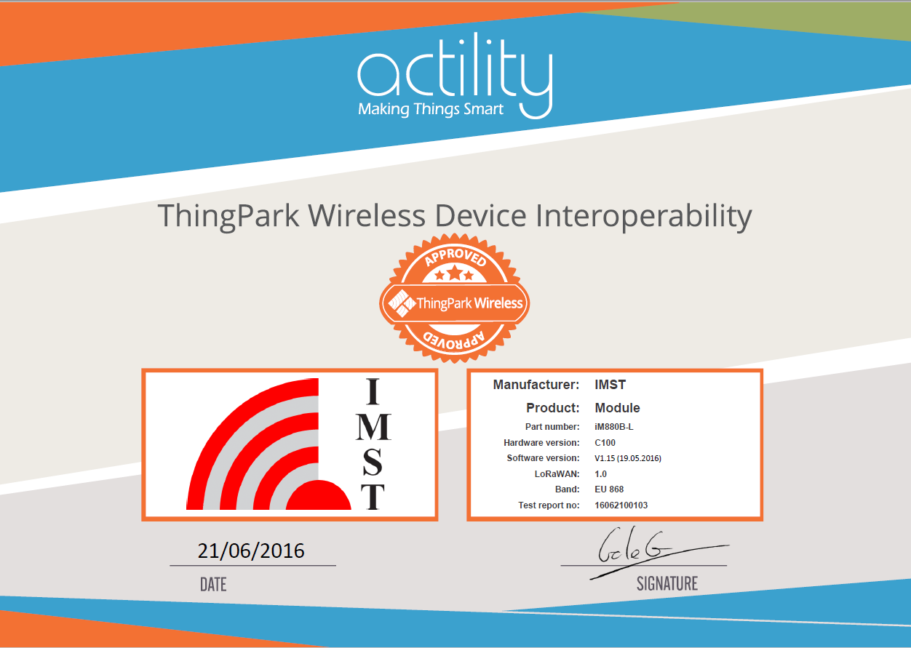

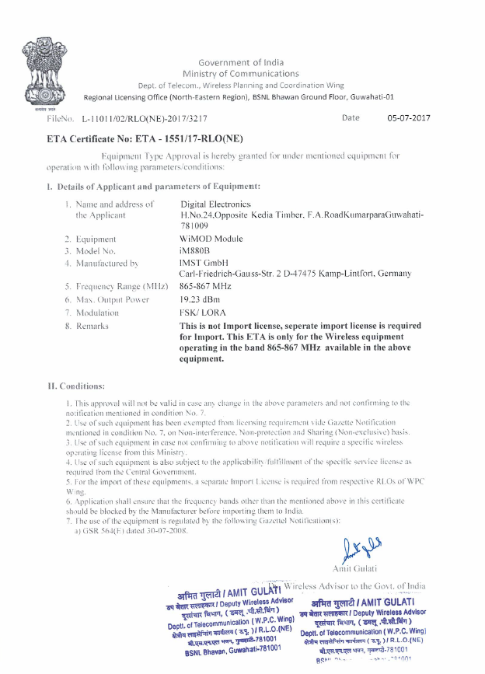





# Appendix F: Project Schedule

|  |  |
| --- | --- |
| Date | Task Description |
| 05-02-2018 | University term begins |
| 07-02-2018 | Schedule meeting with project manager |
| 09-02-2018 | Prepare for oral problem contextualisation |
| 12-02-2018 | Project Milestone 1: Problem Contextualisation Oral |
| 14-02-2018 | Meeting with project manager |
| 19-02-2018 | Project Milestone 2: Problem Identification and Analysis Proposal document |
| 07-03-2018 | Determine possible solutions |
| 12-03-2018 | Project Milestone 3: Evaluation of possible solutions document |
| 14-03-2018 | Determine design specifications |
| 19-03-2018 | Project Milestone 4: Specification document 2 |
| 21-03-2018 | Start design of IOT sensor unit system |
| 28-03-2018 | Start design of system for back end software |
| 20-04-2018 | Complete system design |
| 23-04-2018 | Project Milestone 5: System Design document |
| 24-04-2018 | Start working on detail design |
| 26-05-2018 | Complete detail design for IOT sensor unit and back end software |
| 28-05-2018 | Project Milestone 6: Detail Design document |
| 19-05-2018 | Isolate core aspect of project |
| 20-05-2018 | Implement core aspect of design |
| 18-06-2018 | Project Milestone 7: Implementation & Evaluation: Core Demo |
| 18-07-2018 | Project Milestone 8: Implementation & Evaluation: Functional Demo |
| 19-07-2018 | Correct faulty components of project |
| 20-07-2018 | Start working on integration of project |
| 17-08-2018 | Complete integration IOT sensor unit through the cloud with the back-end software |
| 20-08-2018 | Project Milestone 9: Implementation & Evaluation: Integrated Demo |
| 01-10-2018 | Prepare for performance evaluation |
| 15-10-2018 | Project Milestone 10: Implementation & Evaluation: Performance Evaluation Demo |
| 18-10-2018 | Finish simplified report for Milestone 11 |
| 19-10-2018 | Project Milestone 11: Project at a Glance |
| 26-10-2018 | Complete project report |
| 29-10-2018 | Project Milestone 12: Final Report Submission |
| 30-10-2018 | Create poster for project |
| 02-11-2018 | Project Milestone 13: Poster Submission |
| 06-11-2018 | Prepare for oral examination |
| 07-11-2018 | Project Milestone 14: Oral Exam |
| 07-11-2018 | Close Project |

# Appendix G: Arduino Uno ® schematic

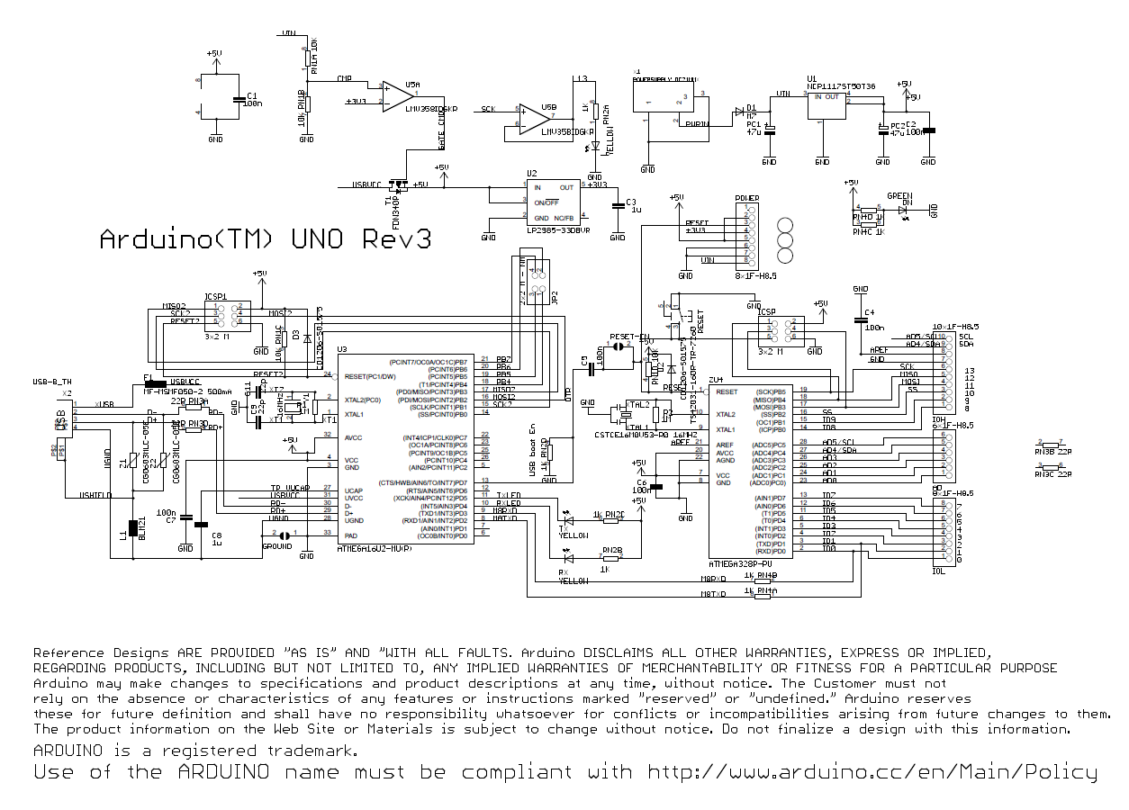

# Appendix H: Work Breakdown Structure

